Tangents and Normals
Remember how you found the gradient given equations in parametric form.
$$x=\cos{t}, y=\sin{t}$$
$$\frac{dy}{dx}=\frac{\left(\frac{dy}{dt}\right)}{\left(\frac{dx}{dt}\right)}=\frac{\cos{t}}{-\sin{t}}=-\cot{t}$$

In the same way for polar coordinates:
$$x=r\cos{θ} y=r\sin{θ}$$
$$\frac{dy}{dx}=\frac{\left(\frac{dy}{dθ}\right)}{\left(\frac{dx}{dθ}\right)}$$
We can find the gradient at any point by differentiating parametrically.

- If $\frac{dy}{dθ}=0$ the tangent is parallel to the initial line

- If $\frac{dx}{dθ}=0$ the tangent is perpendicular to the initial line.
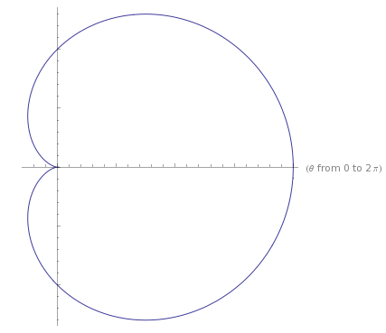

Eaxmple
Find the coordinates of the points on $r=a\left(1+\cos{θ}\right)$ where the tangents are parallel to the initial line $θ=0$.

Test Your Understanding
The curve $C$ has polar equation
$$r=1+2\cos{θ}, 0≤θ≤\frac{π}{2}$$
At the point $P$ on $C$, the tangent to $C$ is parallel to the initial line.
Given that $O$ is the pole, find the exact length of the line $OP$.

Example
Find the equations and the points of contact of the tangents to the curve
$$r=a\sin{2θ, 0≤θ≤\frac{π}{2}}$$
that are (a) parallel to the initial line and (b) perpendicular to the initial line.

Proof of dimple vs egg
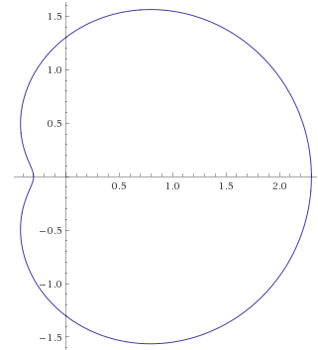
Prove that for $r=p+q\cos{θ}$ we have a ‘dimple’ if $p<2q$.
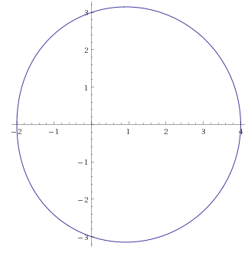
Ex 5D pg 115

