5C Integrating Polar Curves

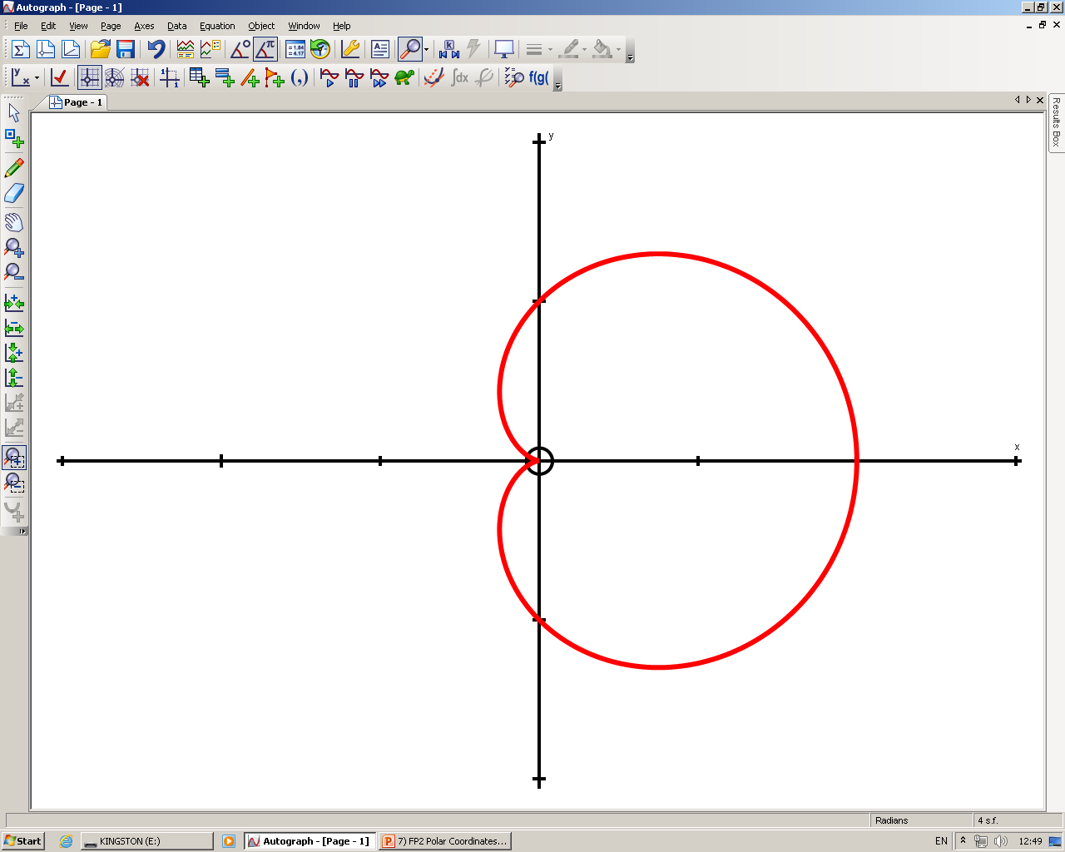
0, 2π
π 2
π
3π 2
$$r=1+cosθ$$
π 6
π 3

- Find the area enclosed by the cardioid with equation:
r = a(1 + cosθ)
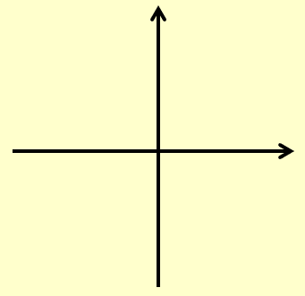

- Find the area of one loop of the curve with polar equation:
r = asin4θ

- On the same diagram, sketch the curves with equations:
r = 2 + cosθ
r = 5cosθ

- Find the polar coordinates of the intersection of these curves

- Find the exact value of the finite region bounded by the 2 curves

