Summary so far:

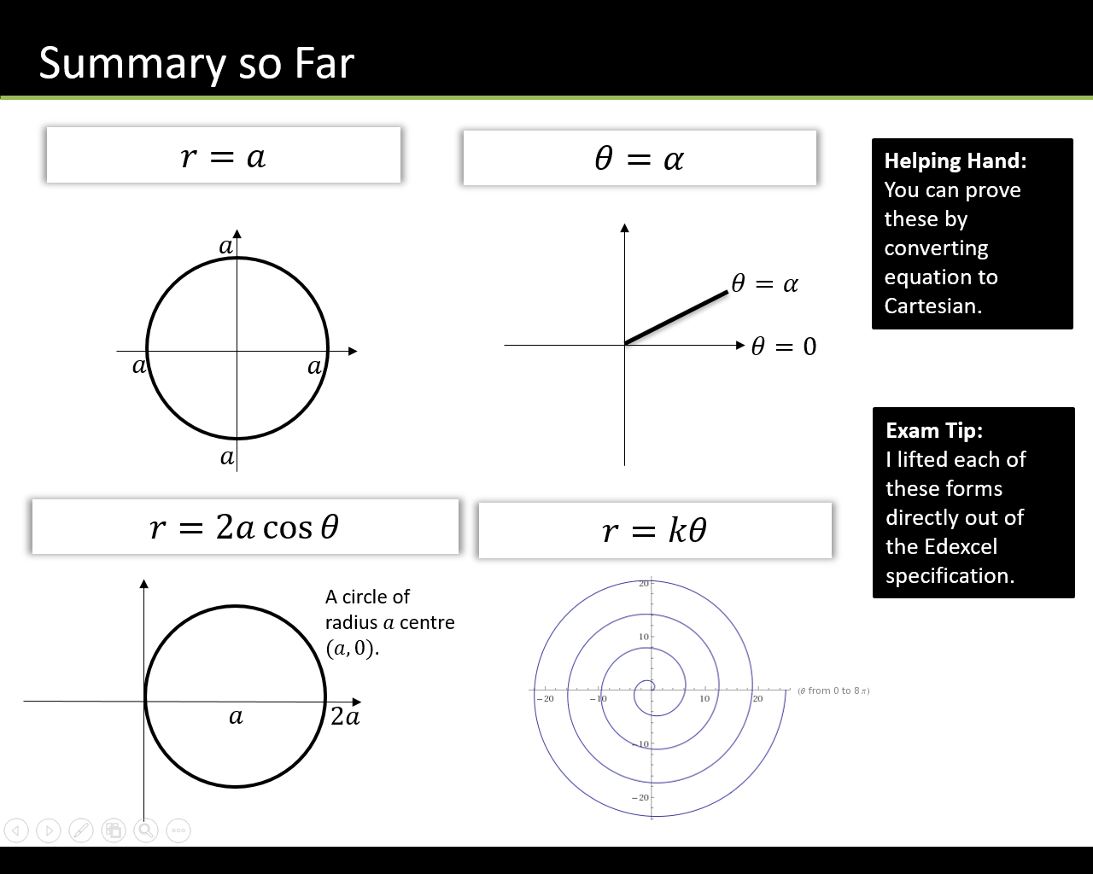

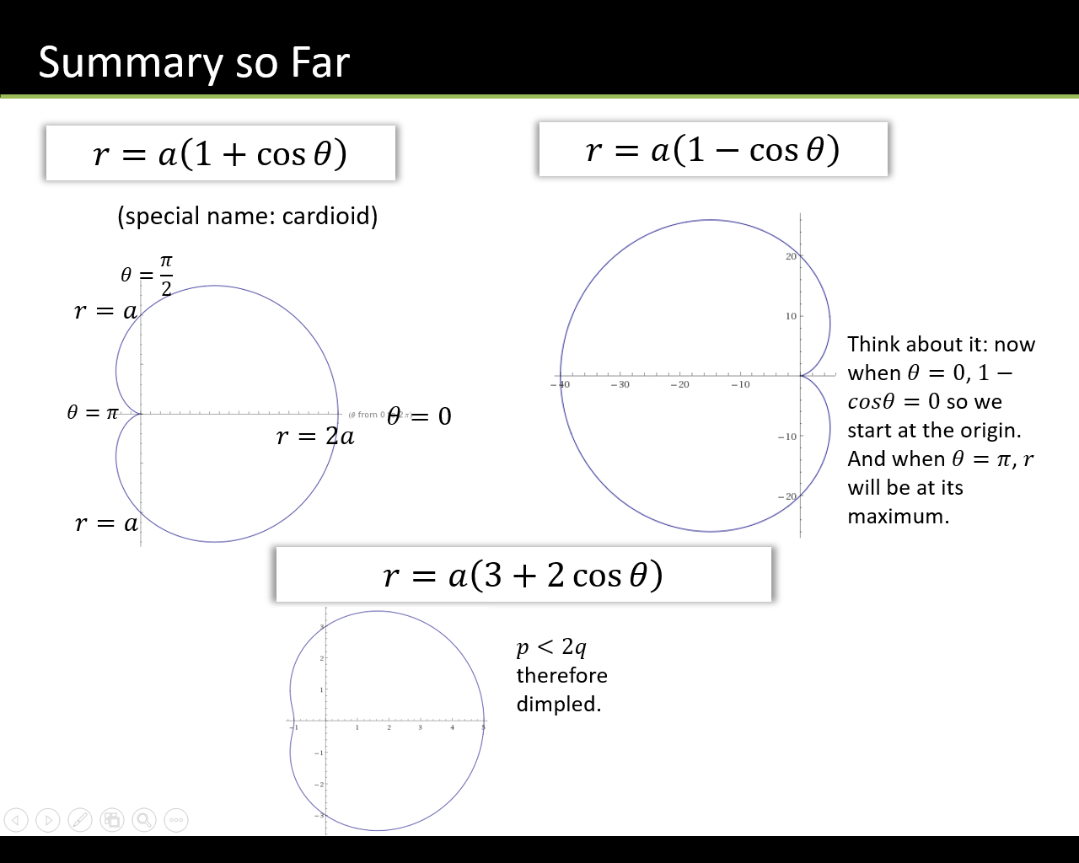

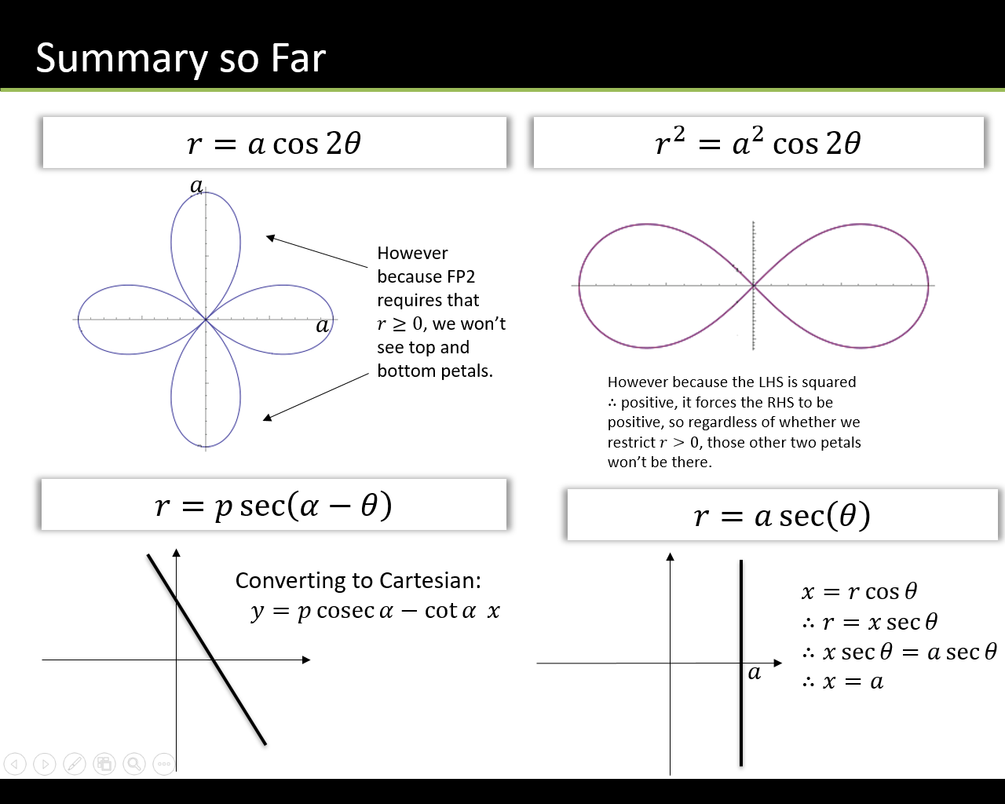

Areas enclosed by polar curves

The area of a sector bounded by a polar curve and the half lines $θ=α$ and $θ=β$ (when θ is given in radians) is given by:

$$A=\frac{1}{2}\int_{α}^{β}{r^{2}dθ}$$

When finding the area of a sector we almost always need to integrate trig functions, in particular using the double angle formulae.

Reminder:

$$cos2θ=2\cos^{2}{θ-1 \cos^{2}{θ=\frac{1}{2}(1+cos2θ)}}$$

$$cos2θ=1-2\sin^{2}{ θ} \sin^{2}{\begin{aligned}θ=\frac{1}{2}(1-cos2θ) \\ \end{aligned}}$$

Example:

1. Find the area enclosed by the cardioid with equation $r=a\left(1+\cos{θ}\right)$
2. Find the area of one loop of the polar rose $r=a\sin{4θ}$

Test Your Understanding

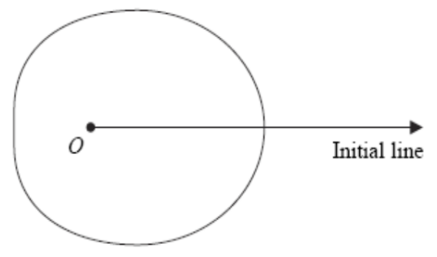Fig. 1 shows a sketch of the curve with polar equation $r=a+3\cos{θ}$ $a>0,0≤θ<2π$

The area enclosed by the curve is $\frac{107}{2}π$.

Find the value of $a$.

(8 marks)

Intersecting Areas

When polar curves intersect we have to consider which curve we’re finding the area under for each value of $θ$.

Example

1. On the same diagram sketch the curves with equations $r=2+\cos{θ}$ and $r=5\cos{θ}$
2. Find the polar coordinates of the points of intersection of these two curves.
3. Find the exact value of the area of the finite region bound between the two curves.

Test your understanding

Figure 1 shows the curves given by the polar equations

$$r=2, 0≤θ<\frac{π}{2}r=1.5+\sin{3θ} 0≤θ≤\frac{π}{2}$$

1. Find the coordinates of the points where the curves intersect. **(3)**
2. 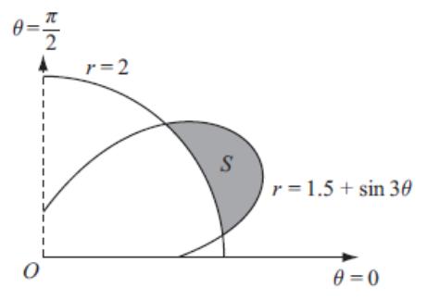The region $S$ for which $r>2$ and $r<1.5+\sin{3θ}$ is shown. Find, by integration, area of $S$ giving your answer in the form $aπ+b\sqrt{3}$ where $a$ and $b$ are simplified fractions. **(7)**

Ex 5c pg 111