5A Polar Coordinates and Equations
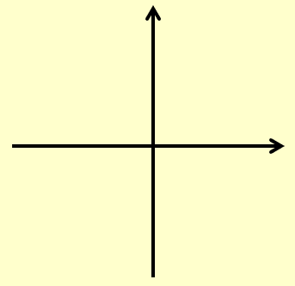
Cartesian Polar
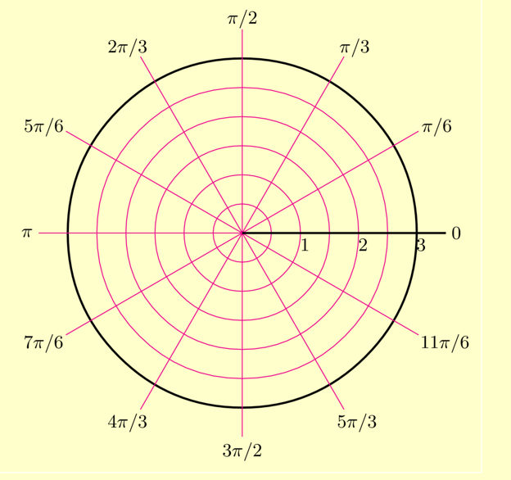

- Find the Polar coordinates of the following point:
- (5,9)

- (5, -12)

- $(-\sqrt{3},-1)$

- Convert the following Polar coordinate into Cartesian form.
- $\left(10, \frac{4π}{3}\right)$

- $\left(8, \frac{2π}{3}\right)$

- Find a Cartesian equation of the following curve:
- $r=5$

- $r=6cosecθ$

- $r=2+cos2θ$

- $r^{2}=Sin2θ$, $0<θ<\frac{π}{2}$

$$2xy$$
$${\left(x^{2}+y^{2}\right)}^{2}=$$
$${\left(x^{2}+y^{2}\right)}^{\frac{3}{2}}={3x}^{2}+y^{2}$$

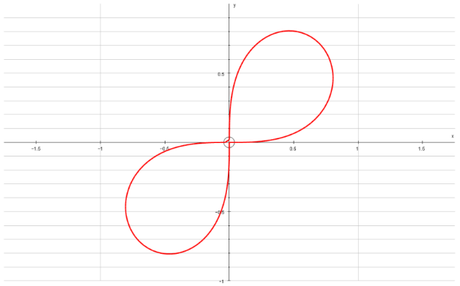
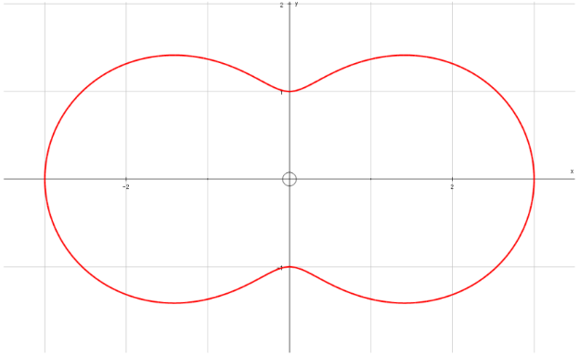

- Find a Polar equivalent for the following Cartesian equation:
- $y^{2}=4x$

- $x^{2}-y^{2}=5$

- $y\sqrt{3}=x+4$

