Core Pure 2
Polar Coordinates

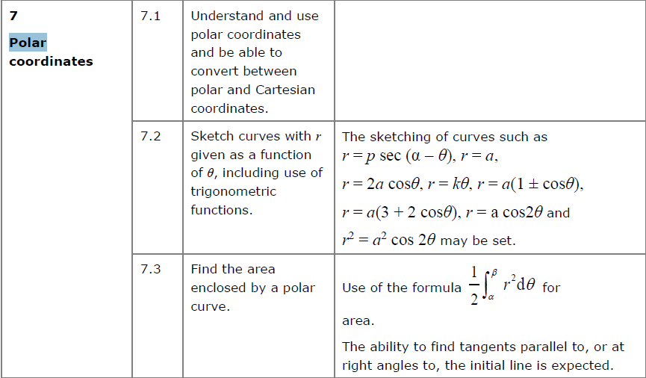

Polar coordinates describe the location of a point in a 2D plane using the distance from the origin and anti-clockwise angle from the positive x-axis.

Recap: Converting to/ from polar coordinates
If: $x=r\cos{θ} y=r\sin{θ}$
Then: $r^{2}=x^{2}+y^{2}$
And: $θ=\tan^{-1}\left(\frac{y}{x}\right)$ (adjusted depending on quadrant)

Cartesian | Polar
$$(0,2)$$
 | $$(3,π)$$
$$(1,1)$$
$$\left(-5,12\right)$$
 | $$\left(6,-\frac{π}{6}\right)$$

The Polar Equation of a Curve: $r=f(θ)$
We can express equations of curves in polar form. Sometimes we can convert the polar form to cartesian form but often equations are simpler when left in polar form.

Find a cartesian equation for the following curves:

- $r=5$

- $r=2+\cos{2θ}$

- $r^{2}=\sin{2θ}$

Converting to Polar Form:
Converting to polar is easier, but the harder part is often finding how to simplify the expression. Know your double angle formulae!

Find polar equations for the following:
- $y^{2}=4x$

- $x^{2}-y^{2}=5$

- $y\sqrt{3}=x+4$

Test your understanding
Find the polar equation of a circle whose centre has polar coordinate (2, 0) with radius 2.

Ex 5A pg 104

