5A Oblique (Angled) Impact with a Plane
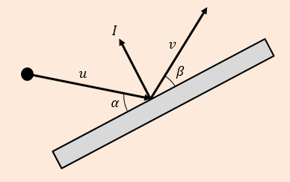
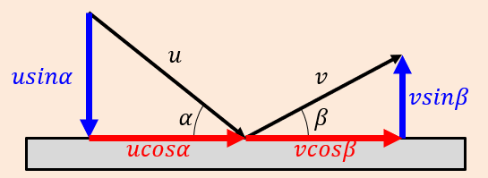

- A smooth sphere $S$ is moving on a smooth horizontal plane with speed $u$ when it collides with a smooth fixed vertical wall. At the instant of collision the direction of motion of $S$ makes an angle of ${60}^{°}$ with the wall. The coefficient of restitution between $S$ and the wall is $\frac{1}{4}$. Find:
- The speed of $S$ immediately after the collision

- The angle of deflection of $S$

- A small smooth ball is falling vertically. The ball strikes a smooth plane which is inclined at an angle $θ$to the horizontal, where $tanθ=\frac{1}{2}$. Immediately before striking the plane, the ball has speed $5ms^{-1}$. The coefficient of restitution between the ball and the plane is $\frac{1}{3}$. Find the speed of the ball immediately after the impact.

- A small smooth ball of mass 2kg is moving in the $xy$ plane and collides with a smooth fixed vertical wall which contains the $y-axis$. The velocity of the ball just before impact is $\left(-6i-4j\right){ms}^{-1}$. The coefficient of restitution between the ball and the wall is $\frac{1}{3}$. Find:
- The velocity of the ball immediately after the impact

- The kinetic energy lost as a result of the impact

- The angle of deflection of the ball

Extra Q (not in book) to support Q11, 15 & 16 from 5A
- A smooth sphere S, of mass m, is moving with velocity 7𝒊 + 𝟐𝒋 when it collides with a smooth fixed vertical wall. After the collision the velocity of the sphere, S, is 3𝒊 – 3𝒋
- Find the impulse exerted by the wall on the ball.

- Use the scalar product to find the coefficient of restitution between the sphere and the wall.
Key Point: Remember that the scalar product can be used to break down vector velocities in given directions!
Scalar multiply a velocity vector by the unit vector in a given direction to find the breakdown of the original velocity vector in the unit vector’s direction.

