5A Polar Coordinates and Equations
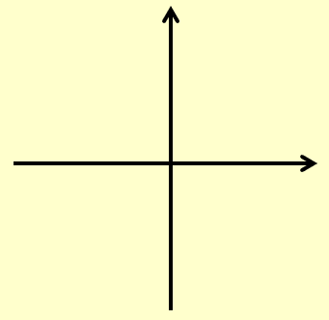
Cartesian Polar
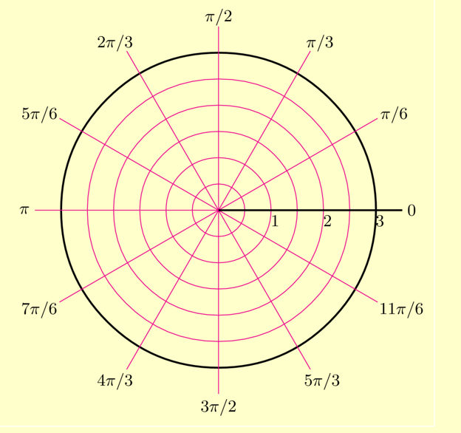

- Find the Polar coordinates of the following point:
- (5,9)

- (5, -12)

- $(-\sqrt{3},-1)$

- Convert the following Polar coordinate into Cartesian form.
- $\left(10, \frac{4π}{3}\right)$

- $\left(8, \frac{2π}{3}\right)$

- Find a Cartesian equation of the following curve:
- $r=5$

- $r=6cosecθ$

- $r=2+cos2θ$

- $r^{2}=Sin2θ$, $0<θ<\frac{π}{2}$

$$2xy$$
$${\left(x^{2}+y^{2}\right)}^{2}=$$
$${\left(x^{2}+y^{2}\right)}^{\frac{3}{2}}={3x}^{2}+y^{2}$$

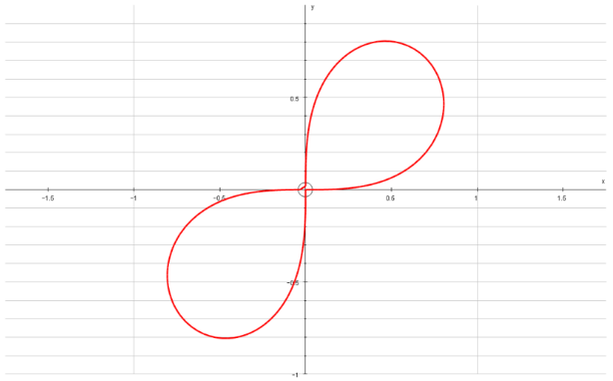
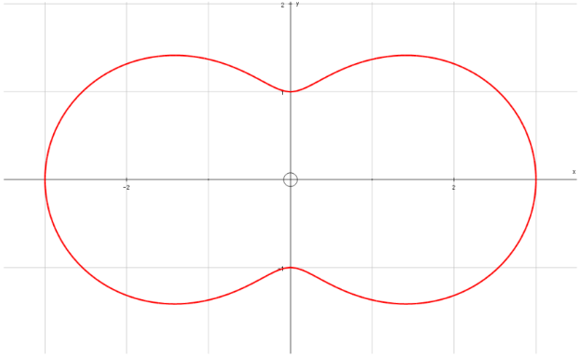

- Find a Polar equivalent for the following Cartesian equation:
- $y^{2}=4x$

- $x^{2}-y^{2}=5$

- $y\sqrt{3}=x+4$

5B Polar Graphs

- Sketch the Polar equation:
- $r=a$
- $θ=a$
- $r=aθ$
- $r=a(1+cosθ)$
- $r=asecθ$
- $r=sin3θ$
- $r^{2}=a^{2}cos2θ$
- $r=a(5+2cosθ)$
- $r=a(3+2cosθ)$
In General
$$r=a(p+qcosθ)$$
p < q q ≤ p < 2q

p = q p ≥ 2q

Some graphs to recognise:

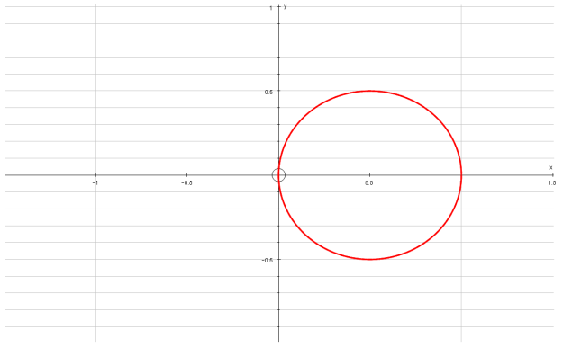
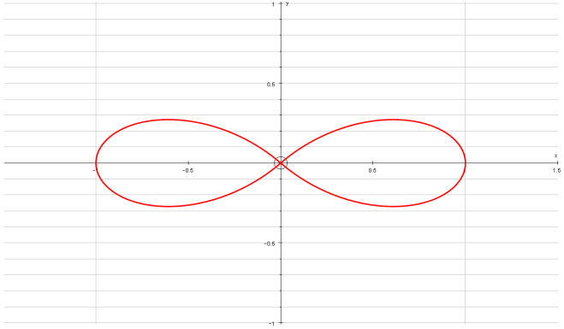
$$r=cosθ$$
$$r=cos2θ$$

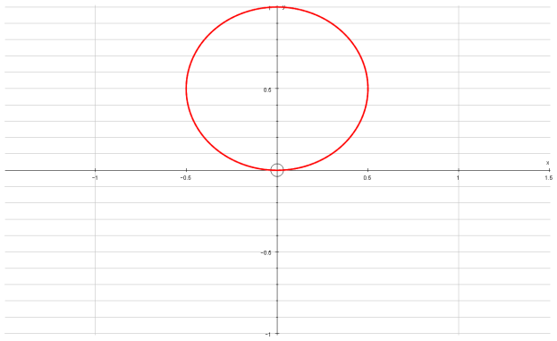
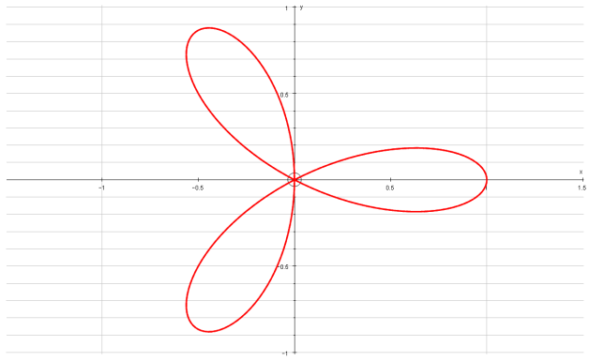
$$r=sinθ$$
$$r=cos3θ$$

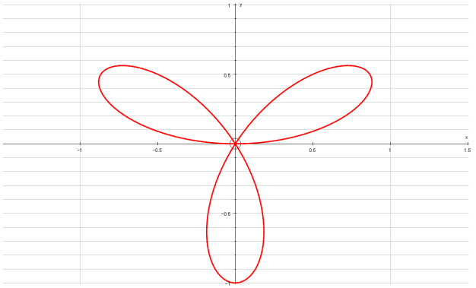
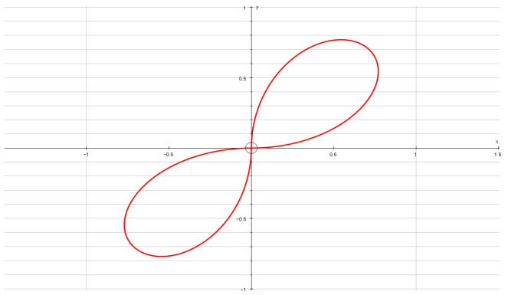
$$r=sin3θ$$
$$r=sin2θ$$

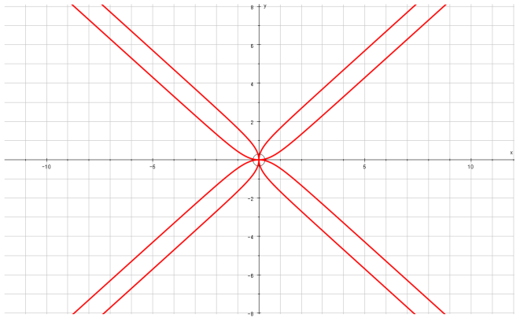
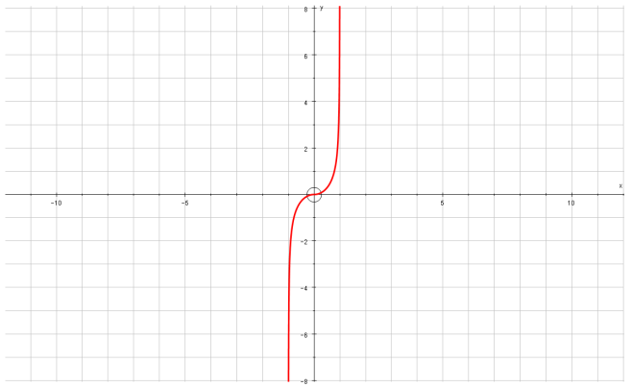
$$r=tan2θ$$
$$r=tanθ$$

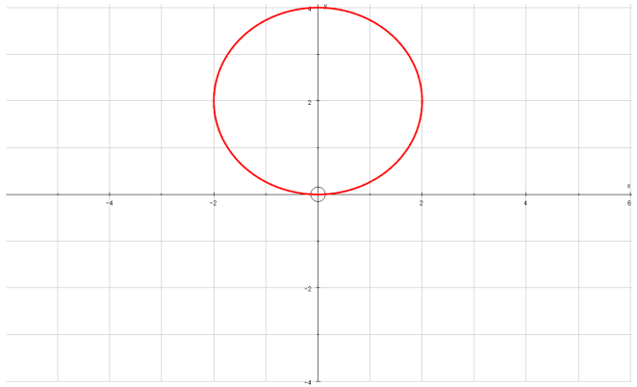
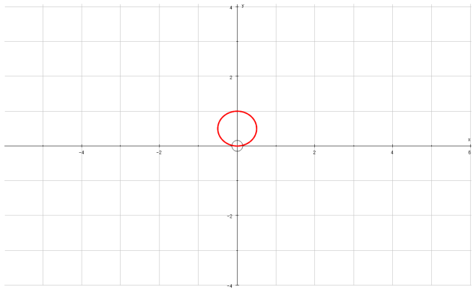
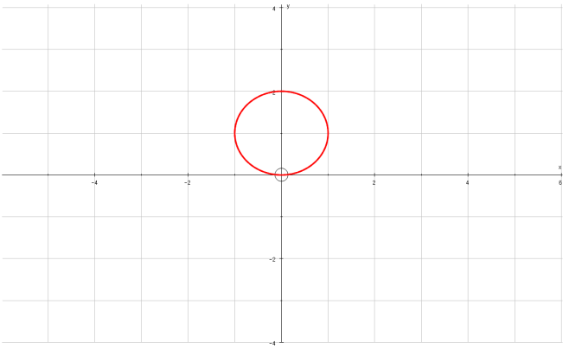
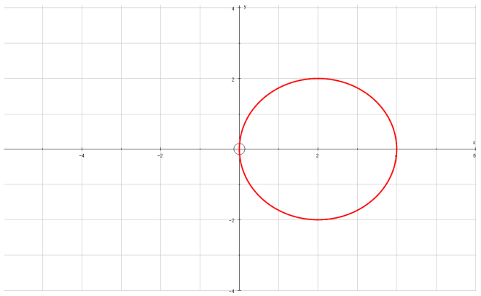
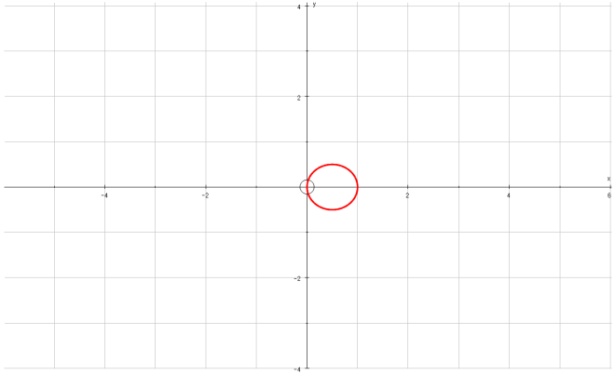
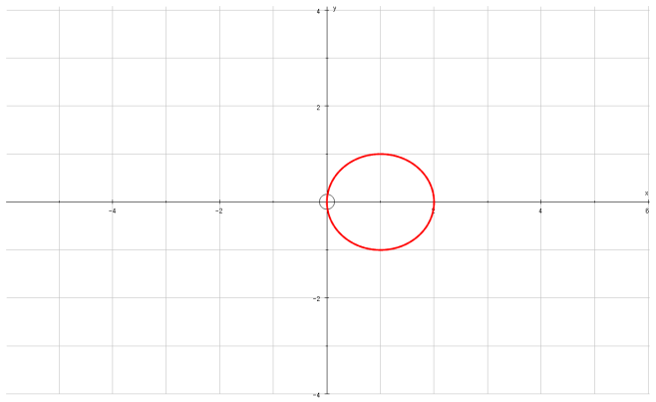
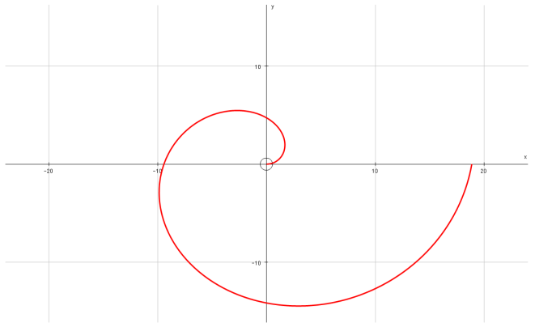
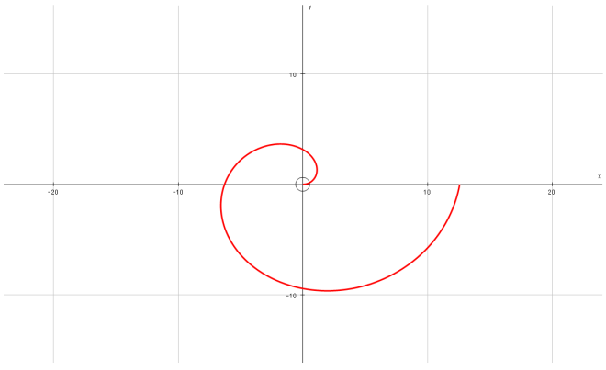
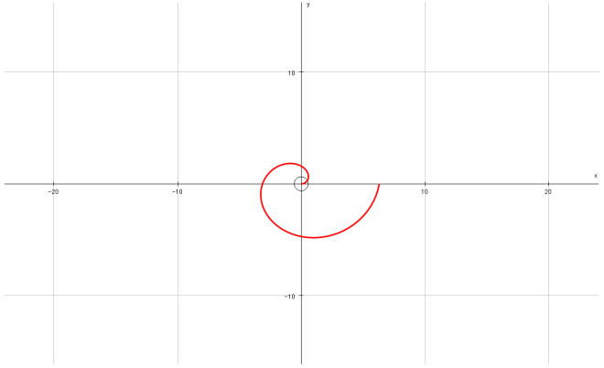
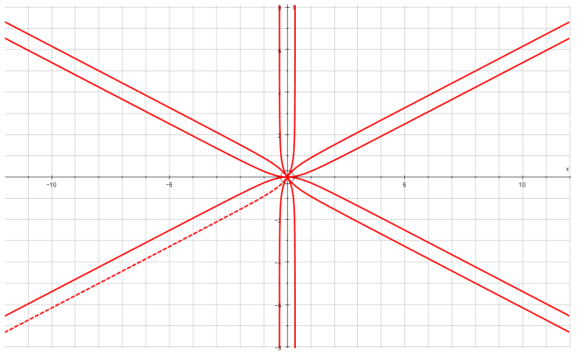
$$r=4sinθ$$
$$r=2sinθ$$
$$r=sinθ$$
$$r=4cosθ$$
$$r=2cosθ$$
$$r=cosθ$$
$$r=3θ$$
$$r=θ$$
$$r=tan3θ$$
$$r=2θ$$

- Show on an argand diagram the locus of points given by the values of $z$ satisfying:
$$\left|z-3-4i\right|=5$$

- Show that the locus of points can be represented by the polar curve:
$$r=6cosθ+8sinθ$$

5C Integrating Polar Curves

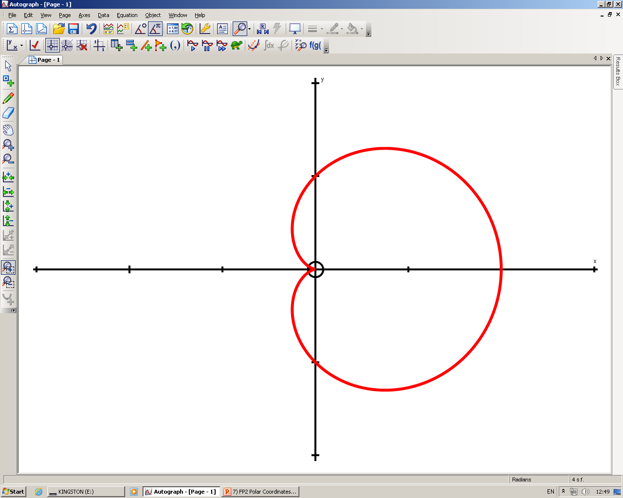
0, 2π
π 2
π
3π 2
$$r=1+cosθ$$
π 6
π 3

- Find the area enclosed by the cardioid with equation:
r = a(1 + cosθ)

- Find the area of one loop of the curve with polar equation:
r = asin4θ

- On the same diagram, sketch the curves with equations:
r = 2 + cosθ
r = 5cosθ

- Find the polar coordinates of the intersection of these curves

- Find the exact value of the finite region bounded by the 2 curves

5D Tangents to Polar Curves

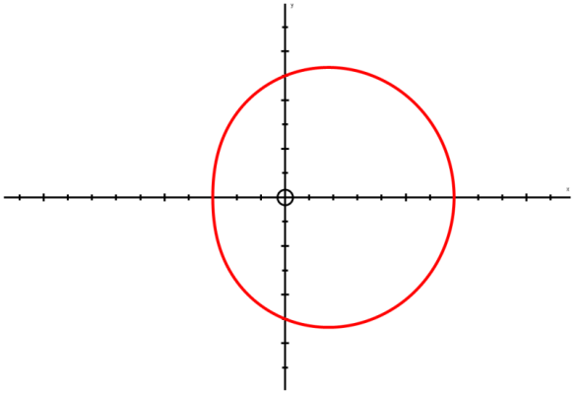

- Find the coordinates of the points on:
r = a(1 + cosθ)
Where the tangents are parallel to the initial line θ = 0.

- Find the coordinates and the equations of the tangents to the curve:
r = asin2θ, 0 ≤ θ ≤ ^{π}/₂
Where the tangents are:
- Parallel to the initial line
Give answers to 3 s.f where appropriate:

- Perpendicular to the initial line
Give answers to 3 s.f where appropriate:

- Prove that for:
r = (p + qcosθ), p and q both > 0 and p ≥ q
to have a ‘dimple’, p < 2q and also
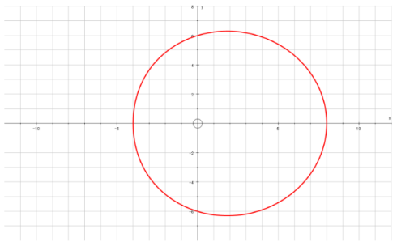
p ≥ q.

