5A Converting Between Radians & Degrees

- Convert the following angle to degrees
- $\frac{7π}{8} rad$

- $\frac{4π}{15} rad$

- Convert the following angle to degrees
- $150°$

- $110°$

Equivalence relationships

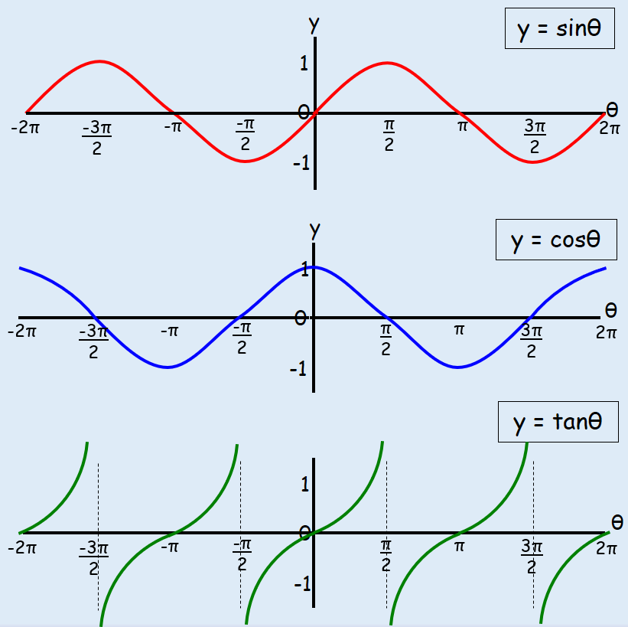
- Sketch the graph of $y=cos\left(x+π\right)$ for $0≤x≤2π$.

5B Trig Key Values as Radians
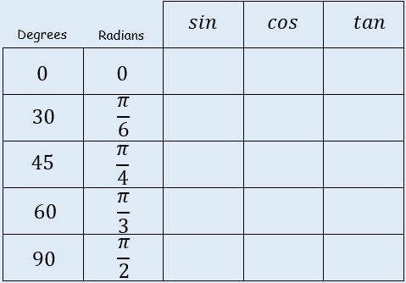

- Find the exact value of:
$$cos\frac{4π}{3}$$

- Find the exact value of:
$$sin\left(-\frac{7π}{6}\right)$$

5C Arc Length
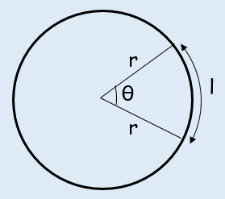

- Find the length of the arc of a circle of radius 5.2cm. The arc subtends an angle of 0.8^{c} at the centre of the circle.

- Arc AB of a circle, with centre O and radius r, subtends an angle of θ radians at O. The Perimeter of sector AOB is P cm. Express r in terms of P and θ.

- The border of a garden pond consists of a straight edge AB of length 2.4m, and a curved part C, as shown in the diagram below. The curved part is an arc of a circle, centre O and radius 2m. Find the length of C.
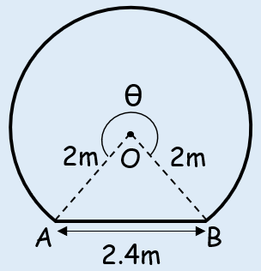

5D Area of Sectors & Segments
Sectors
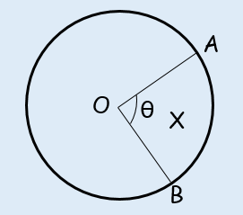

Segments
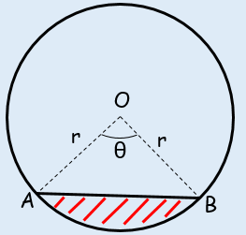

- In the diagram, the area of the minor sector AOB is 28.9cm². Given that angle AOB is 0.8 rad, calculate the value of r.
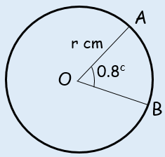

- A plot of land is in the shape of a sector of a circle of radius 55m. The length of fencing that is needed to enclose the land is 176m. Calculate the area of the plot of land.

- Calculate the Area of the segment shown in the diagram below.
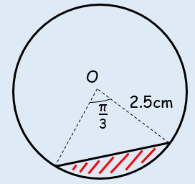

- In the diagram AB is the diameter of a circle of radius r cm, and angle BOC = θ radians. Given that the Area of triangle AOC is 3 times that of the shaded segment, show that 3θ –4sinθ = 0.
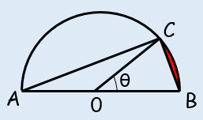

5E Solving Equations in Radians
- Solve the equation:
$4cosθ=2,$ $0≤θ≤2π$

- Solve the equation:
$17cosθ+3\sin^{2}θ=13,$ $0≤θ≤2π$

- Solve the equation:
$sin3θ=\frac{\sqrt{3}}{2},$ $0≤θ≤2π$

5F Small Angle Approximations

- When $θ$ is small, find the approximate value of:
$$\frac{sin2θ+tanθ }{2θ}$$

- When $θ$ is small, find the approximate value of:
$$\frac{cos4θ-1}{θsin2θ}$$

- Show that, when $θ$ is small:
$$sin5θ+tan2θ-cos2θ≈{2θ}^{2}+7θ-1$$

- Hence, state the approximate value of $sin5θ+tan2θ-cos2θ$ for small values of $θ$

