5A Oblique (Angled) Impact with a Plane
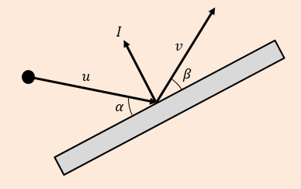
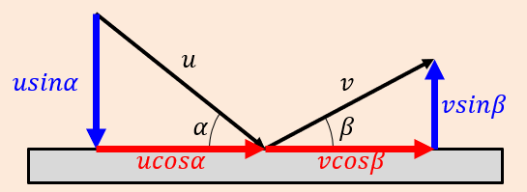

- A smooth sphere $S$ is moving on a smooth horizontal plane with speed $u$ when it collides with a smooth fixed vertical wall. At the instant of collision the direction of motion of $S$ makes an angle of ${60}^{°}$ with the wall. The coefficient of restitution between $S$ and the wall is $\frac{1}{4}$. Find:
- The speed of $S$ immediately after the collision

- The angle of deflection of $S$

- A small smooth ball is falling vertically. The ball strikes a smooth plane which is inclined at an angle $θ$to the horizontal, where $tanθ=\frac{1}{2}$. Immediately before striking the plane, the ball has speed $5ms^{-1}$. The coefficient of restitution between the ball and the plane is $\frac{1}{3}$. Find the speed of the ball immediately after the impact.

- A small smooth ball of mass 2kg is moving in the $xy$ plane and collides with a smooth fixed vertical wall which contains the $y-axis$. The velocity of the ball just before impact is $\left(-6i-4j\right){ms}^{-1}$. The coefficient of restitution between the ball and the wall is $\frac{1}{3}$. Find:
- The velocity of the ball immediately after the impact

- The kinetic energy lost as a result of the impact

- The angle of deflection of the ball

Extra Q (not in book) to support Q11, 15 & 16 from 5A
- A smooth sphere S, of mass m, is moving with velocity 7𝒊 + 𝟐𝒋 when it collides with a smooth fixed vertical wall. After the collision the velocity of the sphere, S, is 3𝒊 – 3𝒋
- Find the impulse exerted by the wall on the ball.

- Use the scalar product to find the coefficient of restitution between the sphere and the wall.
Key Point: Remember that the scalar product can be used to break down vector velocities in given directions!
Scalar multiply a velocity vector by the unit vector in a given direction to find the breakdown of the original velocity vector in the unit vector’s direction.

5B Successive Oblique Impacts
- Two vertical walls meet at right angles. A smooth sphere slides across a smooth, horizontal floor, bouncing off each wall in turn. Just before the first impact the sphere is moving with speed 4ms⁻¹ at an angle of 30˚ to the wall. The coefficient of restitution between the sphere and both walls is $\frac{3}{4}$. Find:
- The direction of motion and speed of the sphere after the first collision

- The direction of motion and speed of the sphere after the second collision

Extension: What do you notice about the initial direction & final direction?
By generalising u and e, will this always be the case (for perpendicular walls & equal e’s)?
- Two cushions of a snooker table $W_{1}$ and $W_{2}$ meet at right angles. A snooker ball travels across the table and collides with $W_{1}$ and then $W_{2}$. The cushions are modelled as smooth. Just before the first impact, the ball is moving with speed $u {ms}^{-1}$ at an angle of ${20}^{°}$ to $W_{1}$. The coefficients of restitution between the ball and the cushions $W_{1}$ and $W_{2}$ are $\frac{1}{2}$ and $\frac{2}{5}$ respectively.
- Find the percentage of the ball’s original kinetic energy that is lost in the collisions

- In reality the cushions may not be smooth. What effect will the model have had on the calculation of the kinetic energy remaining?

- Two smooth vertical walls stand on a smooth horizontal surface and intersect at an angle of ${60}^{°}$. A smooth sphere is projected across the surface with speed $1 {ms}^{-1}$ at an angle of ${20}^{°}$ to one of the walls, and towards the intersection of the walls. The coefficient of restitution between the sphere and the walls is 0.4. Work out the speed and motion of the sphere after:
- The first collision

- The second collision

5C Oblique Impacts with Two Smooth Spheres

- A smooth sphere A, of mass 2kg and moving with speed 6ms⁻¹ collides obliquely with a smooth sphere B of mass 4kg. Just before the impact B is stationary and the velocity of A makes an angle of 60˚ with the lines of centres of the two spheres. The coefficient of restitution between the spheres is $\frac{1}{4}$. Find the magnitudes and directions of the velocities of A and B immediately after the impact.

- A small smooth sphere A of mass 1kg collides with a small smooth sphere B of mass 2kg. Just before the impact A is moving with a speed of 4ms⁻¹ in a direction of 45˚ to the line of centres and B is moving with speed 3ms⁻¹ at 60˚ to the line of centres. Given that the coefficient of restitution between the spheres is $\frac{3}{4}$ and that the spheres collide, find:
- The kinetic energy lost in the impact

- The magnitude of the impulse exerted on A by B

- A smooth sphere $A$ of mass 5kg is moving on a smooth horizontal surface with velocity ${\left(2i+3j\right)ms}^{-1}$. Another smooth sphere $B$ of mass 3kg and the same radius as $A$ is moving on the same surface with velocity ${\left(4i-2j\right)ms}^{-1}$. The spheres collide when their line of centres is parallel to $j$. The coefficient of restitution between the spheres is $\frac{3}{5}$. Find the velocities of both spheres after the impact.

- Two small smooth spheres $A$ and $B$ have equal radii. The mass of $A$ is $2m$ kg and the mass of $B$ is $3m$ kg. The spheres are moving on a smooth horizontal plane and they collide. Immediately before the collision the velocity of $A$ is $5j {ms}^{-1}$ and the velocity of $B$ is $\left(3i-j\right) {ms}^{-1}$. Immediately after the collision the velocity of $A$ is $\left(3i+2j\right) {ms}^{-1}$. Find:
- The speed of $B$ immediately after the collision

- A unit vector parallel to the line of centres of the spheres at the instant of collision

