4B Direct Collisions with a Smooth Plane

Westie’s key note: to find a new velocity after an impact with a wall, just multiply by e (note the final velocity will be in the opposite direction)
- A particle collides normally with a fixed vertical plane.
The diagram shows the speeds (in ms⁻¹) of the particle before and after collision. Find the value of the coefficient of restitution, e.
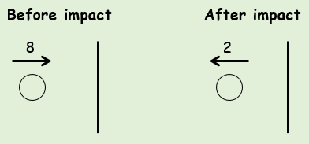

- A small sphere collides normally with a fixed vertical wall. Before the impact, the sphere is moving with a speed of 4ms⁻¹ on a smooth horizontal floor. The coefficient of restitution between the sphere and the wall is 0.2.
Find the speed of the sphere after the collision.

- A particle falls 22.5cm from rest onto a smooth horizontal plane. It then rebounds to a height of 10cm.
Find the coefficient of restitution between the particle and the plane. Give your answer to 2sf.

