4A Direct Collisions & Newton’s Law of Restitution

- In these questions the diagrams show the speeds of two particles A and B just before and just after a collision. The particles are moving on a smooth horizontal plane.
Find the coefficient of restitution in each case.

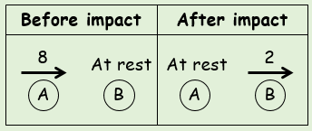

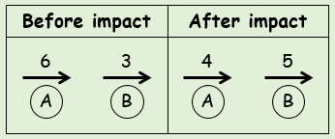

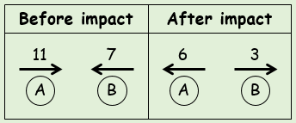

- Find the value of v in the situation shown, given that e = ¹/₃
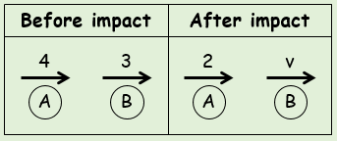

- Calculate the values of v₁ and v₂, given that the coefficient of restitution is ¹/₂
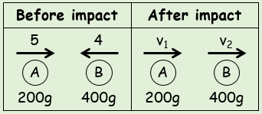

- Two small spheres have mass 3m and 4m respectively. They are moving towards each other in opposite directions on a smooth horizontal plane. P has speed 3u and Q has speed 2u just before the impact. The coefficient of restitution between P and Q is e.
- Show that the speed of Q after the collisions is given by ^{u}/₇(15e + 1)

- Given that the direction of motion of P is unchanged, find the range of possible values for e

- Given that the magnitude of the impulse of P on Q is ^{80mu}/₉, find the value of e

