4A Direct Collisions & Newton’s Law of Restitution

- In these questions the diagrams show the speeds of two particles A and B just before and just after a collision. The particles are moving on a smooth horizontal plane.
Find the coefficient of restitution in each case.

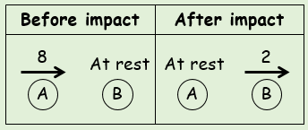

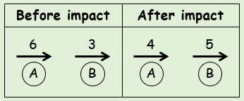

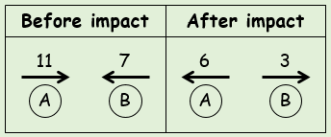

- Find the value of v in the situation shown, given that e = ¹/₃
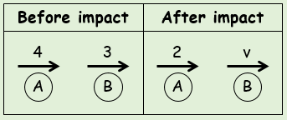

- Calculate the values of v₁ and v₂, given that the coefficient of restitution is ¹/₂
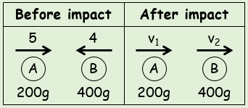

- Two small spheres have mass 3m and 4m respectively. They are moving towards each other in opposite directions on a smooth horizontal plane. P has speed 3u and Q has speed 2u just before the impact. The coefficient of restitution between P and Q is e.
- Show that the speed of Q after the collisions is given by ^{u}/₇(15e + 1)

- Given that the direction of motion of P is unchanged, find the range of possible values for e

- Given that the magnitude of the impulse of P on Q is ^{80mu}/₉, find the value of e

4B Direct Collisions with a Smooth Plane

Westie’s key note: to find a new velocity after an impact with a wall, just multiply by e (note the final velocity will be in the opposite direction)
- A particle collides normally with a fixed vertical plane.
The diagram shows the speeds (in ms⁻¹) of the particle before and after collision. Find the value of the coefficient of restitution, e.
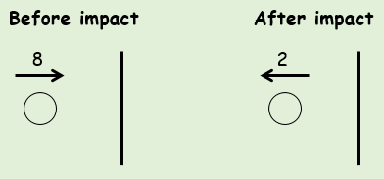

- A small sphere collides normally with a fixed vertical wall. Before the impact, the sphere is moving with a speed of 4ms⁻¹ on a smooth horizontal floor. The coefficient of restitution between the sphere and the wall is 0.2.
Find the speed of the sphere after the collision.

- A particle falls 22.5cm from rest onto a smooth horizontal plane. It then rebounds to a height of 10cm.
Find the coefficient of restitution between the particle and the plane. Give your answer to 2sf.

4C Collisions & Kinetic Energy
- Two spheres have equal radii and masses 3kg and 5kg respectively. A and B move towards each other along the same straight line on a smooth horizontal surface with velocities 3ms⁻¹ and 2ms⁻¹ respectively.
- If the coefficient of restitution is ³/₅, find the velocities of the spheres after the collision

- Find the loss of kinetic energy due to the impact

- A gun of mass 600kg fires a shell of mass 12kg horizontally, with velocity 20ms⁻¹.
- Find the velocity of the gun after the shell has been fired

- Find the total kinetic energy generated on firing

- Show that the ratio of the energy of the gun to the energy of the shell is equal to the ratio of the speed of the gun to the speed of the shell

- Two particles, A and B, of mass 200g and 300g respectively, are connected by a light inextensible string. The particles are side-by-side on a smooth floor and A is projected with speed 6ms⁻¹ away from B. When the string become taut, particle B is jerked into motion and A and B then move a common speed in the direction of A’s original motion.
Find:
- The common speed of the particles after the string becomes taut

- The loss of kinetic energy as a result of the jerk

4D Successive Collisions
- Three spheres A, B and C have masses 1kg, 2kg and 3kg respectively. They are moving along the same straight horizontal plane with A following B, which is following C. The initial velocities of A, B and C are 7ms⁻¹, 3ms⁻¹ and 1ms⁻¹ in the direction ABC. Sphere A collides with sphere B then sphere B collides with sphere C. The coefficient of restitution between A and B is ¹/₂ and between B and C is ¹/_{4.}
- Find the velocities of the 3 spheres after both collisions have taken place

- Explain how you know that there will be a further collision between A and B

- A uniform smooth sphere P of mass 3m is moving in a straight line with speed u on a smooth horizontal table. Another uniform smooth sphere Q of mass m and having the same radius as P, is moving with speed 2u in the opposite direction of P. P and Q collide directly, and their speeds after the collision are v and w respectively. The coefficient of restitution between P and Q is e.
- Find expressions for v and w in terms of u and e.

- Show that, if the direction of motion of P is changed by the collision, then e > ¹/₃

Following the collision with P, the sphere Q then collides with and rebounds from a vertical wall. The coefficient of restitution between Q and the wall is e’
- Given that e = ⁵/₉ and that P and Q collide again in the subsequent motion, show that
e’ > ¹/₉

- A tennis ball, which may be modelled as a particle, is dropped from rest at a height of 90cm onto a smooth horizontal plane. The coefficient of restitution between the ball and the plane is 0.5. Assume there is no air resistance and the ball falls freely under gravity at a right angle to the plane.
- Find the height to which the ball rebounds after the first bounce

- Find the height to which the ball bounces after the second bounce

- Find the total distance travelled by the ball before it comes to rest

