3A Hooke’s Law
Hooke’s Law:

Strings vs Springs

- An elastic string of natural length 2m and modulus of elasticity 29.4N has one end fixed. A particle of mass 4kg is attached to the other end and hangs at rest. Find the extension of the string.

- An elastic spring of natural length 1.5m has one end attached to a fixed point. A horizontal force of magnitude 6N is applied to the other end and compresses the spring to a length of 1m. Find the modulus of elasticity of the spring.

- The elastic springs PQ and QR are joined together at Q to form one long spring. The spring PQ has natural length 1.6m and modulus of elasticity 20N. The spring QR has natural length 1.4m and modulus of elasticity 28N. The ends, P and R, of the whole spring are attached to two fixed points that are 4m apart.
Find the tension in the combined spring.

- An elastic string of natural length 2l and modulus of elasticity 4mg is stretched between 2 points, A and B. The points A and B are on the same horizontal level and AB = 2l. A particle P is attached to the midpoint of the string and hangs in equilibrium with both parts of the string making an angle of 30° with line AB. Find the mass of the particle in terms of m.

- An elastic string has natural length 2m and modulus of elasticity 98N. One end of the string is attached to a fixed point O and the other end is attached to a particle P of mass 4kg. The particle is held in equilibrium by a horizontal force of magnitude 28N, with OP making an angle θ with the vertical, as shown.
Find:
- The value of θ
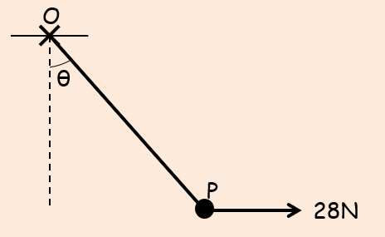

- The length OP

- Two identical elastic springs PQ and QR have natural length l and modulus of elasticity 2mg. The springs are joined together at Q. Their other ends, P and R, are attached to fixed points, with P being 4l vertically above R. A particle of mass m is attached at Q and hangs at rest in equilibrium. Find the distance of the particle below P.

- One end, A, of a light elastic string, AB, of natural length 0.6m and modulus of elasticity 10N, is fixed to a point on a fixed rough plane inclined at an angle $θ$ to the horizontal, where $sinθ=\frac{4}{5}$. A ball of mass 3kg is attached to the end, B, of the string. The coefficient of friction, $μ$, between the ball and the plane is $\frac{1}{3}$. The ball rests in limiting equilibrium, on the point of sliding down the plane, with AB along the line of greatest slope.
- Find the tension in the string, and its length

- If $μ>\frac{1}{3}$, state how your answer to a) would change

A couple of key points:
