3A Hooke’s Law
Hooke’s Law:

Strings vs Springs

- An elastic string of natural length 2m and modulus of elasticity 29.4N has one end fixed. A particle of mass 4kg is attached to the other end and hangs at rest. Find the extension of the string.

- An elastic spring of natural length 1.5m has one end attached to a fixed point. A horizontal force of magnitude 6N is applied to the other end and compresses the spring to a length of 1m. Find the modulus of elasticity of the spring.

- The elastic springs PQ and QR are joined together at Q to form one long spring. The spring PQ has natural length 1.6m and modulus of elasticity 20N. The spring QR has natural length 1.4m and modulus of elasticity 28N. The ends, P and R, of the whole spring are attached to two fixed points that are 4m apart.
Find the tension in the combined spring.

- An elastic string of natural length 2l and modulus of elasticity 4mg is stretched between 2 points, A and B. The points A and B are on the same horizontal level and AB = 2l. A particle P is attached to the midpoint of the string and hangs in equilibrium with both parts of the string making an angle of 30° with line AB. Find the mass of the particle in terms of m.

- An elastic string has natural length 2m and modulus of elasticity 98N. One end of the string is attached to a fixed point O and the other end is attached to a particle P of mass 4kg. The particle is held in equilibrium by a horizontal force of magnitude 28N, with OP making an angle θ with the vertical, as shown.
Find:
- The value of θ
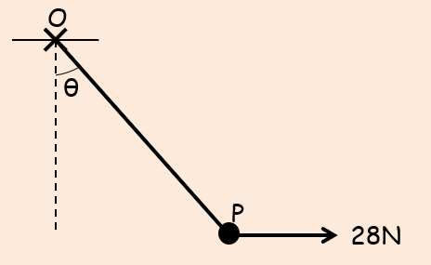

- The length OP

- Two identical elastic springs PQ and QR have natural length l and modulus of elasticity 2mg. The springs are joined together at Q. Their other ends, P and R, are attached to fixed points, with P being 4l vertically above R. A particle of mass m is attached at Q and hangs at rest in equilibrium. Find the distance of the particle below P.

- One end, A, of a light elastic string, AB, of natural length 0.6m and modulus of elasticity 10N, is fixed to a point on a fixed rough plane inclined at an angle $θ$ to the horizontal, where $sinθ=\frac{4}{5}$. A ball of mass 3kg is attached to the end, B, of the string. The coefficient of friction, $μ$, between the ball and the plane is $\frac{1}{3}$. The ball rests in limiting equilibrium, on the point of sliding down the plane, with AB along the line of greatest slope.
- Find the tension in the string, and its length

- If $μ>\frac{1}{3}$, state how your answer to a) would change

A couple of key points:
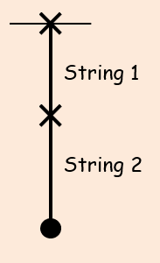

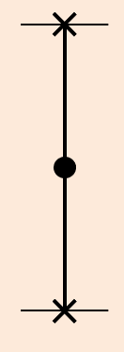

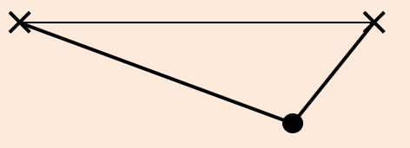

3B Hooke’s Law in Dynamics

- One end of a light elastic string, of natural length 0.5m and modulus of elasticity 20N, is attached to a fixed point A. The other end of the string is attached to a particle of mass 2kg. The particle is held at a point that is 1.5m below A and released from rest. Find:
- The initial acceleration of the particle

- The length of the string when the particle reaches its maximum speed

- A particle of mass 0.5kg is attached to one end of a light elastic spring of natural length 1.5m and modulus of elasticity 19.6N. The other end of the spring is attached to a fixed point O on a rough plane which is inclined to the horizontal at an angle θ, where tanθ = ³/₄. The coefficient of friction between the particle and the plane is 0.2. The particle is held at rest on the plane at a point that is 1m from O down the line of greatest slope of the plane. The particle is released from rest and moves down the slope. Find its initial acceleration.

3C Elastic Energy

- An elastic string has natural length 1.4m and modulus of elasticity 6N. Find the energy stored in the string when its length is increased to 1.6m.

- A light elastic spring has a natural length 0.6m and modulus of elasticity 10N. Find the work done when the spring is compressed from a length of 0.5m to a length of 0.3m.

- A light elastic spring has a natural length 0.6m and modulus of elasticity 10N. Find the work done when the spring is compressed from a length of 0.4m to a length of 0.2m.

3D Work Energy Principle 2.0

- A light elastic string, of natural length 1.6m and modulus of elasticity 10N, has one end fixed at a point A on a smooth horizontal table. A particle of mass 2kg is attached to the other end of the string. The particle is held at point A and projected horizontally across the table with speed 2ms⁻¹. Find how far it travels before first coming to instantaneous rest.

- A particle of mass 0.5kg is attached to one end of an elastic string, of natural length 2m and modulus of elasticity 19.6N. The other end of the elastic string is attached to the point O. If the particle is released from the point O, find the greatest distance it will reach below O.

Alternative approach to 2: just consider GPE (as KE goes from 0 -> 0)

- A light elastic spring, of natural length 1m and modulus of elasticity 20N, has one end attached to a fixed point A. A particle of mass 2kg is attached to the other end of the spring and is held at a point B which is 0.8m vertically below A. The particle is projected vertically downwards from B with speed 2ms⁻¹. Find the distance it falls before first coming to rest.

- A light elastic spring, of natural length 0.5m and modulus of elasticity 10N, has one end attached to a point A on a rough horizontal plane. The other end is attached to a particle P of mass 0.8kg. The coefficient of friction between the particle and the plane is 0.4. The particle initially lies on the plane with AP = 0.5m and is then projected with speed 2ms⁻¹ away from A, along the plane. Find the distance travelled by P before it first comes to rest.

