2A Work Done
Work Done:

Work Done Against Gravity:

- A box is pulled 7m across a horizontal floor by a horizontal force of magnitude 15N. Calculate the work done by the force
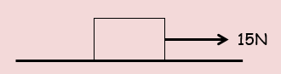

- A packing case is pulled across a horizontal floor by a horizontal rope. The case moves at a constant speed and there is a constant resistance to motion of magnitude R Newtons. When the case has moved a distance of 12m the work done is 96J. Calculate the magnitude of the resistance

- A bricklayer raises a load of bricks of total mass 30kg at a constant speed by attaching a cable to the bricks.
Assuming the cable is vertical, calculate the work done when the bricks are raised a distance of 7m

- A package of mass 2kg is pulled at a constant speed up a rough plane which is inclined at an angle of 30° to the horizontal. The coefficient of friction between the package and the surface is 0.35. The package is pulled 12m up a line of greatest slope of the plane.
Calculate:
- The work done against gravity

- The work done against friction

- A sledge is pulled 15m across a smooth sheet of ice by a force of magnitude 27N. The force is inclined at 25° to the horizontal. By modelling the sledge as a particle, calculate the work done by the force.

