13A Introduction to Integration

- Integrate the following:
- $\frac{dy}{dx}=x^{4}$

- $\frac{dy}{dx}=x^{-5}$

- $\frac{dy}{dx}=6x+2x^{-3}-3x^{\frac{1}{2}}$

- Find:
$$\int{{(x}^{\frac{1}{2}}+2x^{3})dx}$$

- Find:
$$\int{{(4t}^{2}+5)dt}$$

- Find:
$$\int{{(3x}^{2}+px^{-2}+q^{2})dx}$$

- Find:
$$\int{\left({4x}^{2}+\frac{\sqrt{x}+5}{x^{2}}\right) dx}$$

13C Finding C

- The curve X with equation y = f(x) passes through the point (2,15). Given that:

$$f\left(x\right)={5x}^{2}+3x$$
Find the equation of X.

- The curve X with equation y = f(x) passes through the point (4,5). Given that:
$$f^{'}\left(x\right)= \frac{x^{2}-2}{\sqrt{x}}$$
Find the equation of X.

13D Definite Integrals

- $Find: \int_{1}^{2}{{3x}^{2}} dx$

- $Evaluate: \int_{0}^{1}{{\left(x^{\frac{1}{3}}-1\right)}^{2} dx}$

- Given that $P$ is a constant and $\int_{1}^{5}{\left(2Px+7\right) dx}=4P^{2}$, show that there are two possible values for P, and find what they are.

13E Finding Areas

- Find the area of the finite region between the curve with equation $y=20-x-x^{2}$ and the x-axis.

13F Finding Areas Under the X-Axis

- Find the area of the finite region bounded by the curve $y=x(x-3)$ and the x axis.

- a) Sketch the curve with equation:
$y=x(x-1)(x+3)$

b) Find the area of the finite region bounded by the curve and the x-axis

13G Finding Areas Between Curves

Option 1:

Option 2:

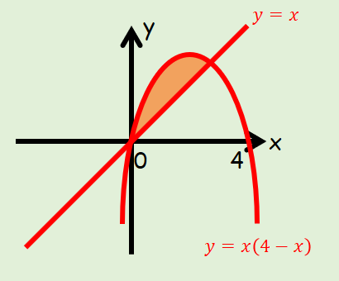
The diagram shows a sketch of part of the curve with equation:
$$y=x(4-x)$$
and the line:
$$y=x$$
Find the area of the region bounded by the curve and the line.

- The diagram below shows a sketch of part of the curve with equation:
$$y=x(x-3)$$
and the line:
$$y=2x$$
Find the area of the shaded region OAC.
