12A Introduction to 3D Vectors

- Find the distance from the origin to the point P(4, 2, 5)

- Find the distance between the points A(1, 3, 4) and B(8, 6, -5)

- The coordinates of A and B are (5, 0, 3) and (4, 2, k) respectively. Given that |AB| is 3 units, find the possible values of k

12B ijk and unit vectors

- Consider the points $A(1,5,-2)$ and $B(0,-3,7)$.
- Find the position vectors of $A$ and $B$ in $ijk$ notation.

- Find the vector $\vec{AB}$ as a column vector

- The vectors $a$ and $b$ are given as:
$a=\left(\begin{matrix}2 \\ -3 \\ 5\end{matrix}\right)$ and $b=\left(\begin{matrix}4 \\ -2 \\ 0\end{matrix}\right)$.
- Find:
i) $4a+b$ ii) $2a-3b$

b) State, with a reason, whether either of these vectors is parallel to $4i-5k$

- Find the magnitude of
$a=2i-j+4k$, and hence find $\hat{a}$, the unit vector in the direction of $a$.

- Given the vector:
$a=2i-j+4k$, with magnitude $\sqrt{21}$, calculate the angle between the vector and the $x$, $y$, and $z$ axes

- The points $A$ and $B$ have position vectors $4i+2j+7k$ and $3i+4j-k$ relative to a fixed origin O. Find $\vec{AB}$ and show that $∆OAB$ is isosceles.

12C Modelling with Vectors
- $A$, $B$, $C$ and $D$ are the points $(2,-5,-8)$, $(1,-7,-3)$, $(0,15,-10)$and $(2,19,-20)$ respectively.
- Find $\vec{AB}$ and $\vec{DC}$, giving your answers in the form $pi+qj+rk$

- Show that the lines $AB$ and $DC$ are parallel and that $\vec{AB}=2\vec{DC}$

- Hence, describe the quadrilateral $ABCD$

- $P$, $Q$ and $R$ are the points $\left(4,-9,-3\right)$, $\left(7, -7, -7\right)$ and $(8,-2,0)$ respectively. Find the coordinates of a point $S$ such that $PQRS$ forms a parallelogram.

- Given that:
$$3i+\left(p+2\right)j+120k=pi-qj+4pqrk$$
Find the values of $p$, $q$ and $r$.

- The diagram shows a cuboid whose vertices are $O$, $A$, $B$, $C$, $D$, $E$, $F$ and $G$. Vectors $a$, $b$ and $c$ are the position vectors of the vertices $A$, $B$ and $C$ respectively. Prove that diagonals $OE$ and $BG$ bisect each other.
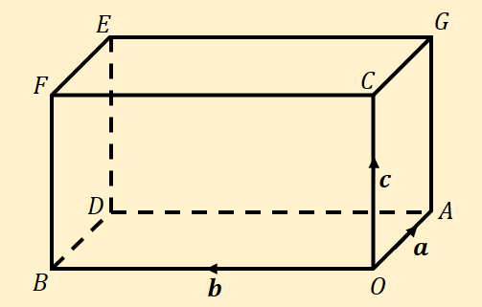

12D Forces as Vectors
- A particle of mass 0.5kg is acted on by 3 forces:
$$F_{1}=\left(2i-j+2k\right)N$$
$$F_{2}=\left(-i+3j-3k\right)N$$
$$F_{3}=\left(4i-3j-2k\right)N$$
- Find the resultant force, $R$, that acts on the particle.

- Find the acceleration of the particle

- Find the magnitude of the acceleration

- Given that the particle starts at rest, find the distance travelled in the first 6 seconds of its motion

