11A Vectors Introduction

- OACB is a parallelogram. The points P, Q, M and N are the midpoints of the sides.
OA = a
OB = b
Express the following in terms of a and b.
a) OC b) AB c) QC d) CN e) QN

- In triangle OAB, M is the midpoint of OA and N divides AB in the ratio 1:2.
OM = a
OB = b
Express ON in terms of a and b

11B i and j

- When vectors are written in terms of the unit vectors i and j you can add them together by adding the terms in i and j separately. Subtraction works in a similar way.
Given that:
a = 5i + 2j
b = 3i - 4j
Find 2a – b in terms of i and j

11C Magnitude and Direction

- Find the magnitude of the vector: ​3i – 7j

- Find the angle between the vector ​-4i + 5j and the positive x-axis

- Vector a has magnitude 10 and makes an angle of 30˚ with j. Find a in column vector format.

11D Position Vectors

- The points A and B in the diagram have coordinates (1,5) and (7,4) respectively. Find, in terms of $i$ and $j$:

- The position vector of $A$

- The position vector of $B$

- The vector $\vec{AB}$

- $\vec{OA}$ = 5i -2j and $\vec{AB}$ = 3i +4j Find:

- The position vector of $B$

- The exact value of $\vec{\left|OB\right|}$ in simplified surd form

11E Geometric Problems
- In the diagram the points A and B have position vectors a and b respectively. The point P divides line AB in the ratio 1:2. Find the position vector of P

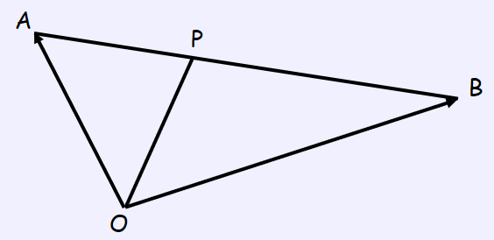

- In triangle $ABC$, $\vec{AB}=3i-2j$ and $\vec{AC}=i-5j$. Find the size of $∠BAC$ in degrees.

- OABC is a parallelogram. P is the point where OB and AC intersect.
The vectors a and c represent OA and OC respectively.
Prove that the diagonals bisect each other.

11F Context Problems notes
- A girl walks 2km due east from a fixed point O to A, and then 3km due south from A to B. Find:
- The total distance travelled

- The position vector of B relative to O

- $\vec{|OB|}$

- The bearing of B from O

- In an orienteering exercise, a cadet leaves the starting point O and walks 15km on a bearing of 120 to reach A, the first checkpoint. From A he walks 9km on a bearing of 240 to the second checkpoint, at B. From B, he returns directly to O. Find:
- The position vector of A relative to O

- $\vec{\left|OB\right|}$

- The bearing of B from O

- The position vector of B relative to O

