CP2 Chapter 8
Modelling with Differential Equations

Course Structure
- Modelling with 1st order differential equations.
- Simple Harmonic Motion
- Damped and Force Harmonic Motion
- Coupled First-Order Differential Equations

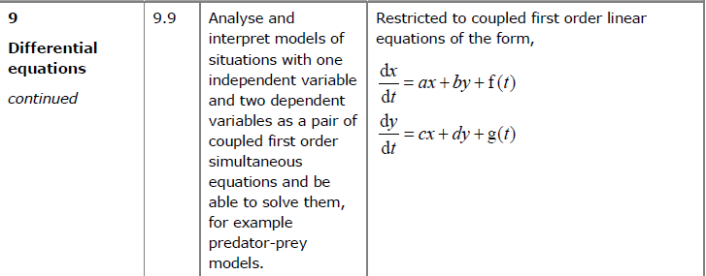
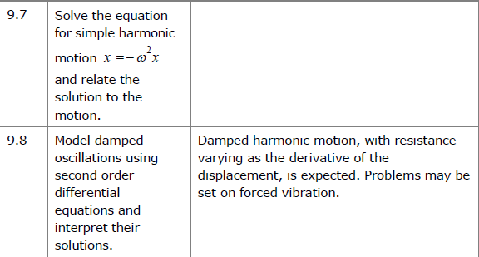

Modelling with 1st Order Differential Equations

Example
A particle $P$ is moving along a straight line. At time $t$ seconds, the acceleration of the particle is given by $a=t+\frac{3}{t}v, t≥0$
Given that $v=0$ when $t=2$, show that the velocity of the particle at time $t$ is given by the equation $v=ct^{3}-t^{2}$ where $c$ is a constant to be found.

Common Example Type:
A storage tank initially containers 1000 litres of pure water. Liquid is removed from the tank at a constant rate of 30 litres per hour and a chemical solution is added to the tank at a constant rate of 40 litres per hour. The chemical solution contains 4 grams of copper sulphate per litre of water. Given that there are $x$ grams of copper sulphate in the tank after $t$ hours and that the copper sulphate immediately disperses throughout the tank on entry,
- Show that the situation can be modelled by the differential equation
$$\frac{dx}{dt}=160-\frac{3x}{100+t}$$
- Hence find the number of grams of copper sulphate in the tank after 6 hours.
- Explain how the model could be refined.

Ex 8A
Simple Harmonic Motion
Simple Harmonic Motion (SHM) is motion in which the acceleration of a particle $P$ is always towards a fixed point $O$ on the line of motion of $P$. The acceleration is proportional to the displacement $x$ of $P$ from $O$.

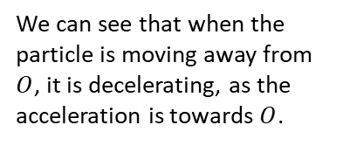
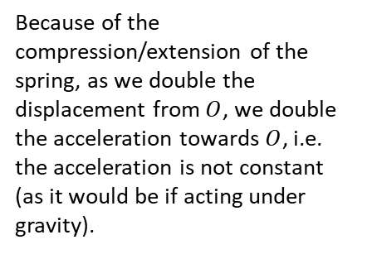

$$O$$

Simple Harmonic Motion:
General solution $x=Asinωt+Bcosωt$
Writing in harmonic form: $x=\operatorname{asin}\left(ωt+α\right)$
So, the general solution of SHM can be expressed as a sine function from which we can deduce:
- The solution varies between a and –a Amplitude
- The solution is periodic with Period $\frac{2π}{ω}$
- The velocity and acceleration can be found by differentiating the solution with respect to t.

Example
A particle is moving along a straight line. At time $t$ seconds its displacement, $x$ m from a fixed point $O$ is such that $\frac{d^{2}x}{dt^{2}}=-4x$.
Given that at $t=0, x=1$ and the particle is moving with velocity 4 ms⁻¹,
(a) find an expression for the displacement of the particle after $t$ seconds
(b) hence determine the maximum displacement of the particle from $O$.

Example
A particle $P$, is attached to the ends of two identical elastic springs. The free ends of the springs are attached to two points $A$ and $B$. The point $C$ lies between $A$ and $B$ such that $ABC$ is a straight line and $AC≠BC$. The particle is held at $C$ and then released from rest.
At time $t$ seconds, the displacement of the particle from $C$ is $x$ m and its velocity is $v$ ms⁻¹. The subsequent motion of the particle can be described by the differential equation $\ddot{x}=-25x$.
- Describe the motion of the particle.
Given that $x=0.4$ and $v=0$ when $t=0$,
(b) solve the differential equation to find $x$ as a function of $t$
(c) state the period of the motion and calculate the maximum speed of $P$.

Ex 8B
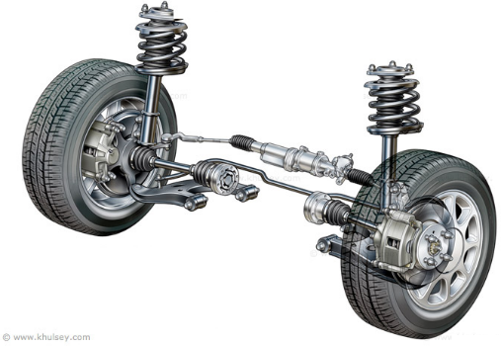
Damped and Force Harmonic Motion
SHM has constant amplitude and goes on forever.
In reality most systems will have oscillations which
gradually decrease with the motion eventually dying
away. This is called damped harmonic motion.

For particle moving with damped harmonic motion:

$$\frac{d^{2}x}{dt^{2}}=-k\frac{dx}{dt}-ω^{2}x$$

$$⇒ \frac{d^{2}x}{dt^{2}}+k\frac{dx}{dt}+ω^{2}x=0$$

The different possibilities for the roots of the auxiliary equation correspond to different types of damping.

Example
- A particle $P$ of mass 0.5 kg moves in a horizontal straight line. At time $t$ seconds, the displacement of $P$ from a fixed point, $O$, on the line is $x$ m and the velocity of $P$ is $v$ ms⁻¹. A force of magnitude $8x$ N acts on $P$ in the direction $PO$. The particle is also subject to a resistance of magnitude $4v$ N. When $t=0, x=1.5$ and $P$ is moving in the direction of increasing $x$ with speed $4$ ms⁻¹,
- Show that $\frac{d^{2}x}{dt^{2}}+8\frac{dx}{dt}+16x=0$
- Find the value of $x$ when $t=1$.

- A particle $P$ hangs freely in equilibrium attached to one end of a light elastic string. The other end of the string is attached to a fixed point $A$. The particle is now pulled down and held at rest in a container of liquid which exerts a resistance to motion on $P$. $P$ is then released from rest. While the string remains taut and the particle in the liquid, the motion can be modelled using the equation
$\frac{d^{2}x}{dt^{2}}+6k\frac{dx}{dt}+5k^{2}x=0,$ where $k$ is a positive real constant
Find the general solution to the differential equation and state the type of damping that the particle is subject to.

- One end of a light elastic spring is attached to a fixed point $A$. A particle $P$ is attached to the other end and hangs in equilibrium vertically below $A$. The particle is pulled vertically down from its equilibrium position and released from rest. A resistance proportional to the speed of $P$ acts on $P$. The equation of motion of $P$ is given as
$$\frac{d^{2}x}{dt^{2}}+2k\frac{dx}{dt}+2k^{2}x=0$$
where $k$ is a positive real constant and $x$ is the displacement of $P$ from its equilibrium position.
- Find the general solution to the differential equation.
- Write down the period of oscillation in terms of $k$.

Forced Harmonic Motion
In addition to the ‘natural’ forces acting on the particle, i.e. damping force and restoring force, there may be a further a further force acting on the particle. This is known as forced harmonic motion.
All structures have natural frequencies of vibration. If an external agent causes them to vibrate at or close to one of these frequencies it can create resonance which can have devastating effects. Engineers must be able to predict these natural frequencies.

Forced harmonic motion
$$\frac{dx^{2}}{dt^{2}}+k\frac{dx}{dt}+ω^{2}x=f(t)$$

We can solve problems like this using the Non-homogeneous DE method.

Example
A particle $P$ of mass 1.5 kg is moving on the $x$-axis. At time $t$ the displacement of $P$ from the origin $O$ is $x$ metres and the speed of $P$ is $v$ ms⁻¹. Three forces act on $P$, namely a restoring force of magnitude $7.5x$ N, a resistance to the motion of $P$ of magnitude $6v$ N and a force of magnitude $12\sin{t}$ N acting in the direction $OP$. When $t=0, x=5$ and $\frac{dx}{dt}=2$.
- Show that $\frac{dx^{2}}{dt^{2}}+4\frac{dx}{dt}+5x=8\sin{t}$
- Find $x$ as a function of $t$.
Describe the motion when $t$ is large.

2. A particle $P$ is attached to end $A$ of a light elastic spring $AB$. Initially the particle and the string lie at rest on a smooth horizontal plane. At time $t=0$, the end $B$ of the string is set in motion and moves with constant speed $U$ in the direction $AB$, and the displacement of $P$ from $A$ is $x$. Air resistance acting on $P$ is proportional to its speed. The subsequent motion can be modelled by the differential equation
$$\frac{d^{2}x}{dt^{2}}+2k\frac{dx}{dt}+k^{2}x=2kU$$
Find an expression for $x$ in terms of $U, k$ and $t$

Ex 8c
Coupled First-Order Linear Differential Equations

Coupled first-order linear differential equations:
$$\frac{dx}{dt}=ax+by+f\left(t\right)$$
$$\frac{dy}{dt}=cx+dy+g(t)$$

Homogeneous if $f\left(t\right)=g\left(t\right)=0$ for all $t$.

How can we solve a set of coupled DE’s?
Consider the equations $\frac{ dx}{dt}=ax+by+c (1)$
$$\frac{ dy}{dt}=dx+ey+f (2)$$

There are 2 possible strategies:
Strategy 1:
1. Make $y$ the subject of first equation then differentiate to find $\frac{dy}{dt}$.
2. Substitute into second equation to get single second-order differential equation just in terms of $x$, and solve.
3. To solve for $y$, no need to repeat whole process. Differentiate $x$ from Step 2 and sub $x$ and $\frac{dx}{dt}$ into $y$ from Step 1.

Strategy 2:
- Differentiate the first equation wrt t, to obtain a second order DE
- Use the second equation to substitute for $\frac{ dy}{dt}$. This gives an equation for $\frac{d^{2}x}{dt^{2}}$
- Rearrange the original equation to make y the subject and sub into the new equation. Rearrange the new equation to a give a second order DE in x.

Example
Find the particular solution of the equations:

$$\frac{ dx}{dt}=4x-2y$$
$$\frac{ dy}{dt}=3x-y$$

For which $x=2 and y=4 when t=0$

Example
At the start of the year 2010, a survey began on the numbers of bears and fish on a remote island in Northern Canada. After $t$ years the number of bears, $x$, and the number of fish, $y$, on the island are modelled by the differential equations
$$\frac{dx}{dt}=0.3x+0.1y (1)\frac{dy}{dt}=-0.1x+0.5y (2)$$
- Show that $\frac{d^{2}x}{dt^{2}}-0.8\frac{dx}{dt}+0.16x=0$
- Find the general solution for the number of bears on the island at time $t$.
- Find the general solution for the number of fish on the island at time $t$.
- At the start of 2010 there were 5 bears and 20 fish on the island.
Use this information to find the number of bears predicted to be on the island in 2020.
Comment on the suitability of the model.

Test Your Understanding
Two barrels contain contaminated water. At time $t$ seconds, the amount of contaminant in barrel $A$ is $x$ ml and the amount of contaminant in barrel $B$ is $y$ ml. Additional contaminated water flows into barrel $A$ at a rate of 5ml per second. Contaminated water flows from barrel $A$ to barrel $B$ and from barrel $B$ to barrel $A$ through two connecting hoses, and drains out of barrel $A$ to leave the system completely.
The system is modelled using the differential equations
$$\frac{dx}{dt}=5+\frac{4}{9}y-\frac{1}{7}x \left(1\right)\frac{dy}{dt}=\frac{3}{70}x-\frac{4}{9}y (2)$$
Show that $630\frac{d^{2}y}{dt^{2}}+370\frac{dy}{dt}+28y=135$

Congratulations
A Level Further Maths is Complete!

