CP2 Chapter 7
Differential Equations

Course Structure
- First Order Differential Equations (Booklet 1)
- Second Order Differential Equations – Homogeneous (Booklet 2)
- Second Order Differentials – Non-homogeneous (Booklet 3)

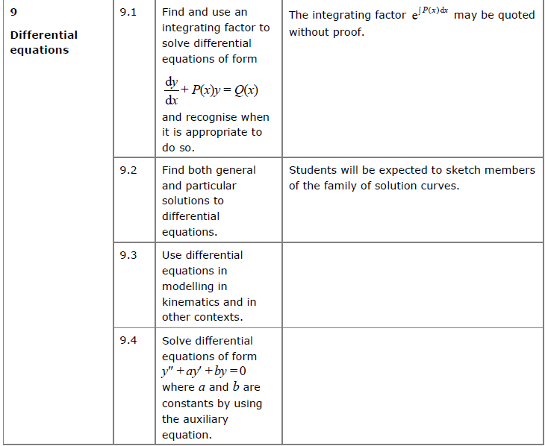
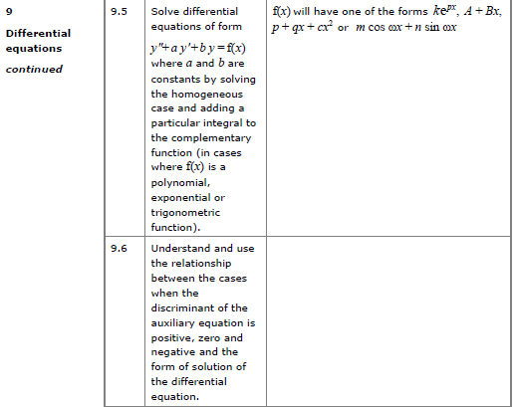

First order Differential Equations
A differential equation is an equation involving a derivative. A ‘first order’ differential equation means the equation contains the first derivative ($\frac{dy}{dx}$) but not the second derivative or beyond. D.E’s are used to model situations which involve rates of change and their solution gives the relationship between the variables themselves, not their derivatives.
- General Solution:

- Particular Solution:

Solving First Order DE’s

There are 3 methods to solve first order DE’s:
- Separating variables
- Reverse Product rule – perfect derivative
- Integrating Factor to produce a perfect derivative

- Separating Variables (Pure Year 2 Recap)

Examples:
- $\frac{dy}{dx}=2$

- Find general solutions to $\frac{dy}{dx}=-\frac{x}{y}$

- Find general solutions to $\frac{dy}{dx}=xy+x$

- Find general solutions to $\frac{dy}{dx}=-\frac{y}{x}$

- Reverse Product Rule
How could we find general solutions of the equation $x^{3}\frac{dy}{dx}+3x^{2}y=\sin{x}$
We can’t separate the variables. But do you notice anything about the LHS?

Examples
- $x\frac{dy}{dx}+y=cosx$

- $x^{2}e^{y}\frac{dy}{dx}+2{xe}^{y}=x$

Test Your Understanding
- Find general solutions of the equation $\frac{1}{x}\frac{dy}{dx}-\frac{1}{x^{2}}y=e^{x}$

- Find general solutions of the equation $4xy\frac{dy}{dx}+2y^{2}=x^{2}$

- Integrating Factors

Example
Find the general solution of $\frac{dy}{dx}-4y=e^{x}$

Why do we use $e^{\int{P} dx}$ ?
Solve the general equation $\frac{dy}{dx}+Py=Q$, where $P, Q$ are functions of $x$.

What happens when there’s something on front of the $dy/dx$?
Examples
- Find the solution of $x^{2}\frac{dy}{dx}+xy=\frac{2}{x} when y=1, x=2$

- Find the general solution of $\cos{x}\frac{dy}{dx}+2y\sin{x}=\cos^{4}{x}$

Test Your Understanding
Find the general solution of the differential equation
$$x\frac{dy}{dx}+5y=\frac{\ln{x}}{x}, x>0$$
Ex 7A, page 151

Second Order Differential Equations (Homogenous)
Higher order DE’s are often used in Mechanics to model situations which involve acceleration. Second order differential equations involve the second derivative.

Classification of DE’s

Recap of First Order, linear, homogeneous DE’s
Consider the general DE: $a\frac{dy}{dx}+by=0$

Solution:
We could use this general result to “guess” at the solution of a DE:

If $5\frac{dy}{dx}+y=0$, we can assume that $y=Ae^{αx}. Hence$ $\frac{dy}{dx}=$

Substituting these expressions back into the original DE gives:

For second order DE’s: We will consider 4 different situations for second order DE’s in relation to their Auxilary Equation:
- Two Distinct Real Roots

- Complex Roots which
  - purely imaginary
  - general

- Repeated Roots

- Two Distinct Real Roots to Auxilary Equation
Let’s ‘guess’ that the solution of $a\frac{d^{2}y}{dx^{2}}+b\frac{dy}{dx}+cy=0$ is similar, and of the form $Ae^{mx}$
Let $y=Ae^{mx}$

- The equation $am^{2}+bm+c=0$ is called the auxiliary equation, and if $m$ is a root of the auxiliary equation then $y=Ae^{mx}$ is a solution of the differential equation
$$a\frac{d^{2}y}{dx^{2}}+b\frac{dy}{dx}+cy=0$$
- When the auxiliary equation has two real distinct roots $α$ and $β$, the general solution of the differential equation is $y=Ae^{αx}+Be^{βx}$, where $A$ and $B$ are arbitrary constants. The solution involves exponential growth or decay. Initial conditions allow us to find the values of A and B.

Example
Find the general solution of the equation $2\frac{d^{2}y}{dx^{2}}+5\frac{dy}{dx}+3y=0$

Test Your Understanding
Find the solution of the equation $\frac{d^{2}y}{dx^{2}}+4\frac{dy}{dx}+3y=0$. Given that when $x=0, y=0, \frac{dy}{dx}=1$.

- Two Complex Roots to Auxiliary Equation which are:

- Purely imaginary

Example
Find the general solution of the differential equation $\frac{d^{2}y}{dx^{2}}+16y=0$

b. More General Complex Roots

Example
Find the general solution of the differential equation $\frac{d^{2}y}{dx^{2}}-6\frac{dy}{dx}+34y=0$

- Repeated Roots to Auxiliary Equation
Find the general solution of the differential equation $\frac{d^{2}y}{dx^{2}}-4\frac{dy}{dx}+4y=0$

Quickfire Questions:

Auxiliary Equation | Roots | General Solution
$$m^{2}+6m+8=0$$ | $$m=-2, -4$$
$$m^{2}-1=0$$ | $$m=±1$$
$$m^{2}-2m+1=0$$ | $$m=1$$
$$m^{2}+4=0$$ | $$m=±2i$$
$$m^{2}+10x+25=0$$ | $$m=-5$$
$$m^{2}-12m+45=0$$ | $$m=6±3i$$
$$m^{2}+10=0$$ | $$m=±\sqrt{10}$$
$$m^{2}+2m+5$$ | $$m=-1±2i$$

Ex 7B, Page 156
Second Order Non-Homogenous DE’s

Non – homogeneous, second order DE’s have the form
$$a\frac{d^{2}y}{dx^{2}}+b\frac{dy}{dx}+cy=f(x)$$

Question: Start by considering the solution to the 1st order DE: $\frac{ dy}{dx}+2y=3x-1$

Consider another example with the same LHS: $\frac{ dy}{dx}+2y=e^{3x}$

Solving a Second Order, Non – Homogeneous DE

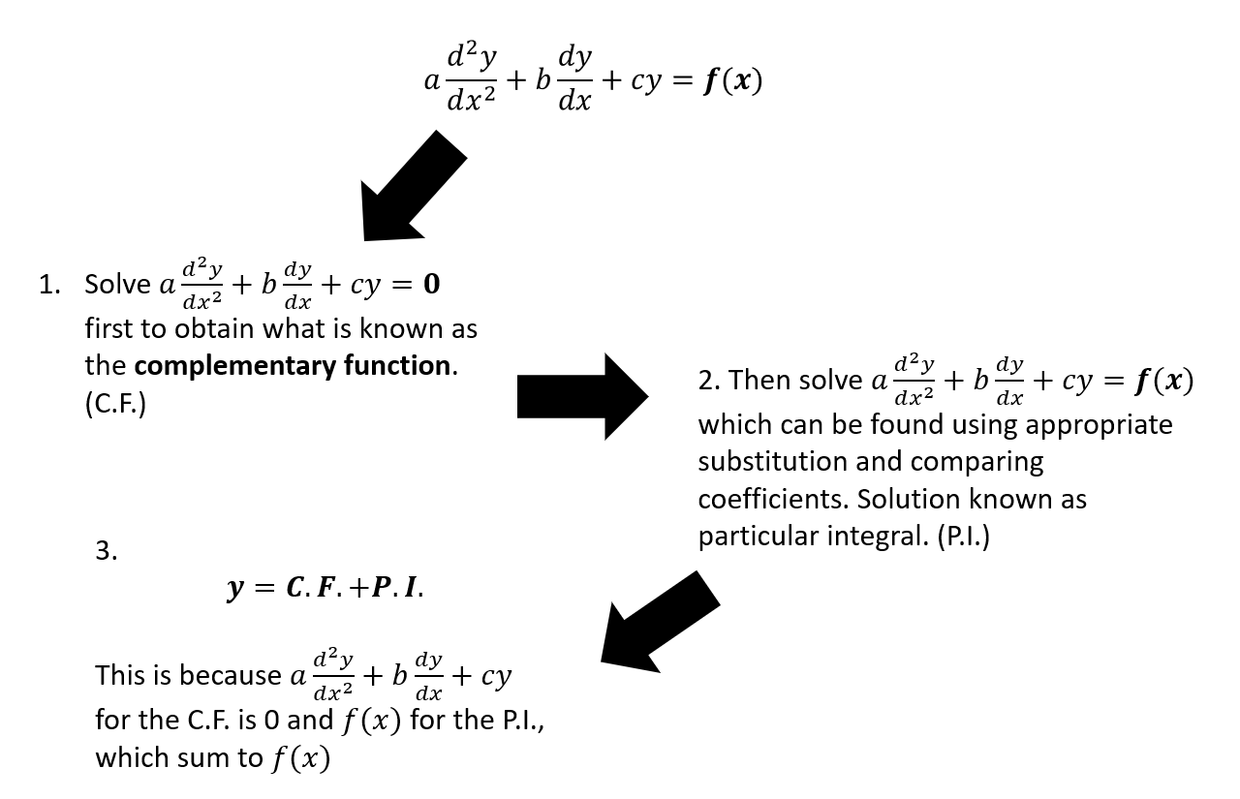

How do we find the Particular Integral?
To find a particular integral you need to establish a trial function whose form depends on the form of $f\left(x\right).$
Function ($f\left(x\right))$ | Form of Particular Integral
$$p$$ | $$λ$$
$$p+qx$$ | $$λ+µx$$
$$p+qx+rx^{2}$$ | $$λ+µx+vx^{2}$$
$$pe^{kx}$$ | $$λe^{kx}$$
$$pcosωx+qsinωx$$ | $$λcosωx+µsinωx$$
$$pcosωx$$ | $$λcosωx+µsinωx$$

The Particular Integral is a function which satisfies the original DE. We take our trial form and sub it back into the DE to find the value of the coefficients.

Example
Find the particular integral of the differential equation $\frac{d^{2}y}{dx^{2}}-5\frac{dy}{dx}+6y=3$

Example:
Find the general solution of the differential equation $\frac{d^{2}y}{dx^{2}}-5\frac{dy}{dx}+6y=2x$

Example:
Find the general solution of the differential equation $\frac{d^{2}y}{dx^{2}}-5\frac{dy}{dx}+6y=3x^{2}$

Example:
Find the general solution of the differential equation $\frac{d^{2}y}{dx^{2}}-5\frac{dy}{dx}+6y=e^{x}$

Interesting (and important) Example!
Find the general solution of the differential equation $\frac{d^{2}y}{dx^{2}}-5\frac{dy}{dx}+6y=e^{2x}$

Example:
Find the general solution of the differential equation $\frac{d^{2}y}{dx^{2}}-2\frac{dy}{dx}=3$

Boundary Conditions
Example
Find $y$ in terms of $x$, given that $\frac{d^{2}y}{dx^{2}}-y=2e^{x}$, and that $\frac{dy}{dx}=0$ and $y=0$ at $x=0$.

Test Your Understanding

- Find the value of $λ$ for which $y=λx\sin{5x}$ is a particular integral of the differential equation (4 marks)
$$\frac{d^{2}y}{dx^{2}}+25y=3\cos{5x}$$
- Using your answer to part (a), find the general solution of the differential equation (3 marks)
$$\frac{d^{2}y}{dx^{2}}+25y=3\cos{5x}$$
(c) Given that at $x=0, y=0$ and $\frac{dy}{dx}=5$, find the particular solution to this differential equation, giving your solution in the form $y=f(x)$ (5)
(d) Sketch the curve with equation $y=f(x)$ for $0≤x≤π$ (2)

- Find the general solution of the differential equation

$$\frac{d^{2}x}{dt^{2}}+5\frac{dx}{dt}+6x=2\cos{t}-\sin{t}$$

Ex7C/ D and Mixed Ex

