CP2 Chapter 6
Hyperbolic Functions

Course Structure
- Definition of hyperbolic functions and their sketches.
- Inverse hyperbolic functions.
- Hyperbolic Identities and Solving Equations
- Differentiation
- Integration
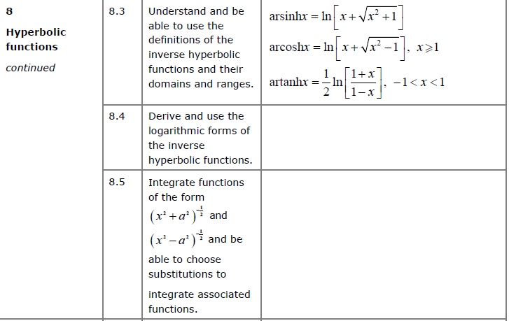
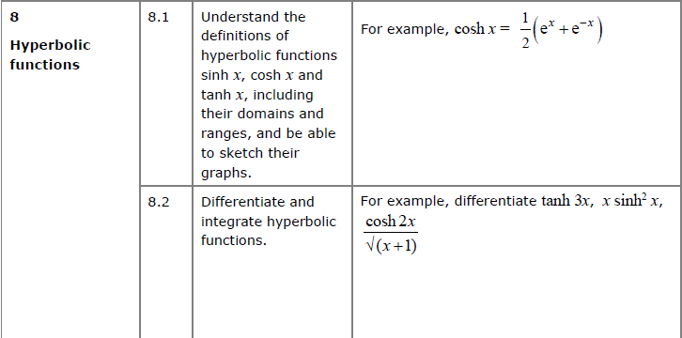

Conic Sections
In mathematics there are a number of different families of curves. Each of these have different properties and their equations have different forms.
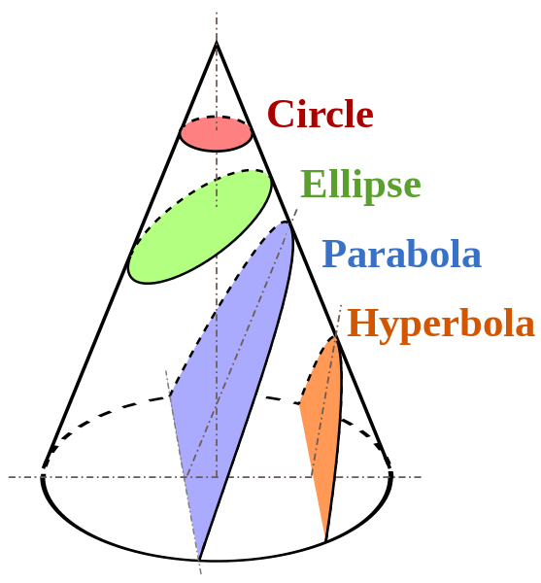
It is possible to obtain these different types of curves by slicing a cone, hence “conic sections”.
The axis of the parabola is parallel to the side of the cone.

For interest:
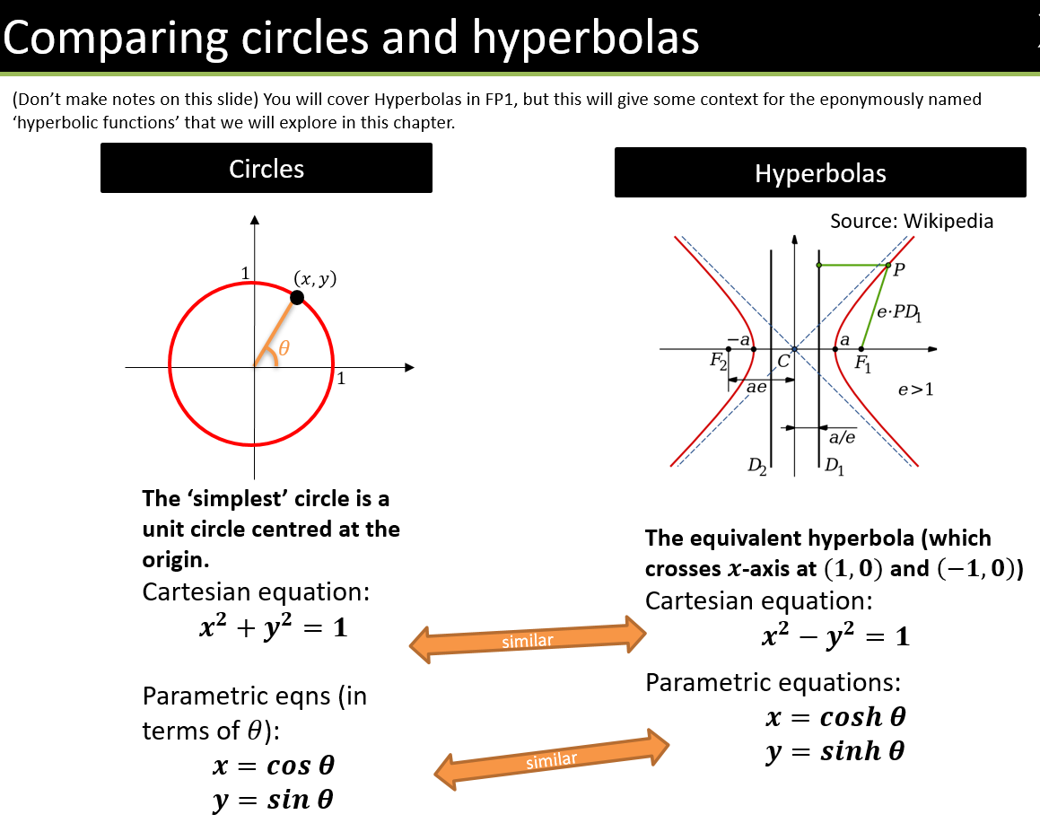

What’s the point of hyperbolic functions?
Hyperbolic functions often result from differential equations (e.g. in mechanics), and we’ll see later in this module how we can use these functions in calculus.
For example, we can consider forces acting on each point on a hanging piece of string.
Solving the relevant differential equations, we end up with coshx.

Equations for Hyperbolic Functions

Hyperbolic sine:
$$\sinh{x}=\frac{e^{x}-e^{-x}}{2} x∈R$$

Hyperbolic cosine:
$$\cosh{x}=\frac{e^{x}+e^{-x}}{2} x∈R$$

Hyperbolic tangent:
$$tanh x{=}\frac{\sinh{x}}{\cosh{x}}=\frac{e^{2x}-1}{e^{2x}+1} x∈R$$

Hyperbolic secant:
$$\operatorname{sech}{x}=\frac{1}{\cosh{x}}=\frac{2}{e^{x}+e^{-x}} x∈R$$

Hyperbolic cosecant:
$$\operatorname{cosech}{x}=\frac{1}{\sinh{x}}=\frac{2}{e^{x}-e^{-x}} x∈R, x≠0$$

Hyperbolic cotangent:
$$\coth{x}=\frac{1}{\tanh{x}}=\frac{e^{2x}+1}{e^{2x}-1} x∈R, x≠0$$

Examples:
- Calculate (using both your $sinh$ button and using the formula)
$$\sinh{3}=10.02$$

- Write in terms of $e$:$\operatorname{cosech}{3}$

- Find the exact value of:$tanh \left(ln 4\right)$

- Solve $sinh x=5$

Sketching Hyperbolic Functions

- $y=\sinh{x}$ is the average of $e^{x}$ and $-e^{-x}$:

- $y=\cosh{x}$ is the average of $e^{x}$ and $e^{-x}$:

- $\tanh{x}=\frac{\sinh{x}}{\cosh{x}}$

Test Your Understanding

Sketch the graph of $y=\operatorname{sech}{x}$

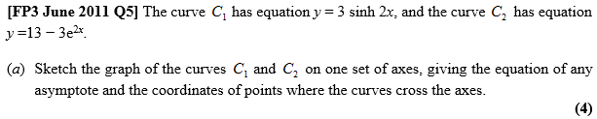

Ex 6A pg 122
Inverse Hyperbolic Functions
Each hyperbolic function has an inverse.

$y=arsinh x,$

$y=arcosh x,$

$y=artanh x$

$y=arsech x,$
$y=arcosech x,$
$y=arcoth x$
Expressing Inverse Hyperbolic Functions in terms of $ln$
Given that hyperbolic functions can be written in terms of $e$ inverse hyperbolic can be expressed in terms of $ln$.
Example:
Prove that $arsinh x=\ln\left(x+\sqrt{x^{2}+1}\right)$

Test Your Understanding
Prove that $arcosh x=\ln\left(x+\sqrt{x^{2}-1}\right), x≥1$

Summary so far:

$$arsinh x=\ln\left(x+\sqrt{x^{2}+1}\right)$$
$$arcosh x=\ln\left(x+\sqrt{x^{2}-1}\right), x≥1$$
$$artanh x=\frac{1}{2}\ln\left(\frac{1+x}{1-x}\right), \left|x\right|<1$$

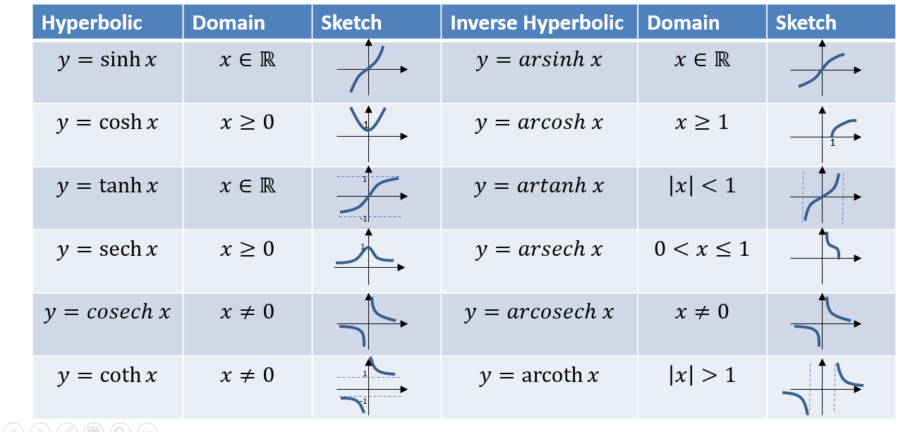

Ex 6B pg 125
Hyperbolic Identities
Use the definitions of $sinh$ and $cosh$ to find:

$\cosh^{2}{x}-\sinh^{2}{x}=$

$1-tanh^{2}x=$

$coth^{2}x-1=$

Also:
$$sinh \left(A±B\right)=sinh A cosh B±cosh A sinh B$$
$$cosh \left(A±B\right)=cosh A cosh B±sinh A sinh B$$

Hence:

$tanh \left(A±B\right)=$

Osborn’s Rule
We can get these identities from the normal sin/cos ones using Osborn’s rule:
Osborn’s Rule:
- Replace $sin→sinh$ and $cos→cosh$
- Negate any explicit or implied product of two sines.

$$\sin{A}\sin{B}=$$

$$\tan^{2}{A} =$$

$$cos2A=2\cos^{2}{A}-1 →$$

$$\tan\left(A-B\right)=\frac{\tan{A}-\tan{B}}{1+\tan{A}\tan{B}} →$$

Solving Equations
To solve equations either use hyperbolic identities or basic definitions of hyperbolic functions.

Examples
- Solve for all real $x, 6\sinh{x}-2\cosh{x}=7$

- Solve for all real $x, 2\cosh^{2}{x}-5sinh{x}=5$

Recap: If $\cos{x}=\frac{3}{5}$, find $\sin{x}$

- If $\sinh{x}=\frac{3}{4}$, find the exact value of:
a) $\cosh{x}$
b) $\tanh{x}$
c) $\sinh{2x}$

Test Your Understanding

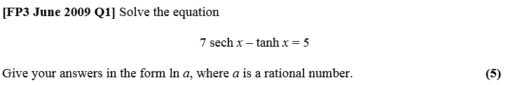

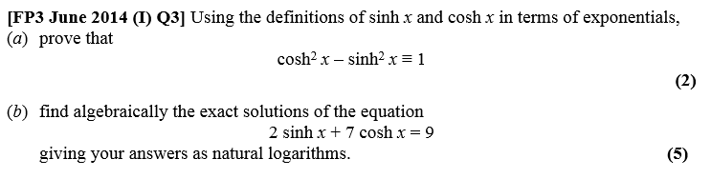

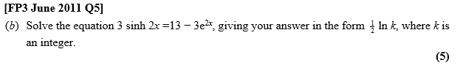
Ex 6C, pg 128

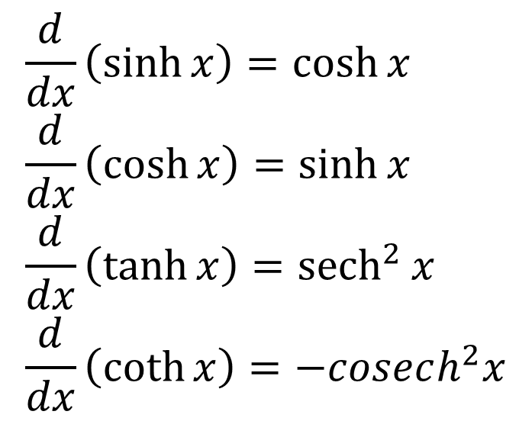
Differentiating hyperbolic functions

Example
Prove that $\frac{d}{dx}\left(\sinh{x}\right)=\cosh{x}$

Test Your Understanding
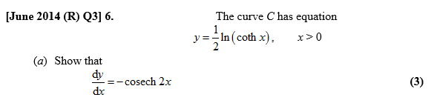

Inverse Hyperbolic Functions
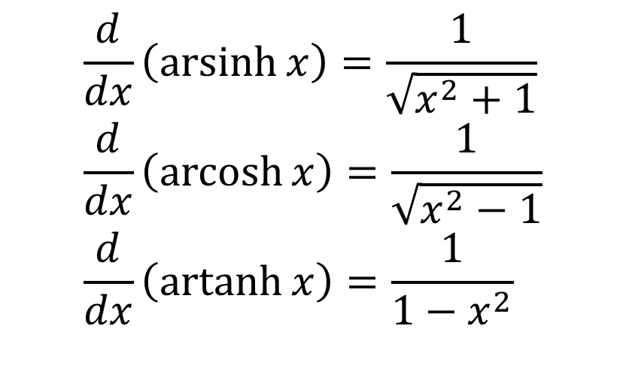

Proof of $\frac{d}{dx}\left(\operatorname{arsinh}{x}\right)=\frac{1}{\sqrt{x^{2}+1}}$

Examples
- Find $\frac{d}{dx}\left(artanh 3x\right)$

- Given that $y={\left(arcosh x\right)}^{2}$ prove that $\left(x^{2}-1\right){\left(\frac{dy}{dx}\right)}^{2}=4y$

Test Your Understanding
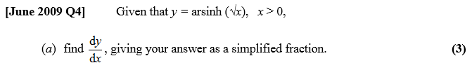

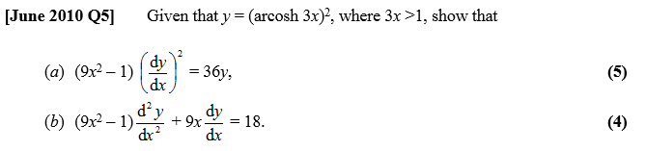

Using Maclaurin expansions for approximations

Textbook Example
(a) Show that $\frac{d}{dx}\left(arsinh x\right)=\frac{1}{\sqrt{1+x^{2}}}$ [We did this earlier]
(b) Find the first two non-zero terms of the series expansion of $arsinh x$.
The general form for the series expansion of $arsinh x$ is given by
$$arsinh x=\sum_{r=0}^{∞}{\left(\frac{{\left(-1\right)}^{n}\left(2n\right)!}{2^{2n}{\left(n!\right)}^{2}}\right)\frac{x^{2n+1}}{2n+1}}$$
(c) Find, in simplest terms, the coefficient of $x^{5}$.
(d) Use your approximation up to and including the term in $x^{5}$ to find an approximate value for $arsinh 0.5$.
(e) Calculate the percentage error in using this approximation.

Ex 6D pg 133
Standard Integrals

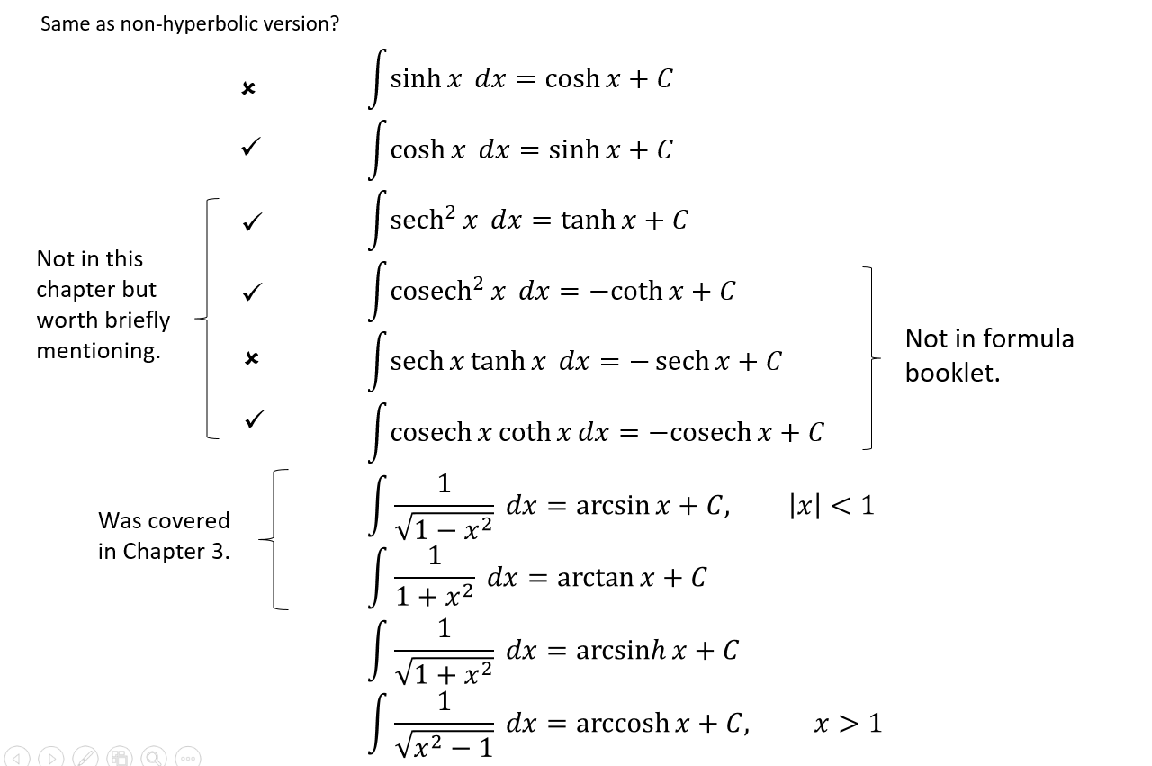

Standard Integral Examples
$$\int{\cosh\left(4x-1\right)dx}=$$
$$\int{sinh \left(\frac{2}{3}x\right)} dx=$$
$$\int{\frac{3}{\sqrt{1+x^{2}}}dx}=$$
$$\int{\frac{4}{\sqrt{x^{2}-1}}dx}=$$
$$\int{sinh \left(3x\right)} dx=$$
$$\int{\frac{10}{\sqrt{x^{2}-1}}dx}=$$
$$\int{\frac{2}{\sqrt{1+x^{2}}}dx}=$$

Not Quite so Standard Examples
- $\int{\frac{2+5x}{\sqrt{x^{2}+1}} dx}$

- $\int{\cosh^{5}{2x}\sinh{2x} dx}$

- $\int{\tanh{x} dx}$

Using Identities

- $\int{\cosh^{2}{3x} dx}$

- $\int{\sinh^{3}{x} dx}$

What now??
Sometimes there are techniques which work on non-hyperbolic trig functions but doesn’t work on hyperbolic ones. Just first replace any hyperbolic functions with their definition.

Examples
- Find $\int{e^{2x}\sinh{x} dx}$

- Find $\int{\operatorname{sech}{x} dx}$

Dealing with $1/\sqrt{a^{2}+x^{2}}$, $1/\sqrt{x^{2}-a^{2}}$, ….
We can use substitution to deal with this style of integration.

$$\sin^{2}{θ}+\cos^{2}{θ}=1$$
$$1+\tan^{2}{θ}=\sec^{2}{θ}$$
$$1+\sinh^{2}{u}=\cosh^{2}{u}$$

- Consider $\int{\frac{1}{\sqrt{a^{2}+x^{2}}}dx}$ . What substitution might we use?

- Consider$\int{\frac{1}{\sqrt{a^{2}+x^{2}}}dx}$. What substitution might we use?

$$\int{\frac{1}{\sqrt{a^{2}+x^{2}}}dx}=$$

$$\int{\frac{1}{\sqrt{x^{2}-a^{2}}}dx}=$$
Example
- Show that $\int{\frac{1}{\sqrt{x^{2}-a^{2}}}dx}=arcosh \left(\frac{x}{a}\right)+c$

- Show that $\int_{5}^{8}{\frac{1}{\sqrt{x^{2}-16}}dx}=\ln\left(\frac{2+\sqrt{3}}{2}\right)$

- Show that $\int{\sqrt{1+x^{2}} dx}=\frac{1}{2}arsinh x+\frac{1}{2}x\sqrt{1+x^{2}}+C$.

Test Your Understanding

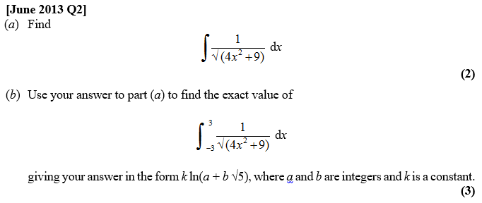

2)Using a hyperbolic substitution, evaluate $\int_{0}^{6}{\frac{x^{3}}{\sqrt{x^{2}+9}} dx}$

Integrating by Completing the Square
By completing the square, we can then use one of the standard results.
Examples
- Determine $\int{\frac{1}{x^{2}-8x+8}dx}$

- Determine $\int{\frac{1}{\sqrt{12x+2x^{2}}}dx}$

Test Your Understanding
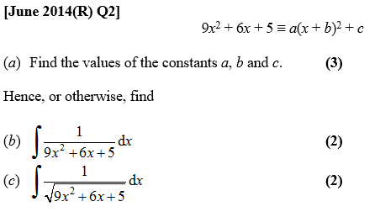

Ex 6E and Mixed Ex 6

