Core Pure 2
Polar Coordinates

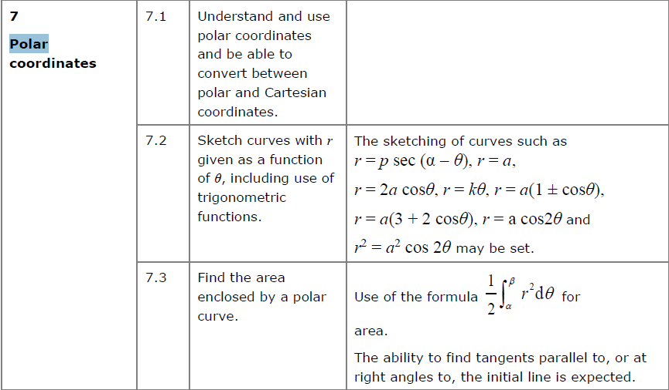

Polar coordinates describe the location of a point in a 2D plane using the distance from the origin and anti-clockwise angle from the positive x-axis.

Recap: Converting to/ from polar coordinates
If: $x=r\cos{θ} y=r\sin{θ}$
Then: $r^{2}=x^{2}+y^{2}$
And: $θ=\tan^{-1}\left(\frac{y}{x}\right)$ (adjusted depending on quadrant)

Cartesian | Polar
$$(0,2)$$
 | $$(3,π)$$
$$(1,1)$$
$$\left(-5,12\right)$$
 | $$\left(6,-\frac{π}{6}\right)$$

The Polar Equation of a Curve: $r=f(θ)$
We can express equations of curves in polar form. Sometimes we can convert the polar form to cartesian form but often equations are simpler when left in polar form.

Find a cartesian equation for the following curves:

- $r=5$

- $r=2+\cos{2θ}$

- $r^{2}=\sin{2θ}$

Converting to Polar Form:
Converting to polar is easier, but the harder part is often finding how to simplify the expression. Know your double angle formulae!

Find polar equations for the following:
- $y^{2}=4x$

- $x^{2}-y^{2}=5$

- $y\sqrt{3}=x+4$

Test your understanding
Find the polar equation of a circle whose centre has polar coordinate (2, 0) with radius 2.

Ex 5A pg 104

Sketching Curves of Polar Equations
How would you sketch each of the following? (Listed on specification)
Summary

- $r=a$

- $θ=α$

- $r=aθ$

Sketching Using a Table of Values

Use the table to sketch the graph of $r=a\left(1+\cos{θ}\right)$

$$θ$$ | $$0$$ | $$\frac{π}{2}$$ | $$π$$ | $$\frac{3π}{2}$$ | $$2π$$
$$r$$

(NB: Negative values of r are discounted in Edexcel CP2)

Examples:

- $r=\sin{3θ}$

- $r^{2}=a^{2}\cos{2θ}$

Investigate these:

$$1. r=2sinθ$$

$$2. r=2cosθ$$

$$3. r=3sin4θ$$

$$4.r=3cos4θ$$

$$5. r=4sinθ$$

$$6. r=4cosθ$$

Observations:

Egg or Dimple?$r=a\left(p+q\cos{θ}\right)$
Polar graphs of the form $r=±p±q\cos{θ} or r=±p±q\sin{θ}$ with p,q > 0 are known as limaçons.
The ratio $\frac{p}{q}$tells us about the general shape of the limaçon.
For CP2 we are required to sketch limaçons of the $r=a\left(p+q\cos{θ}\right)$ and $r=a\left(1±\cos{θ}\right)$. Since we require r > 0 we need only situations where p ≥ q.

Case 1: p = q

Case 2: p > 2q

Case 3: q < p < 2q

Case 4: (not required but interesting!) p < q

Examples:
- Sketch $r=a\left(5+2\cos{θ}\right)$

- Sketch $r=a\left(3+2\cos{θ}\right)$

- (a) Show on an Argand diagram the locus of points given by the values of $z$ satisfying $\left|z-3-4i\right|=5$
(b) Show that this locus of points can be represented by the polar curve
$r=6\cos{θ}+8\sin{θ}$
Ex 5B pg 108/ 109

Summary so far:
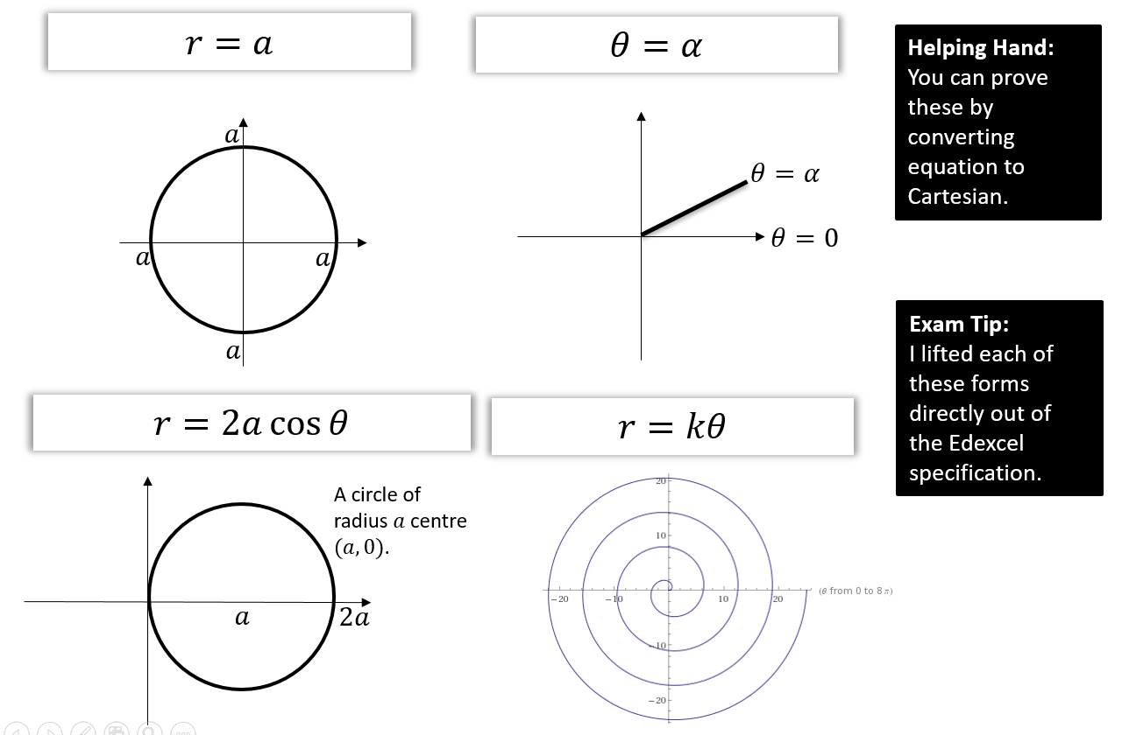

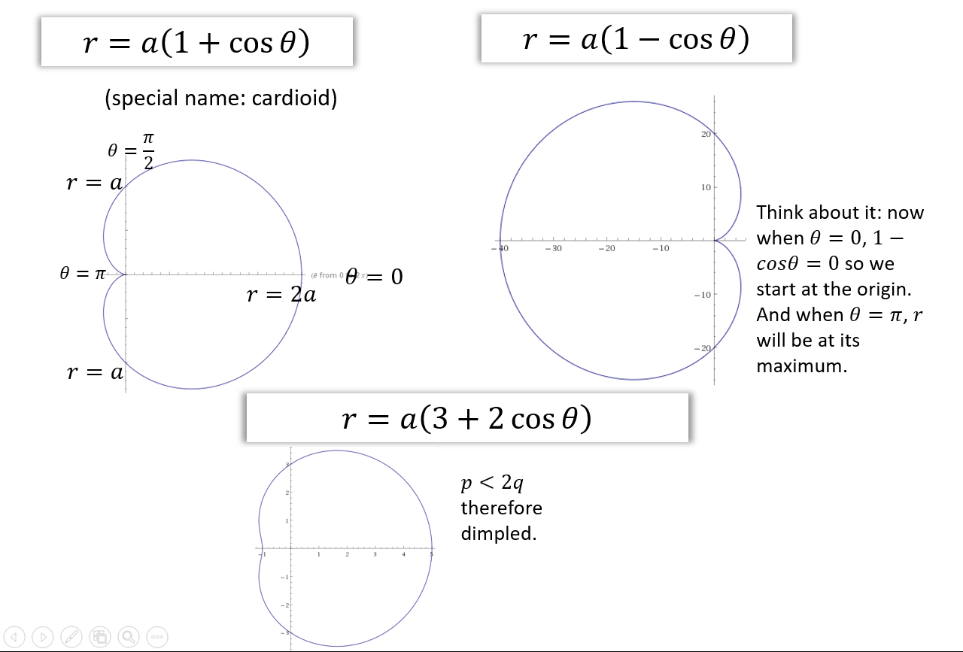

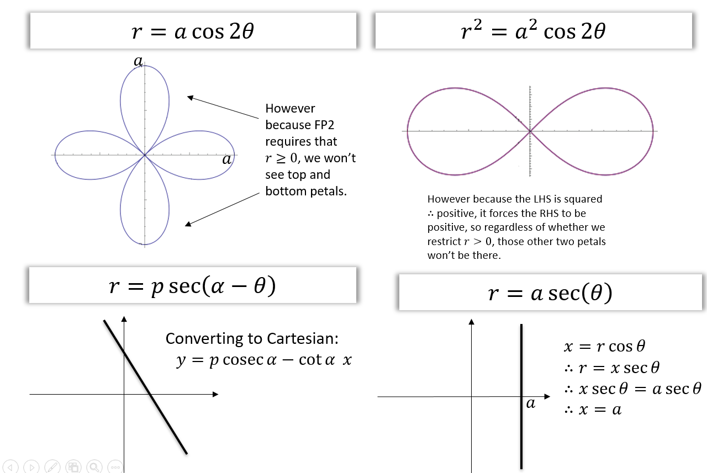

Areas enclosed by polar curves
The area of a sector bounded by a polar curve and the half lines $θ=α$ and $θ=β$ (when θ is given in radians) is given by:
$$A=\frac{1}{2}\int_{α}^{β}{r^{2}dθ}$$
When finding the area of a sector we almost always need to integrate trig functions, in particular using the double angle formulae.

Reminder:
$$cos2θ=2\cos^{2}{θ-1 \cos^{2}{θ=\frac{1}{2}(1+cos2θ)}}$$
$$cos2θ=1-2\sin^{2}{ θ} \sin^{2}{\begin{aligned}θ=\frac{1}{2}(1-cos2θ) \\ \end{aligned}}$$
Example:
- Find the area enclosed by the cardioid with equation $r=a\left(1+\cos{θ}\right)$

- Find the area of one loop of the polar rose $r=a\sin{4θ}$

Test Your Understanding
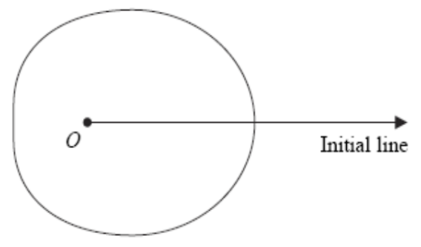
Fig. 1 shows a sketch of the curve with polar equation $r=a+3\cos{θ}$ $a>0,0≤θ<2π$
The area enclosed by the curve is $\frac{107}{2}π$.
Find the value of $a$.
(8 marks)

Intersecting Areas
When polar curves intersect we have to consider which curve we’re finding the area under for each value of $θ$.
Example
- On the same diagram sketch the curves with equations $r=2+\cos{θ}$ and $r=5\cos{θ}$
- Find the polar coordinates of the points of intersection of these two curves.
- Find the exact value of the area of the finite region bound between the two curves.

Test your understanding
Figure 1 shows the curves given by the polar equations
$$r=2, 0≤θ<\frac{π}{2}r=1.5+\sin{3θ} 0≤θ≤\frac{π}{2}$$
- Find the coordinates of the points where the curves intersect. (3)
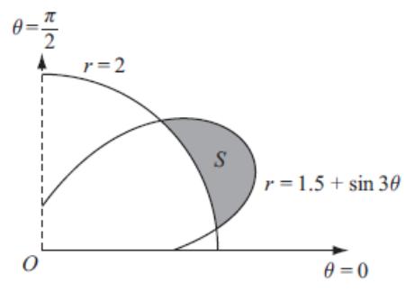
- The region $S$ for which $r>2$ and $r<1.5+\sin{3θ}$ is shown. Find, by integration, area of $S$ giving your answer in the form $aπ+b\sqrt{3}$ where $a$ and $b$ are simplified fractions. (7)

Ex 5c pg 111

Tangents and Normals
Remember how you found the gradient given equations in parametric form.
$$x=\cos{t}, y=\sin{t}$$
$$\frac{dy}{dx}=\frac{\left(\frac{dy}{dt}\right)}{\left(\frac{dx}{dt}\right)}=\frac{\cos{t}}{-\sin{t}}=-\cot{t}$$

In the same way for polar coordinates:
$$x=r\cos{θ} y=r\sin{θ}$$
$$\frac{dy}{dx}=\frac{\left(\frac{dy}{dθ}\right)}{\left(\frac{dx}{dθ}\right)}$$
We can find the gradient at any point by differentiating parametrically.

- If $\frac{dy}{dθ}=0$ the tangent is parallel to the initial line

- If $\frac{dx}{dθ}=0$ the tangent is perpendicular to the initial line.
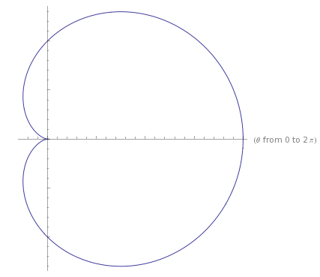

Eaxmple
Find the coordinates of the points on $r=a\left(1+\cos{θ}\right)$ where the tangents are parallel to the initial line $θ=0$.

Test Your Understanding
The curve $C$ has polar equation
$$r=1+2\cos{θ}, 0≤θ≤\frac{π}{2}$$
At the point $P$ on $C$, the tangent to $C$ is parallel to the initial line.
Given that $O$ is the pole, find the exact length of the line $OP$.

Example
Find the equations and the points of contact of the tangents to the curve
$$r=a\sin{2θ, 0≤θ≤\frac{π}{2}}$$
that are (a) parallel to the initial line and (b) perpendicular to the initial line.

Proof of dimple vs egg
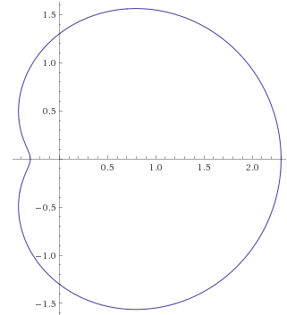
Prove that for $r=p+q\cos{θ}$ we have a ‘dimple’ if $p<2q$.
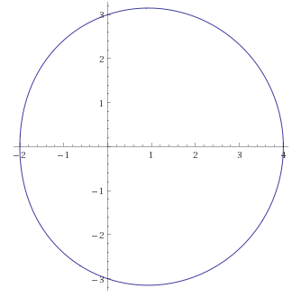
Ex 5D pg 115

