Core Pure 2

Volumes of Revolution

Chapter Overview

1: Revolving around the $x$-axis.

2: Revolving around the $y$-axis.

3: Volumes of revolution with parametric curves.

4: Modelling



This chapter involves volumes of revolution but with trickier integration than in CP1.

Revolving around the x-axis

**Recap: When revolving around the $x$-axis, $V=π\int_{b}^{a}{y^{2} dx}$**

Example

The region $R$ is bounded by the curve with equation $y=\sin{2x}$, the $x$-axis and $x=\frac{π}{2}$. Find the volume of the solid formed when region $R$ is rotated through $2π$ radians about the $x$-axis.

Edexcel C4(Old) Jan 2013 Q6

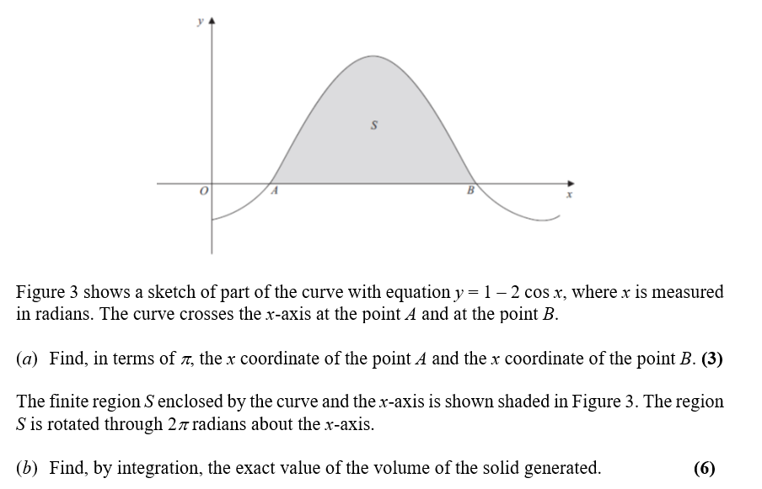

Ex4A p. 78-80

Revolving around the $y$-axis

**Recap**: When revolving around the $y$-axis, $V=π\int_{b}^{a}{x^{2} dy}$

i.e. we are just **swapping the roles of $x$ and $y$** .

Example

The diagram shows the curve with equation $y=4\ln{x}-1$. The finite region $R$, shown in the diagram, is bounded by the curve, the $x$-axis, the $y$-axis and the line $y=4$. Region $R$ is rotated by $2π$ radians about the $y$-axis. Use integration to show that the exact value of the volume of the solid generated is $2π\sqrt{e}\left(e^{2}-1\right)$.

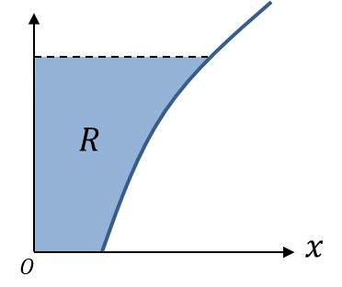

Ex4B p. 81-83

**Volumes of revolution for parametric curves**

We have seen in Pure Year 2 that parametric equations are where, instead of some single equation relating $x$ and $y$, we have an equation for each of $x$ and $y$ in terms of some parameter, e.g. $t$. As $t$ varies, this generates different points $\left(x,y\right)$.

**To integrate parametrically, the trick was to replace $dx$ with $\frac{dx}{dt} dt$**

$V=π\int_{x=b}^{x=a}{y^{2} dx}$

Note that as we’re integrating with respect to $t$ now, we need to find the equivalent limits for $t$. We can do the same for revolving around the $y$-axis: just replace $dy$ with $\frac{dy}{dt}$ and change the limits.

Example

The curve $C$ has parametric equations $x=t(1+t)$, $y=\frac{1}{1+t}$, $t≥0$.

The region $R$ is bounded by $C$, the $x$-axis and the lines $x=0$ and $y=0$. Find the exact volume of the solid formed when $R$ is rotated $2π$ radians about the $x$-axis.

Test Your Understanding

Edexcel C4(Old) June 2011 Q7

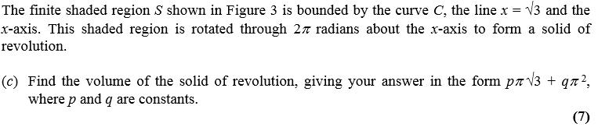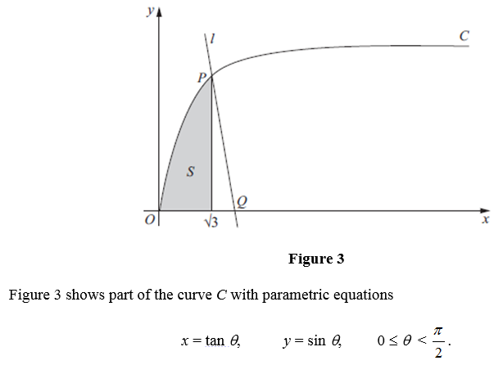

Ex4C p. 84-87

**Modelling with Volumes of Revolution**

Example

The diagram shows a model of a goldfish bowl. The cross-section of the model is described by the curve with parametric equations $x=2\sin{t}, y=2\cos{t}+2$  
, $\frac{π}{6}≤t≤\frac{11π}{6}$, where the units of $x$ and $y$ are in cm. The goldfish bowl is formed by rotating this curve about the $y$-axis to form a solid of revolution.

1. Find the volume of water required to fill the model to a height of 3cm.

The real goldfish bowl has a maximum diameter of 48cm.

(b) Find the volume of water required to fill the real goldfish bowl to the corresponding height.

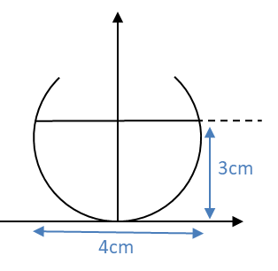

Ex4D p. 88-89