CP2, Chapter 3
Methods in Calculus

Course Structure
- Improper Integrals
- Mean Value of a Function
- Differentiating and Integrating Inverse Trig Functions
- Integrating using Partial Fractions

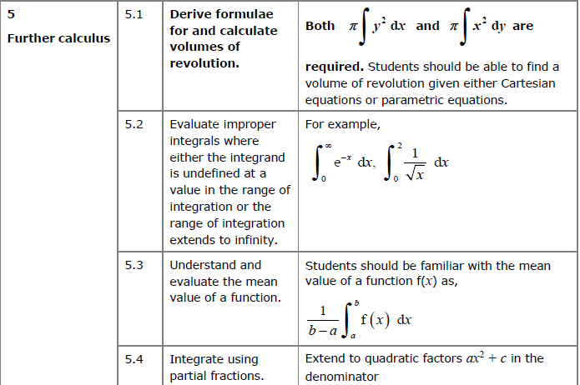
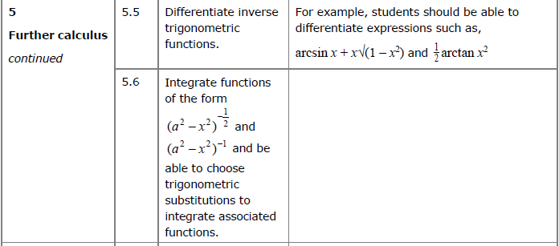

Improper Integrals

STARTER 1: Determine $\int_{-1}^{1}{\frac{1}{x^{2}} dx}$. Is there an issue?

STARTER 2: Determine $\int_{-1}^{1}{\frac{1}{x^{2}} dx}$. Is there an issue?

STARTER 3: Determine $\int_{0}^{1}{\frac{1}{\sqrt{x}} dx}$. Is there an issue?

If a function $f\left(x\right)$ exists and is continuous for all values of x in the interval $\left[a,b\right]$ then the definite integral $\int_{a}^{b}{f\left(x\right) dx}$ represents the area enclosed by the curve $y=f\left(x\right),$ the x axis and the lines $x=a$ and $x=b.$
Here, we consider integrals where one or both of the limits are infinite, or where the function is not defined at some point within in the given interval. These are called improper integrals. In these cases, it is still possible for the function to enclose a finite area.
The integral $\int_{a}^{b}{f\left(x\right) dx}$ is improper if either:
- One or both of the limits is infinite
- $f(x)$ is undefined at $x=a, x=b$ are another point in the interval $[a,b]$.

If an improper integral exists it is said to be convergent. If it does not exist it is said to be divergent.

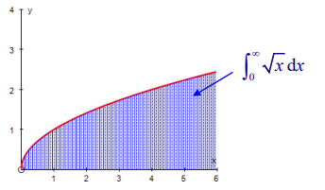
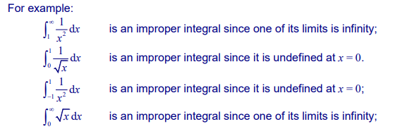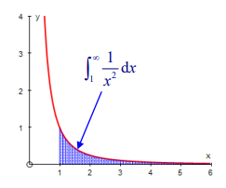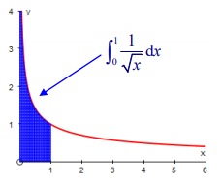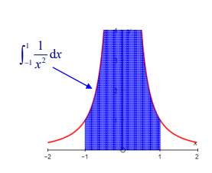

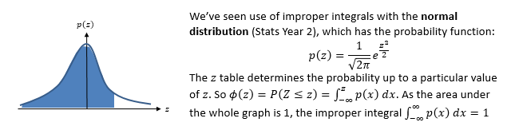

We can’t use $∞$ in calculations directly. We can make use of the $lim$ function we saw in differentiation by first principles.
To find $\int_{a}^{∞}{f\left(x\right) dx}$, determine $\lim_{t→∞}\int_{a}^{t}{f\left(x\right) dx}$

Examples

1.Evaluate $\int_{1}^{∞}{\frac{1}{x^{2}} dx}$ or show that it is not convergent.

2. Evaluate $\int_{1}^{∞}{\frac{1}{x} dx}$ or show that it is not convergent.

Undefined Values of $f\left(x\right)$
We need to avoid values with the range $[a,b]$ for which the expression is not defined. But just as we avoided $∞$ by considering the limit as $t→∞$, we can similarly find what the area converges to as $x$ tends towards the undefined value.

Examples
- Evaluate $\int_{0}^{1}{\frac{1}{x^{2}} dx}$ or show that it is not convergent.

- Evaluate $\int_{0}^{2}{\frac{x}{\sqrt{4-x^{2}}} dx}$ or show that it is not convergent.

Further Examples
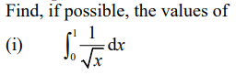

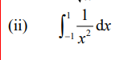

Integrating between $-∞$ and $∞$

If both limits in the integral are infinite, then you need to split the integral into the sum of 2 improper integrals.

If both these integrals converge, then the original integral converges, but if either diverges, then the original integral is also divergent.

Example

(a) Find $\int{xe^{-x^{2}}dx}$

(b) Hence show that $\int_{-∞}^{∞}{xe^{-x^{2}}}dx$ converges and find its value.

Ex 3a, pages 56-58
The Mean Value of a Function

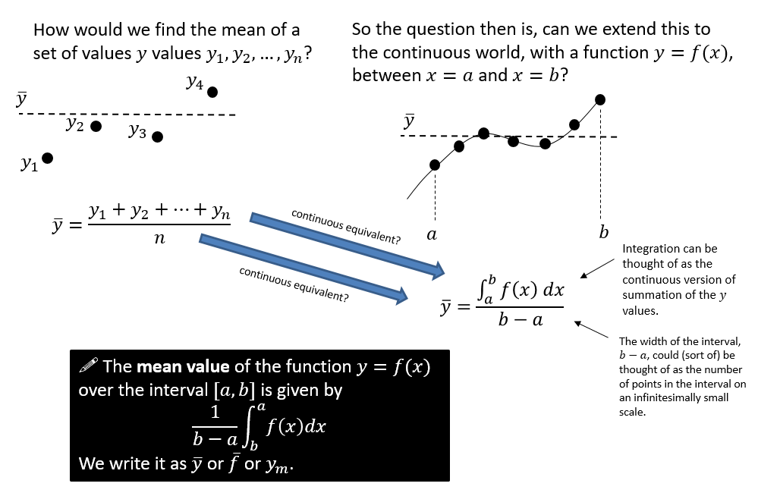

Textbook Example
- Find the mean value of $f\left(x\right)=\frac{4}{\sqrt{2+3x}}$ over the interval $\left[2,6\right]$.

- $f\left(x\right)=\frac{4}{1+e^{x}}$
- Show that the mean value of $f(x)$ over the interval $\left[\ln{2},\ln{6}\right]$ is $\frac{4\ln{\frac{9}{7}}}{\ln{3}}$
- Use your answer to part a to find the mean value over the interval $[\ln{2},\ln{6}]$ of $f\left(x\right)+4$.
Use geometric considerations to write down the mean value of $-f(x)$ over the interval $\left[\ln{2},\ln{6}\right]$

Ex 3B Page 61

Differentiating inverse trigonometric functions

Examples
- Show that if $y=\arcsin{x}$, then $\frac{dy}{dx}=\frac{1}{\sqrt{1-x^{2}}}$
Remember that we’re trying to turn $\cos{y}$ into an expression in terms of $x$; we have to use $x=\sin{y}$ in some way. You then might think “Oh, I know an identity that relates $\cos{y}$ and $\sin{y}$!”

- Given that $y=\arcsin{x^{2}}$ find $\frac{dy}{dx}$

$$\frac{d}{dx}\left(\arcsin{x}\right)=\frac{1}{\sqrt{1-x^{2}}}$$

$$\frac{d}{dx}\left(\arccos{x}\right)=-\frac{1}{\sqrt{1-x^{2}}}$$

$$\frac{d}{dx}\left(\arctan{x}\right)=\frac{1}{1+x^{2}}$$

Test Your Understanding
- Given that $y=\operatorname{arcsec}{2x}$, show that $y=\frac{1}{x \sqrt{4x^{2}-1}}$

- Given that $y=\arctan\left(\frac{1-x}{1+x}\right)$, find $\frac{dy}{dx}$

Ex 3C Pg 62
Integrating with inverse trigonometric functions

Use an appropriate substitution to show that $\int{\frac{1}{1+x^{2}}dx}=\arctan{x}+C$
Think what value of $x$ would make $1+x^{2}$ nicely simplify.

Dealing with $1/(a^{2}-x^{2})$ , $1/\sqrt{a^{2}-x^{2}}$, ….

Use our previous results to fill in the table below:

$$\int{\frac{1}{\sqrt{1-x^{2}}} dx}= \left|x\right|<a$$

$$\int{\frac{1}{1+x^{2}} dx}=$$

Show that $\int{\frac{1}{\sqrt{a^{2}-x^{2}}}dx}=\arcsin\left(\frac{x}{a}\right)+c$ where $a$ is a positive constant and $\left|x\right|<a$.

We can extend these results to give some standard results which are given in the formulae book:
$$\int{\frac{1}{\sqrt{a^{2}-x^{2}}} dx}=\arcsin\left(\frac{x}{a}\right)+C, \left|x\right|<a$$

$$\int{\frac{1}{a^{2}+x^{2}} dx}=\frac{1}{a}\arctan\left(\frac{x}{a}\right)+C$$

- Find $\int{\frac{4}{5+x^{2}}dx}$

- Find $\int{\frac{1}{25+9x^{2}}dx}$

- Find $\int_{-\frac{\sqrt{3}}{4}}^{\frac{\sqrt{3}}{4}}{\frac{1}{\sqrt{3-4x^{2}}}}dx$

- Find $\int{\frac{x+4}{\sqrt{1-4x^{2}}}dx}$

Ex 3D Pg 67-68

Solving using partial fractions

We have already seen in Pure Year 2 how we can use partial fractions to integrate. We can use this to further expand our repertoire of integration techniques for expressions of the form $\frac{1}{a^{2}±x^{2}}$ and $\frac{1}{\sqrt{a^{2}±x^{2}}}$

Example
Prove that $\int{\frac{1}{a^{2}-x^{2}} dx}=\frac{1}{2a}\ln\left|\frac{a+x}{a-x}\right|+c$

When you write as partial fractions, ensure you have the most general possible non-top heavy fraction, i.e. the ‘order’ (i.e. maximum power) of the numerator is one less than the denominator.
$$\frac{1}{x(x^{2}+1)}≡\frac{A}{x}+\frac{Bx+C}{x^{2}+1}$$

Example
Show that $\int{\frac{1+x}{x^{3}+9x}}dx=A\ln\left(\frac{x^{2}}{x^{2}+9}\right)+B\arctan\left(\frac{x}{3}\right)+c$, where $A$ and $B$ are constants to be found.

If the fraction is top-heavy, you’ll have a quotient. As per Pure Year 2, if the order of numerator and denominator is the same, you’ll need an extra constant term. If the power is 1 greater in the numerator, you’ll need a quotient of $Ax+B$, and so on.
$$\frac{4x^{2}+x}{x^{2}+x}=\frac{4x^{2}+x}{x\left(x+1\right)}=A+\frac{B}{x}+\frac{C}{x+1}$$

Test Your Understanding
(a) Express $\frac{x^{4}+x}{x^{4}+5x^{2}+6}$ as partial fractions.
(b) Hence find $\int{\frac{x^{4}+x}{x^{4}+5x^{2}+6}} dx$.
Ex 3D Pg 67-68

