Chapter 1

Complex Numbers

Chapter Overview

1. Exponential form of a complex number

2. Multiplying and dividing complex numbers

3. De Moivre’s Theorem

4. De Moivre’s for Trigonometric Identities

1. Expressing $\cos{nθ }$/ $\sin{nθ}$ in terms of powers of $\cos{θ}$
2. Finding expressions for and

5. Roots

6. Sums of series



Recap: Mod/ arg form

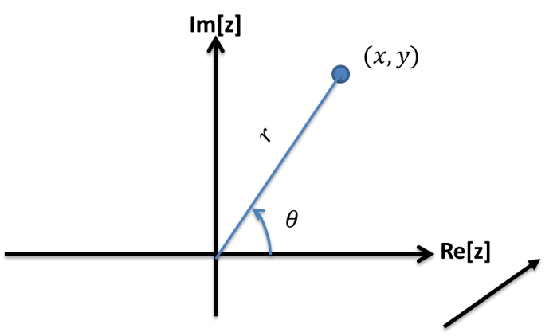

$z=x+iy$

$r=\left|z\right|=$

$θ=arg\left(z\right)=$

$x=$

$y=$

$z=x+iy =$

|  |  |  |  |
| --- | --- | --- | --- |
| $$x+iy$$ | $$r$$ | $$θ$$ | **Mod-arg form** |
| $$-1$$ |  |  |  |
| $$i$$ |  |  |  |
| $$1+i$$ |  |  |  |
| $$-\sqrt{3}+i$$ |  |  |  |

Exponential Form

We’ve seen the Cartesian form a complex number $z=x+yi$ and the modulus-argument form $z=r(\cos{θ+i\sin{θ})}$. But wait, there’s a third form!

In the later chapter on Taylor expansions, you’ll see that you that you can write functions as an infinitely long polynomial:

$$\cos{x}=1 -\frac{x^{2}}{2!} +\frac{x^{4}}{4!} -\frac{x^{6}}{6!} +$$

$$\sin{x} =x -\frac{x^{3}}{3!} +\frac{x^{5}}{5!} -…$$

$$e^{x}= 1+x+\frac{x^{2}}{2!}+\frac{x^{3}}{3!}+\frac{x^{4}}{4!}+\frac{x^{5}}{5!}+\frac{x^{6}}{6!}+$$

It looks like the $\cos{x}$ and $\sin{x}$ somehow add to give $e^{x}$. The one problem is that the signs don’t quite match up.

|  |  |  |
| --- | --- | --- |
| $$x+iy$$ | **Mod-arg form** | **Exp Form** |
| $$-1$$ |  |  |
| $$2-3i$$ |  |  |
|  | $$\sqrt{2}\left(\cos{\frac{π}{10}}+i\sin{\frac{π}{10}}\right)$$ |  |
|  |  | $$z=\sqrt{2}e^{\frac{3πi}{4}}$$ |
|  |  | $$z=2e^{\frac{23πi}{5}}$$ |

**Exponential form $z=re^{iθ}$**

Example

Use $e^{iθ}=\cos{θ}+i\sin{θ}$ to show that $\cos{θ}=\frac{1}{2}(e^{iθ}+e^{-iθ})$

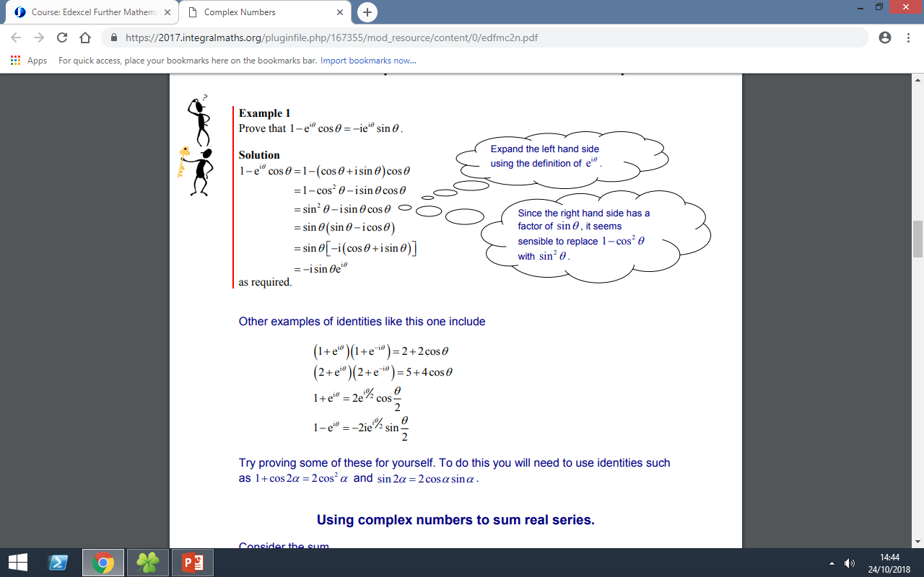

Ex 1a pg 5

Multiplying and Dividing Complex Numbers

Examples

1.

2.

3. Write in the form $re^{iθ}$:

$\frac{2\left(\cos{\frac{π}{12}}+i\sin{\frac{π}{12}}\right)}{\sqrt{2}\left(\cos{\frac{5π}{6}}+i\sin{\frac{5π}{6}}\right)}$

Test Your Understanding

If $z=5\sqrt{3}-5i$, find:

1. $|z|$ (b) $arg⁡(z)$ in terms of $π$

If $w=2\left(\cos{\frac{π}{4}}+i\sin{\frac{π}{4}}\right),$ find:

(c) $\left|\frac{w}{z}\right|$ (d) $\arg\left|\frac{w}{z}\right|$

Ex 1b pg 7

De Moivre’s Theorem

Example

Prove by induction that $z^{n}=r^{n}\left(\cos{nθ}+i\sin{nθ}\right)$

De Moivre’s Theorem: Exponential Form

Examples

1. Simplify $\frac{{\left(\cos{\frac{9π}{17}}+i\sin{\frac{9π}{17}}\right)}^{5}}{{\left(\cos{\frac{2π}{17}} - i\sin{\frac{2π}{17}}\right)}^{3}}$
2. Express ${\left(1+\sqrt{3} i\right)}^{7}$ in the form $x+iy$ where $x,y∈R$.

Test your understanding

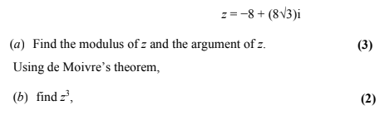

Ex 1C pg 10

Applications of de Moivre’s

**Trig identities**

De Moivre’s theorem can be used to give multiple angle expressions ($\cos{nθ }$/ $\sin{nθ}$) in terms of powers, and to express powers of sin and cos in terms of multiple angles. This is useful in integration.

We derive these identities by applying the binomial expansion to $(cosθ+{isinθ)}^{n}$

Recap

${\left(a+b\right)}^{n}=a^{n}+\left({n \atop 1}\right)a^{n-1}b+\left({n \atop 2}\right)a^{\left(n-2\right)}b^{2}$ +….

1. **Expressing $\cos{nθ }$ and $\sin{nθ}$ in terms of powers of $\cos{θ}$**

Example

Express $\cos{3θ}$ in terms of powers of $\cos{θ}$

Test Your understanding

1. **Express $\cos{6θ}$ in terms of $\cos{θ}$**

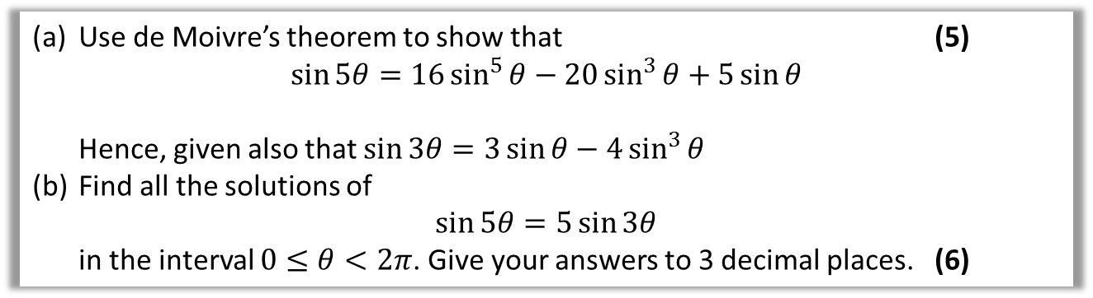2.

**b. Finding expressions for $\sin^{n}{ θ}$ and $\cos^{n}{θ}$**

**Exponential Form**

**Examples**

**1. Express $\cos^{5}{θ}$ in the form $a\cos{5θ}+b\cos{3θ}+c\cos{θ}$**

**2. Prove that $\sin^{3}{θ}=-\frac{1}{4}\sin{3θ}+\frac{3}{4}\sin{θ}$**

Test Your Understanding

**a) Express $\sin^{4}{θ}$ in the form $a\cos{4θ}+b\cos{2θ}+c$**

**(b) Hence find the exact value of $\int_{0}^{\frac{π}{2}}{\sin^{4}{θ} dθ}$**

Ex 1D pg 14

Sum of Series

We can extend our knowledge of geometric series into complex numbers, where the same formulae hold true.

For $w,z∈C$,

$$Σ_{r=0}^{n-1}wz^{r}=w+wz+wz^{2}+…+wz^{n-1}=\frac{w\left(z^{n}-1\right)}{z-1}$$

$Σ_{r=0}^{∞}wz^{r}=w+wz+wz^{2}+…+wz^{n-1}=\frac{w}{z-1}$

provided $\left|z\right|<1$

**IMPORTANT:** One of

Remember:

$$z^{n}-z^{-n}=2i\sin{nθ}$$

Thus if we had an expression of the form $e^{iθ}-1$, we could cleverly factorise out $e^{\frac{iθ}{2}}$ (i.e. half the power) to get

$$e^{\frac{iθ}{2}}\left(e^{\frac{iθ}{2}}-e^{-\frac{iθ}{2}}\right) \\ →e^{\frac{iθ}{2}}\left(2i\sin\left(\frac{θ}{2}\right)\right)$$

Thus where $e^{iθ}-1$ occurs in a fraction, multiply numerator and denominator by $e^{-\frac{iθ}{2}}$ so that we have just $e^{\frac{iθ}{2}}-e^{-\frac{iθ}{2}}$

**Example**

**Given that $z=\cos{\frac{π}{n}}+i\sin{\frac{π}{n}}$, where $n$ is a positive integer, show that**

$$1+z+z^{2}+…+z^{n-1}=1+i\cot\left(\frac{π}{2n}\right)$$

**Practise the factorising……...**

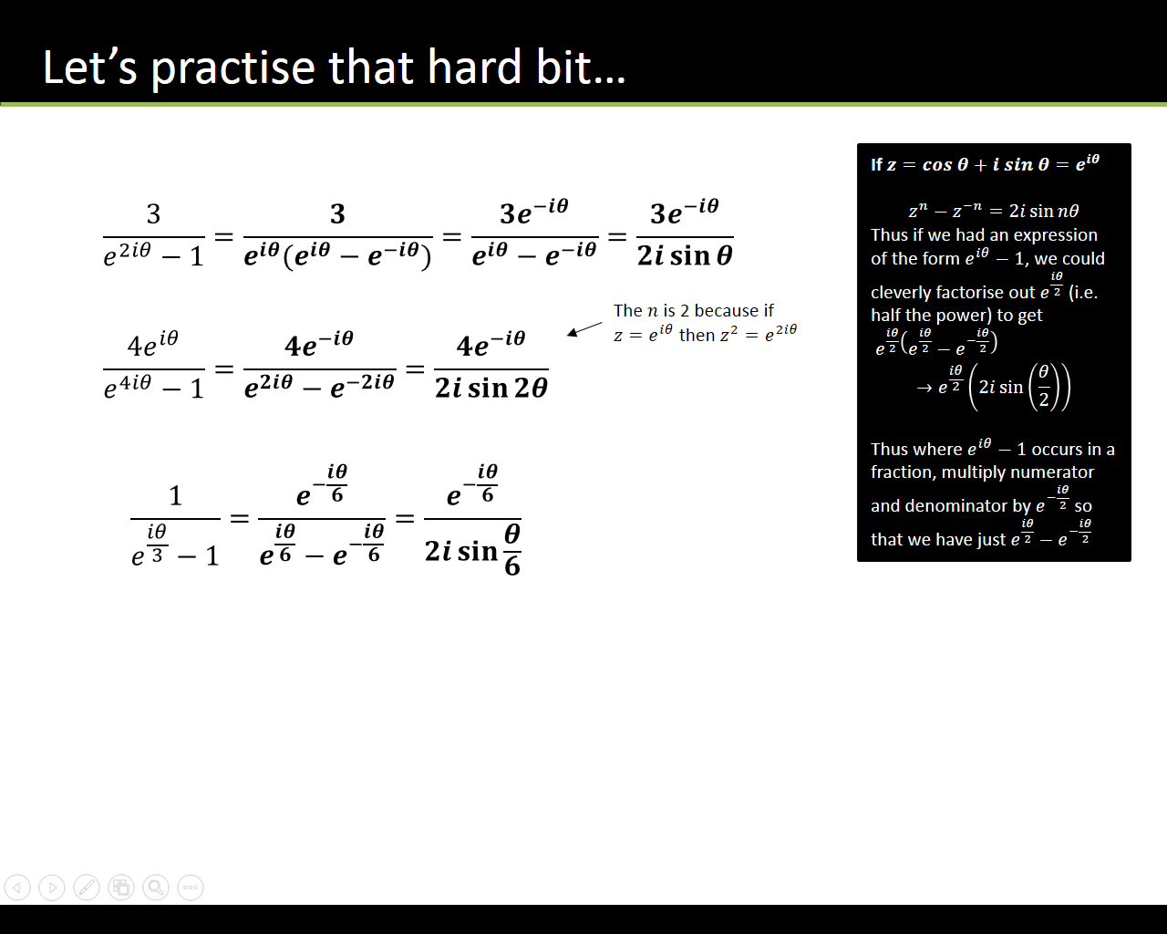

Using mod-arg form to split summations

$e^{iθ}+e^{2iθ}+e^{3iθ}+…+e^{niθ}$**is a geometric series,**

$$∴e^{iθ}+e^{2iθ}+e^{3iθ}+…+e^{niθ}=\frac{e^{iθ}\left(e^{niθ}-1\right)}{e^{iθ}-1}$$

Converting each exponential term to modulus-argument form would allow us to consider the real and imaginary parts of the series separately:

**Example**

$S=e^{iθ}+e^{2iθ}+e^{3iθ}+…+e^{8iθ}$**, for $θ≠2nπ$, where $n$ is an integer.**

1. **Show that $S=\frac{e^{\frac{9iθ}{2}}\sin{4θ}}{\sin{\frac{θ}{2}}}$**

**Let $P=\cos{θ}+\cos{2θ}+\cos{3θ}+…+\cos{8θ}$ and $Q=\sin{θ}+\sin{2θ}+…+\sin{8θ}$**

**(b) Use your answer to part a to show that $P=\cos{\frac{9θ}{2}}\sin{4θ} cosec\frac{θ}{2}$ and find similar expressions for $Q$ and $\frac{Q}{P}$**

**Example**

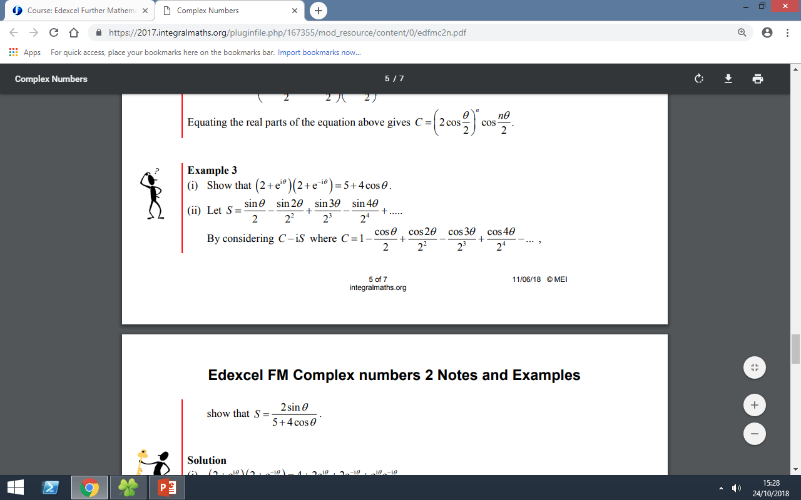

Applications of De’Moivre’s Theorem 2: Roots

De Moivre’s theorem also holds true for rational powers. We can use De Moivre’s to solve equations of the form $z^{n}=w$, where $z,w∈∁$. This is equivalent to finding the nth roots of $w$

The fundamental theorem of algebra holds true for complex numbers:

Hence $z^{n}=w$, where $z,w∈∁$ has n distinct roots.

If w = 1 we call these roots of unity.

To find the roots of a complex equation we use the fact that the argument of a complex number is not unique:

If $z^{n}=r^{n}\left(cosnθ+isinnθ\right)$ then $z=r(\cos\left(θ+2Kπ\right)+isin(θ+2kπ)$)

**Roots of Unity Example**

**Solve $z^{3}=1$**

Method 1: By factorising Method 2: De Moivre’s

Notice:

* The first root will always be 1 since $1^{n}=1$
* We add $\frac{2kπ}{n}$ to the argument but leave the modulus unchanged e.g. when $n=3$ we rotate the line $\frac{2π}{3}$ each time. When $k=n$ we have rotated $\frac{2πn}{n}=2π$ so we get back to where we started.
* The first root is z1 = 1, call the second root z2 = . Then…

Consider $ω^{2}=$

$=$

$=$

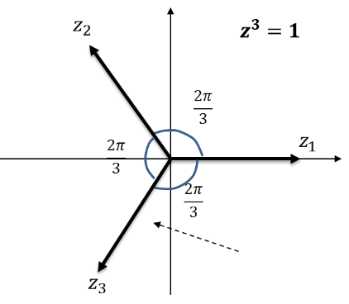What do you notice?

What would z3 be?

The roots of $z^{n}=1$ can be represented as $1, ω, ω^{2}, where ω=e^{\frac{2πi}{n}}.$

Since the resultant ‘vector’ is 0, then $1+ω+ω^{2}=0$

These roots form the vertices of a regular n-gon and all lie on a circle, radius r.

General nth Roots: $z^{n}=w, w≠1$

We can use a similar method when w is not equal to 1. Again, our first step is to write w in mod-arg form and consider multiples of the argument.

**Example**

**Solve $z^{4}=2+2\sqrt{3} i$**

Test your understanding

1. Express the complex number $-2+\left(2\sqrt{3}\right)i$ in the form $r\left(\cos{θ+i\sin{θ}}\right)$, $-π<θ≤π$. (3)
2. Solve the equation $$z^{4}=-2+\left(2\sqrt{3}\right)i$$ 
   giving the roots in the form $r\left(\cos{θ}+i\sin{θ}\right)$, $-π<θ≤π$. (5)

Ex 1F pg 24

Solving Geometric Problems

We have already seen in the previous exercise that the roots of an equation such as that below give evenly spaced points in the Argand diagram, because the modulus remained the same but we kept adding $\frac{2π}{n}$ to the argument.

These points formed a regular hexagon, and in general for $z^{n}=s$, form a regular $n$-agon.

Recall that $ω$ is the first root of unity of $z^{n}=1$:

$ω=\cos\left(\frac{2π}{n}\right)+i\sin\left(\frac{2π}{n}\right)$.

This has modulus 1 and argument $\frac{2π}{n}$.

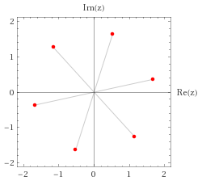

$$z^{6}=7+24i$$

Suppose $z_{1}$ was the first root of $z^{6}=7+24i$. Then consider the product $z_{1}ω$. What happens? Why does this work?

If $z_{1}$ is one root of the equation $z^{6}=s$,

and $1,ω,ω^{2},…,ω^{n-1}$ are the $n$ th roots of unity,

then the roots of $z^{n}=s$ are given by

$z_{1},z_{1}ω,z_{1}ω^{2},…,z_{1}ω^{n-1}$.

Example

The point $P\left(\sqrt{3},1\right)$ lies at one vertex of an equilateral triangle. The centre of the triangle is at the origin.

1. Find the coordinates of the other vertices of the triangle.
2. Find the area of the triangle.

Test your understanding

An equilateral triangle has its centroid located at the origin and a vertex at (1,0). What are the coordinates of the other two vertices?

Ex 1G pg 26