CP1 Chapter 8

Proof by Induction

Chapter Overview

1. Summation Proofs
2. Divisibility Proofs
3. Matrix proofs

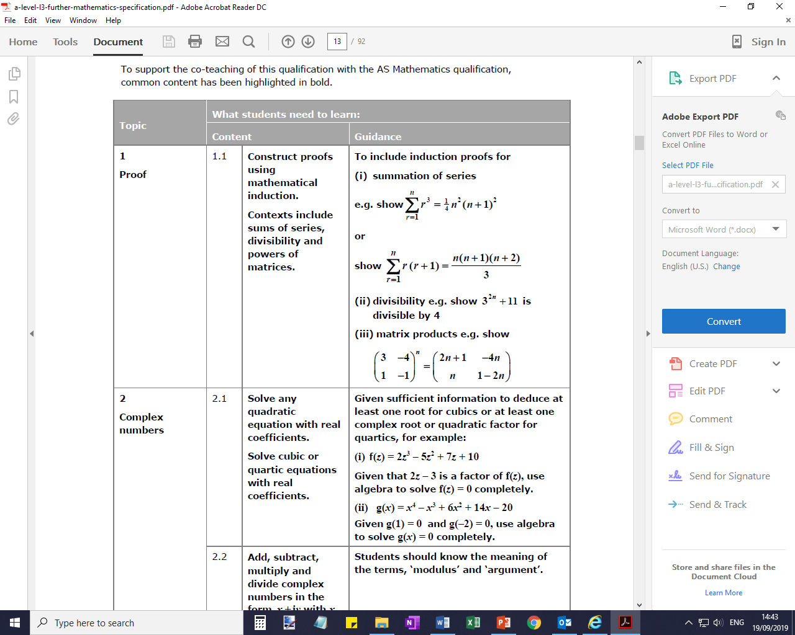

What is poof by induction?

We can often use **proof by induction** whenever we want to show some property holds for all integers (usually positive) up to infinity.

Example

Show that $\sum_{i=1}^{n}{i}=\frac{1}{2}n\left(n+1\right)$ for all $n∈N$.

We can show this is true for certain examples. However, no number of examples are sufficient to show the statement is true for **all** integers $n$.

The key part of induction is that **we need to show that “if the statement is true for a particular value, then it is true for the next value**”.

Basic Example:

Prove by induction that if the first term of a sequence is $a_{1}=3$ and $a_{n+1}=a_{n}+2$, then **every term in the sequence is odd**.

**Proof by induction:**

Step 1: **Basis:** Prove the general statement is true for $n=1$.

Step 2: **Assumption:** Assume the general statement is true for $n=k$.

Step 3: **Inductive:** Show that the general statement is then true for $n=k+1$.

Step 4: **Conclusion:** The general statement is then true for all positive integers $n$.

Type 1: Summation Proofs

Example 1: Show that $\sum_{r=1}^{n}{(2r-1)}=n^{2}$ for all $n∈N$.

Basis step:

Assumption:

Inductive:

Conclusion:

Conclusion step – key points

(For method mark)

**Any 3 of these seen anywhere in the proof:**

* **“true for $n=1$”**
* **“assume true for $n=k$”**
* **“true for $n=k+1$”**
* **“true for all $n$/positive integers”**

Example 2. Prove by induction that for all positive integers $n$,

$$\sum_{r=1}^{n}{r2^{r}}=2\left(1+\left(n-1\right)2^{n}\right)$$

Test Your Understanding

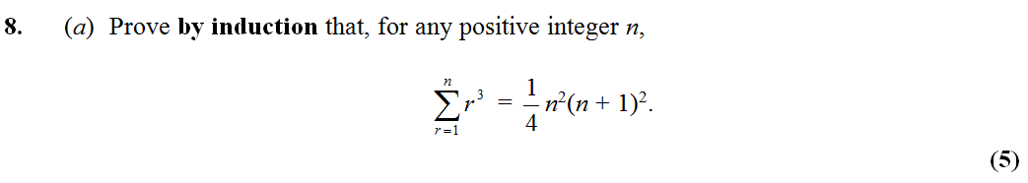

Ex 8A Pages 158-159

Type 2: Divisibility Proofs

There are different techniques for the inductive step. For the following example we will consider 2 different methods.

Example

Prove by induction that $3^{2n}+11$ is divisible by 4 for all positive integers $n$.

Basis step:

Assumption:

Inductive step: method 1 Inductive step: method 2

Conclusion:

Example:

Prove by induction that $8^{n}-3^{n}$ is divisible by 5.

Question:

Prove by induction that $n^{3}-7n+9$ is divisible by 3 for all positive integers $n$.

Ex 8B Pages 162

Type 3: Matrix Proofs

Example

Prove by induction that ${\left(\begin{matrix}1 & -1 \\ 0 & 2\end{matrix}\right)}^{n}=\left(\begin{matrix}1 & 1-2^{n} \\ 0 & 2^{n}\end{matrix}\right)$ for all $n∈Z^{+}$.

Example

Prove by induction that ${\left(\begin{matrix}-2 & 9 \\ -1 & 4\end{matrix}\right)}^{n}=\left(\begin{matrix}-3n+1 & 9n \\ -n & 3n+1\end{matrix}\right)$ for all $n∈Z^{+}$.

Ex 8C Pages 164

Be the examiner!

How many marks does this deserve??



