**Core Pure 1**

**Volumes of Revolution**

Chapter Overview

**1**: Find the volume when a curve is rotated around the $x$-axis.

**2**: Find the volume when a curve is rotated around the $y$-axis.

3: Find more complex volumes by adding/subtracting.



**Revolving around the x-axis**

$\int_{a}^{b}{y dx}$ gives the area bounded between $y=f(x)$, $x=a$, $x=b$ and the $x$-axis.

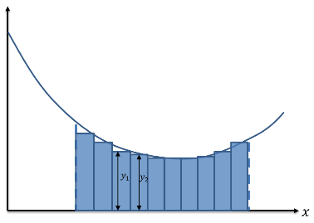

If we split up the area into thin rectangular strips,

each with width $dx$ and each with height the $y=f\left(x\right)$

for that particular value of $x$. Each has area $f\left(x\right)× dx$.

If we had ‘discrete’ strips, the total area would be:

$$Σ_{x=a}^{b} (f\left(x\right) dx)$$

But because the strips are infinitely small and we have to think continuously, we use $∫$ instead of $Σ$.

Integration therefore can be thought of as a continuous version of summation.

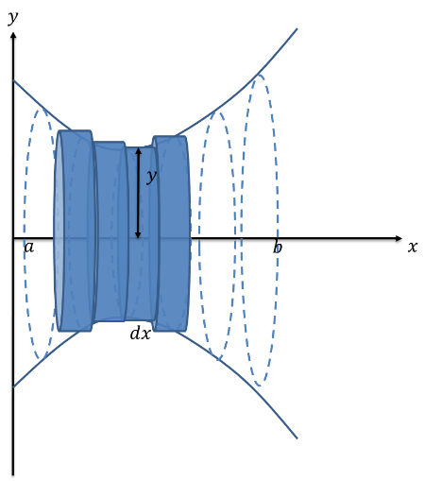

Now suppose we spun the line $y=f(x)$ about the

$x$ axis to form a solid (known as a *volume of revolution*)

**Examples**

1. The region $R$ is bounded by the $y$-axis, the curve with equation

$$y=\sqrt{(6x^{2} - 3x + 2)}$$

and the lines x = 1 and x = 2 . The region is rotated through $360°$ about

the $x$-axis. Find the exact volume of the solid generated.

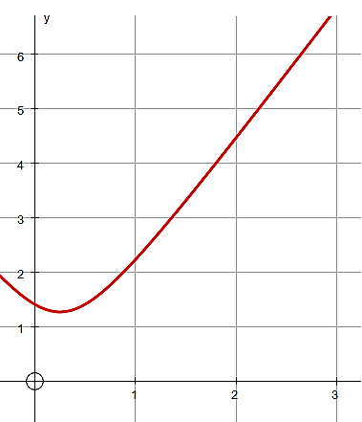

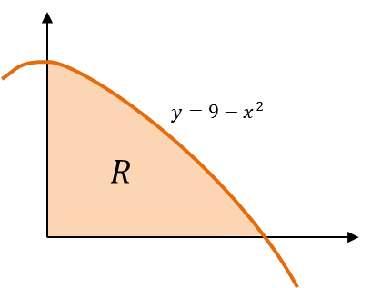2. The diagram shows the region $R$ which is bounded by the $x$-axis, the $y$-axis and the curve with equation $y=9-x^{2}$. The region is rotated through $360°$ about the $x$-axis. Find the exact volume of the solid generated.

Test Your Understanding

$$y={\left(x^{\frac{2}{3}}-9\right)}^{\frac{1}{2}}$$

The finite region *R* which is bounded by the curve *C*, the *x*-axis and the line *x* = 125 is shown shaded in Figure 3. This region is rotated through $360°$ about the *x*-axis to form a solid of revolution.

Use calculus to find the exact value of the volume of the solid of revolution.  **(5)**

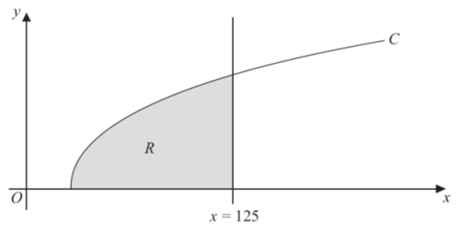

Ex 5a Pg 73-75

**Revolving around the y-axis**

**Examples**

1. R is the area enclosed by the curve with equation $y=\sqrt{x^{2}+5},$ the $y$-axis and the lines $y=3$ and $y=6$. The region is rotated through $360°$ about the $y$-axis. Find the volume of the solid generated.

2. The diagram shows the curve with equation $y=\sqrt{x-1}$. The region $R$ is bounded by the curve, the $y$-axis and the lines $y=1$ and $y=3$. The region is rotated through $360°$ about the $y$-axis. Find the volume of the solid generated.

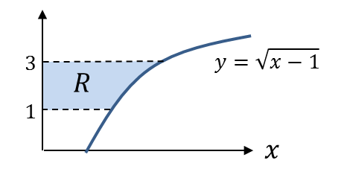

Test your Understanding

A curve has equation $y=\sqrt[3]{2x+1}$. The region $R$ is bounded by the curve, the $y$-axis and the lines $y=2$ and $y=4$. The region is rotated through $360°$ about the $y$-axis. Find the volume of the solid generated.

Ex 5b Pg 77-78

**Adding and Subtracting Volumes**

With more complex volumes you may need to consider compound areas or volumes of general shapes.

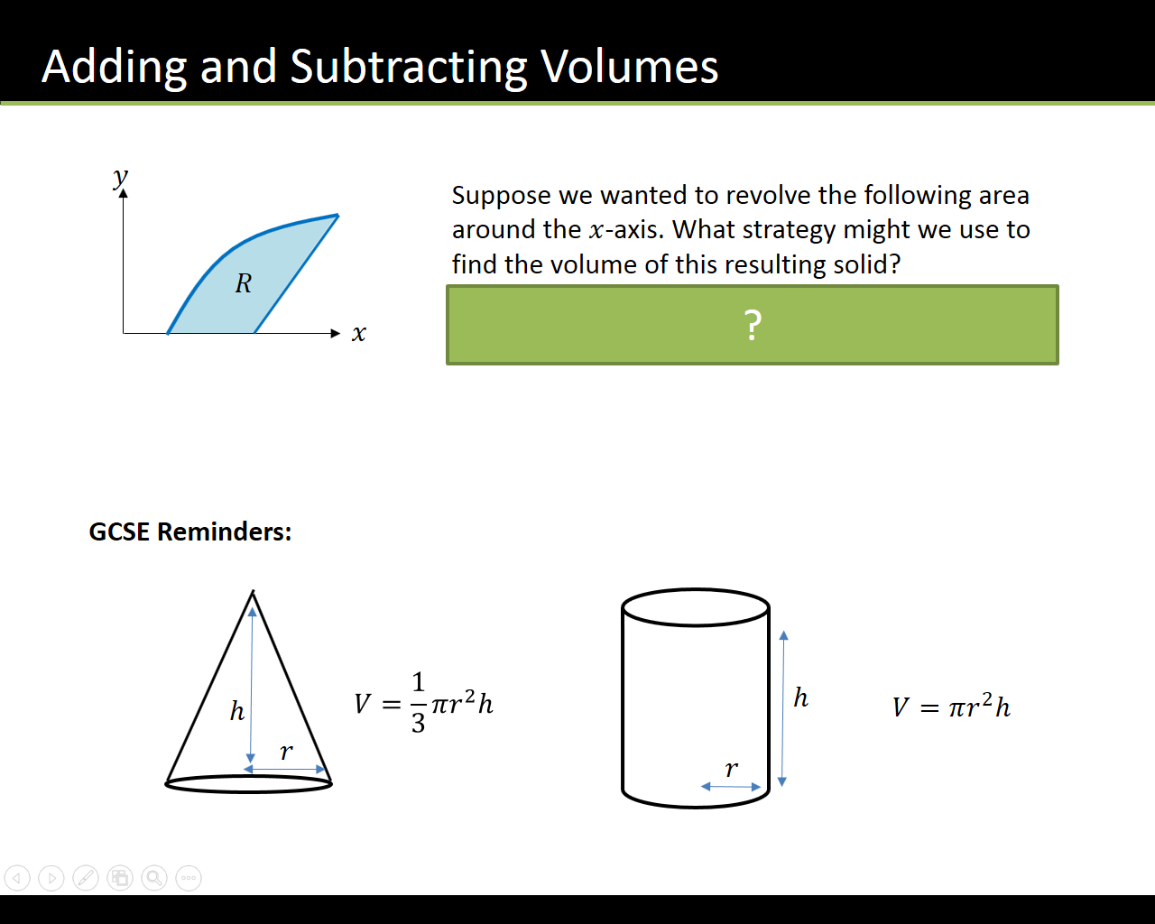

Example

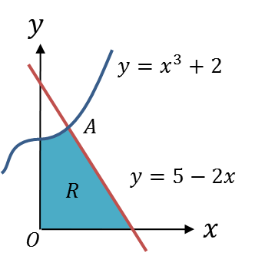The region $R$ is bounded by the curve with equation $y=x^{3}+2$, the line $y=5-2x$ and $x$ and $y$-axes.

1. Verify that the coordinates of $A$ are $\left(1,3\right)$.

A solid is created by rotating the region $360°$ about the $x$-axis.

(b) Find the volume of this solid.

**Example**

The diagram shows the region $R$ bounded by the curves with equations $y=\sqrt{x}$ and $y=\frac{1}{8x}$ and the line $x=1$.

The region is rotated through $360°$ about the $x$-axis. Find the exact volume of the solid generated.

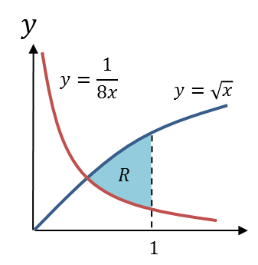

Test Your Understanding

The area between the lines with equations $y=x$ and $y=\sqrt[3]{x}$, where $x≥0$ is rotated $360°$ about the $x$-axis. Determine the volume of the solid generated.

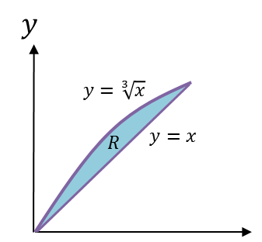

Ex 5C Pg 81-83

**Modelling with Volumes of revolution**

Eg. In the 1990 film ‘Ghost’. Patrick Swayze (now sadly, also no longer living) is shot, only to come back as a ghost to resolve ‘unfinished ghost business’. In one iconic scene, he engages in some saucy ghost-pottery with fiancé Demi Moore (who is not dead).

The filmmakers want to know how much clay to buy. The equation of the outside curve can be modelled with the equation

$$x=\frac{1}{100}{\left(y-30\right)}^{2}+10$$

where $x$ and $y$ are in cm. The pottery spins about the $y$-axis. If the height of the resulting pottery will be 40cm, determine the volume of clay needed, giving your answer to 3 significant figures.

Test Your Understanding

A manufacturer wants to cast a prototype for a new design for a pen barrel out of solid resin. The shaded region shown in the diagram is used as a model for the cross-section of the pen barrel. The region is bounded by the $x$-axis and the curve with equation $y=k-100x^{2}$, and will be rotated around the $y$-axis. Each unit on the coordinate axes represents 1cm.

(a) Suggest a suitable value for $k$. ***(Let’s say pens are 10cm long)***

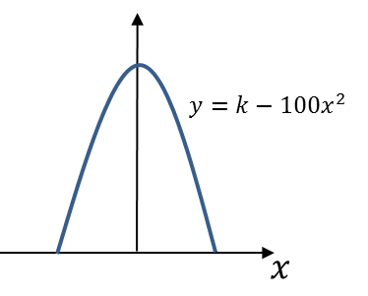(b) Use your value of $k$ to estimate the volume of resin needed to make the prototype.

(c) State one limitation of this model.

Ex 5D Pg 84-86