**Core Pure 1**

**Roots of Polynomials**

*Course Overview*

1. Use relationships between coefficients and roots of a quadratic, cubic or quartic equation.

2. Find the value of expressions based on the roots of a polynomial.

3. Find the new polynomial when the roots undergo a linear transformation.



**Roots of Polynomials**

The purpose of this chapter is to understand the underlying relationship between the **roots** of a polynomial, and the **coefficients** of each term.

**Roots of Quadratics**

If $α$ and $β$ are the roots of a quadratic $ax^{2}+bx+c$ then

$$ax^{2}+bx+c≡a\left(x-α\right)\left(x-β\right)$$

$$=$$

$$=$$

This pattern generalises to higher order polynomials which will be discussed further later on.

**Quadratic Example**

**The roots of the quadratic equation $2x^{2}-5x-4=0$ are $α$ and $β$. Without solving the equation, find the values of:**

**(a) $α+β$**

**(b) $αβ$**

**(c) $\frac{1}{α}+\frac{1}{β}$**

**(d) $α^{2}+β^{2}$**

***Question***

**The roots of the quadratic equation $3x^{2}-4x+2=0$ are $α$ and $β$. Without solving the equation, find the values of:**

**(a) $α+β$**

**(b) $αβ$**

**(c) $\frac{1}{α}+\frac{1}{β}$**

**(d) $α^{2}+β^{2}$**

**Example**

**The roots of a quadratic equation $ax^{2}+bx+c=0$ are $α=-\frac{3}{2}$ and $β=\frac{5}{4}$. Find integer values for $a, b$ and $c$.**

***Test Your Understanding***

1. **For the quadratic $x^{2}+2x+3$, find:**

1. **The sum of the roots.**
2. **The product of the roots.**

2. **If the roots of a quadratic equation $ax^{2}+bx+c=0$ are $α=\frac{2}{3}$ and $β=\frac{1}{5}$, determine integer values for $a,b,c$.**

Ex 4a pg 56-57

**Roots of Cubics**

By the Fundamental Theorem of Algebra, a cubic equation $ax^{3}+bx^{2}+cx+d=0$ always has 3 (potentially repeated) roots, $α,β,γ$. We saw in the previous chapters that these could be…



**Example**

**Find a cubic equation with roots 2, -1 and -3.**

**Example**

1.  **and are the roots of the cubic equation $2x^{3}+3x^{2}-4x+2=0$. Without solving the equation, find the values of:**

**(a)**

**(b)**

**(c)**

**(d)**

2. **The roots of a cubic equation $ax^{3}+bx^{2}+cx+d=0$ are $α=1-2i$, $β=1+2i$ and $γ=2$. Find integers values for $a,b,c$ and $d$.**

Ex 4b pg 58-59

**Roots of Quartics**

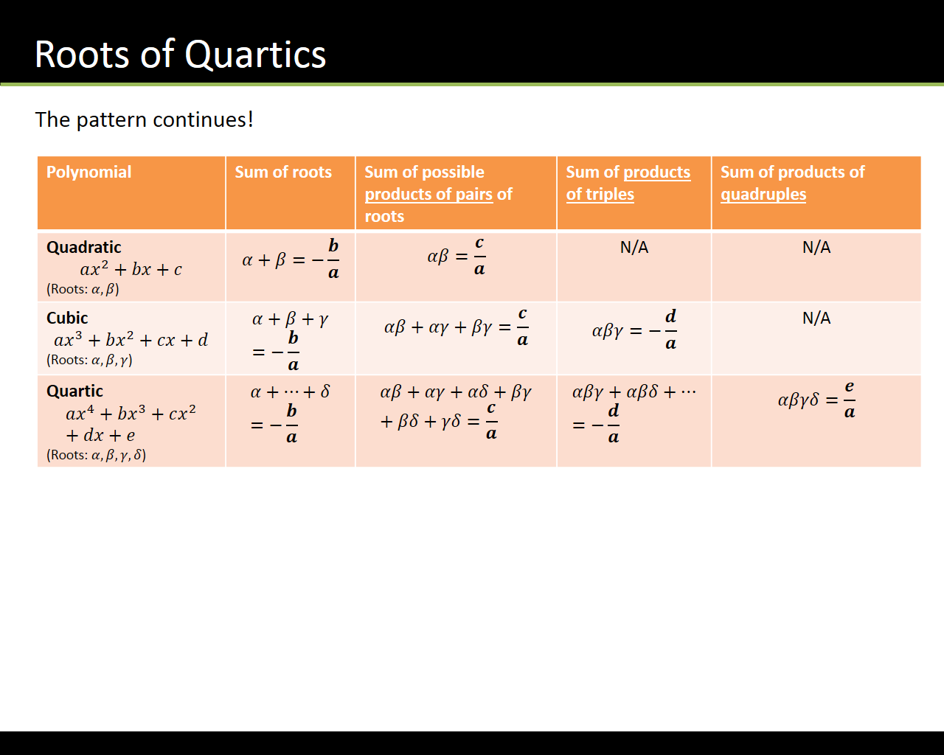

**Example**

**Find the quartic equation with roots 1, -2 and 3 (repeated).**

**Example**

**The equation $x^{4}+2x^{3}+px^{2}+qx-60=0, x∈C, p,q∈R$, has roots $α, β,γ,δ$. Given that $γ=-2+4i$ and $δ=γ^{*}$.**

1. **Show that $α+β-2=0$ and that $αβ+3=0$**
2. **Hence find all the roots of the quartic equation and find the values of $p$ and $q$.**

Ex 4C pg 60-61

**Expressions Related to the Roots of Polynomials**

**Sums of squares**:

* Quadratic: $α^{2}+β^{2}={\left(α+β\right)}^{2}-2αβ$
* Cubic: $α^{2}+β^{2}+γ^{2}={\left(α+β+γ\right)}^{2}-2(αβ+βγ+γα)$
* Quartic: $α^{2}+β^{2}+γ^{2}+δ^{2}={\left(α+β+γ+δ\right)}^{2}-2(αβ+ αβ+αγ+βγ+…)$

**Sums of cubes**:

* Quadratic: $α^{3}+β^{3}={\left(α+β\right)}^{3}-3αβ\left(α+β\right)$
* Cubic: $α^{3}+β^{3}+γ^{3}={\left(α+β+γ\right)}^{3}-3\left(α+β+γ\right)\left(αβ+ βγ+γα\right)+3αβγ$

**Reciprocals:**

* Quadratic: $\frac{1}{α}+\frac{1}{β}=\frac{α+β}{αβ}$
* Cubic: $\frac{1}{α}+\frac{1}{β}+\frac{1}{γ}=\frac{αβ+βγ+γα}{αβγ}$
* Quartic: $\frac{1}{α}+\frac{1}{β}+\frac{1}{γ}+\frac{1}{δ}=\frac{Σαβγ}{αβγδ}$

**Products of Powers**

* Quadratic: $α^{n}+β^{n}={\left(αβ\right)}^{n}$
* Cubic: ${\left(α+β+γ\right)}^{n}=(αβ{γ)}^{n}$
* Quartic: ${\left(α+β+γ+δ\right)}^{n}=(αβ{γδ)}^{n}$

**Example**

**The three roots of a cubic equation are $α,β$ and $γ$. Given that $αβγ=4$, $αβ+βγ+γα=-5$ and $α+β+γ=3$, find the value of**

$$\left(α+3\right)\left(β+3\right)(γ+3)$$

Ex 4D pg 63-64

**Linear Transformations of Roots**

We can use the general results regarding roots of polynomials to find an equation whose roots are related to the roots of the original equation i.e. the roots of the new equation are simply a linear transformation of the original roots.

**Example**

**The polynomial $x^{2}-3x-10=0$ has the roots $α$ and $β$. Without finding the roots, determine the equation with roots $α-1$ and $β-1$.**

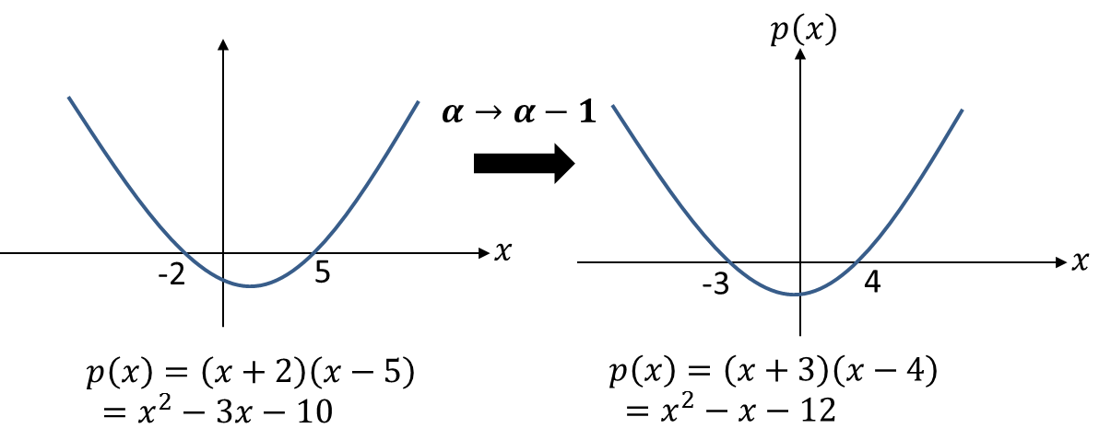

2 Methods:

**Example**

**The quartic equation $x^{4}-3x^{3}+15x+1=0$ has roots $α, β,γ,δ$. Find the equation with roots $(2α+1)$, $\left(2β+1\right)$, $\left(2γ+1\right)$ and $(2δ+1)$.**

***Test Your Understanding***

**The cubic equation $x^{3}-2x^{2}+4=0$ has roots $α, β,γ$. Find the equation with roots $(3α-1)$, $\left(3β-1\right) and \left(3γ-1\right).$**

Ex 4E pg 66-67