Core Pure 1

Argand diagrams

Chapter Overview

**1**: Represent complex numbers on an Argand Diagram.

**2**: Put a complex number in modulus-argument form.

**3:** Identify loci and regions.

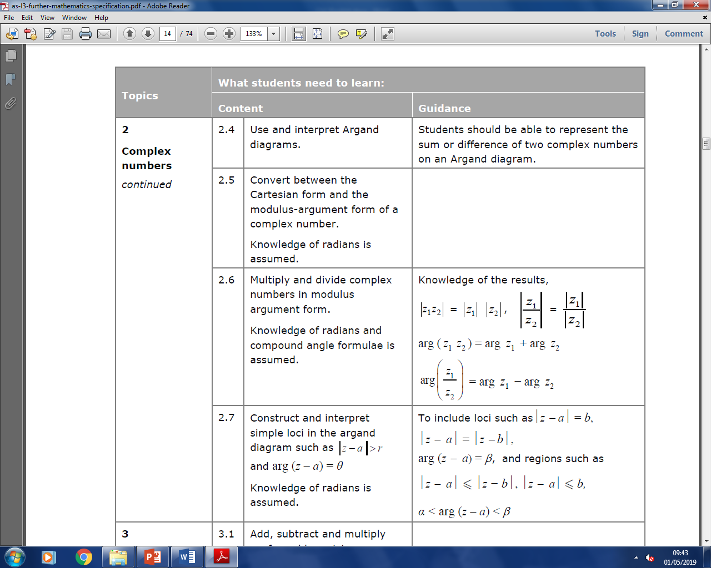

Argand diagrams

Just as $x$- $y$ axes were a useful way to visualise coordinates, an Argand diagram allows us to visualise complex numbers.

$Re$ is a function which gives you the real part of a complex number. e.g. $Re\left(3+2i\right)=3$.

$$Im(z)$$

$$Re(z)$$

-3 -2 -1 1 2 3

3

2

1

-1

-2

-3

Exercise 2A Page 19

Examples

Determine the modulus and argument of:



$5+12i$

$-1+i$

$-2i$

$-1-3i$

$$Re[z]$$

$$Im[z]$$

12

$$θ$$

5

$\left|z\right|=\sqrt{5^{2}+{12}^{2}}=13$ $\arg\left(z\right)=\tan^{-1}\left(\frac{12}{5}\right)$ $=1.18$ (3sf)

$$Re[z]$$

$$Im[z]$$

1

$$θ$$

1

$\left|z\right|=\sqrt{1^{2}+1^{2}}=\sqrt{2}$ $$\arg\left(z\right)=π-\tan^{-1}\left(\frac{1}{1}\right)=\frac{3}{4}π$$

$$Re[z]$$

$$Im[z]$$

$$θ$$

2

$\left|z\right|=2$ $\arg\left(z\right)=-\frac{π}{2}$

**The argument is given as an angle between $-π<\arg\left(z\right)≤π$**

$$Re[z]$$

$$Im[z]$$

$$θ$$

1

$\left|z\right|=\sqrt{1^{2}+3^{2}}=\sqrt{10}$ $$=1.89$$

We could have also used $π-\tan^{-1}\left(\frac{3}{1}\right)$

3

a

b

c

d

?

?

?

?

**Modulus and argument**

$4+3i$ is plotted on an Argand diagram.

1. What is its distance from the origin?
2. What is its anti-clockwise angle from the positive real axis? (in radians)

$$Re[z]$$

$$Im[z]$$

4

3

$$θ$$

a)

b)

These are respectively known as the modulus $|z|$ and argument $arg⁡(z)$ of a complex number.

Examples

Determine the modulus and argument of:



$5+12i$

$-1+i$

$-2i$

$-1-3i$

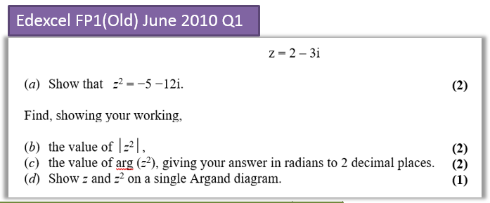

Exercise 2B Page 21

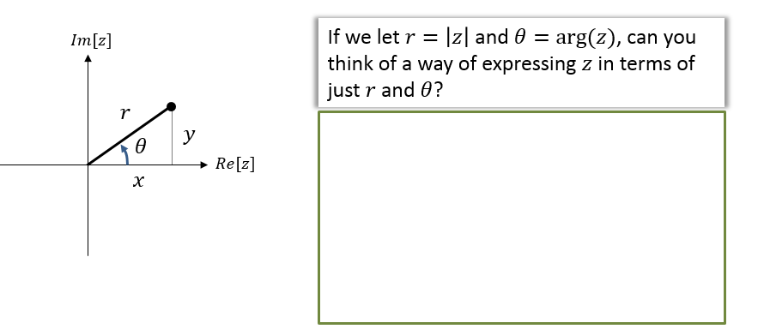

Modulus-Argument Form

**Context: $\left(r,θ\right)$** is known as a polar coordinate and you learn about these in Core Pure Year 2. Instead of coordinates being specified by their $x$ and $y$ position (known as a Cartesian coordinate), they are specified by their distance from the origin (the ‘pole’) and their rotation.

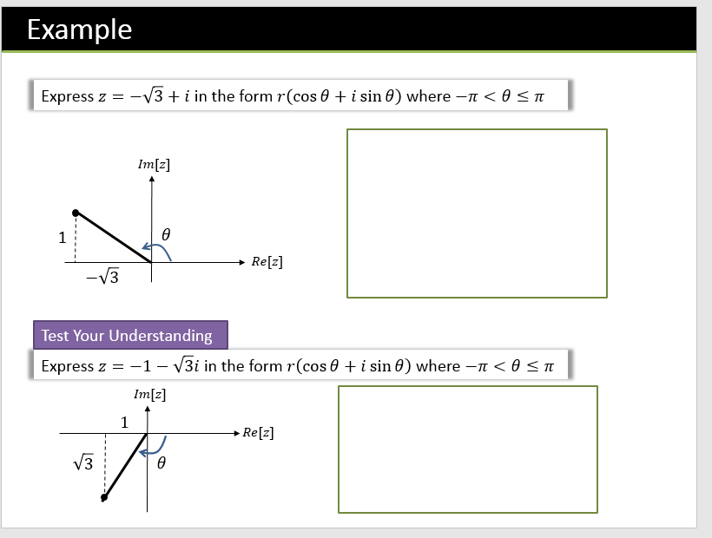

Exercise 2C Page 24

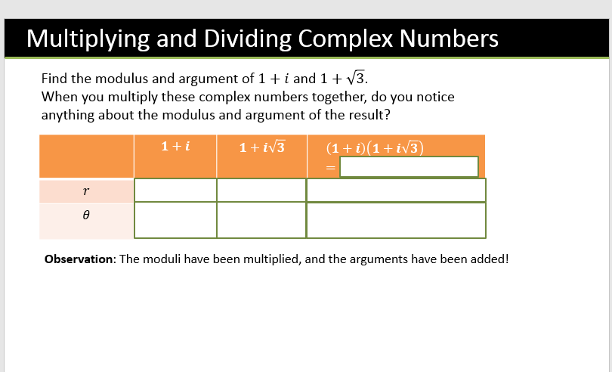

**Proof (not assessed):**

Recall from Pure Year 2 that:

$$sin\left(a+b\right)=sin a cos b+cos a sin bcos\left(a+b\right)=cos a cos b-sin a sin b$$

Let $z_{1}=r_{1}\left(\cos{θ_{1}}+i\sin{θ_{1}}\right)$ and $z_{1}=r_{1}\left(\cos{θ_{2}}+i\sin{θ_{2}}\right)$.

Then $z_{1}z_{2}=r_{1}r_{2}\left[\left(\cos{θ_{1}}\cos{θ_{2}}-\sin{θ_{1}}\sin{θ_{2}}\right)+i\left(\sin{θ_{1}}\cos{θ_{2}}+\sin{θ_{1}}\cos{θ_{2}}\right)\right]$

$=r_{1}r_{2}\left[\cos\left(θ_{1}+θ_{2}\right)+i\sin\left(θ_{1}+θ_{2}\right)\right]$

So $\left|z_{1}z_{2}\right|=r_{1}r_{2}=\left|z_{1}\right|\left|z_{2}\right|$

and $arg\left(z_{1}z_{2}\right)=θ_{1}+θ_{2}=\arg\left(z_{1}\right)+\arg\left(z_{2}\right)$

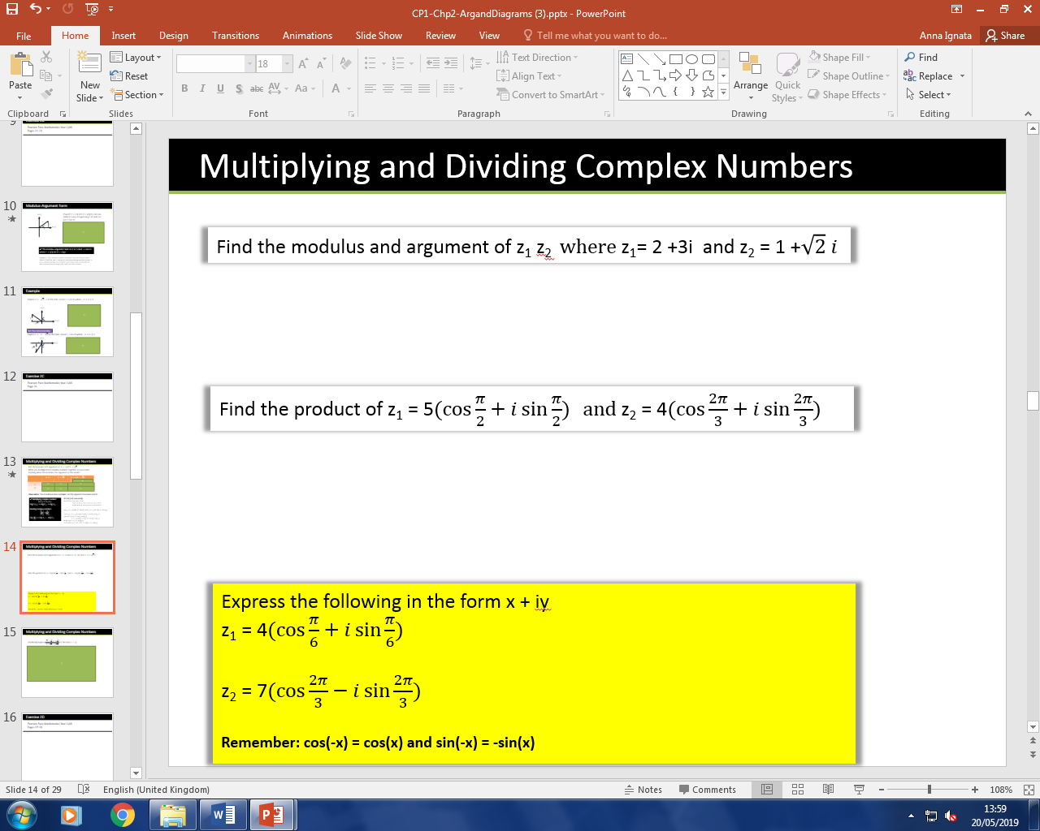

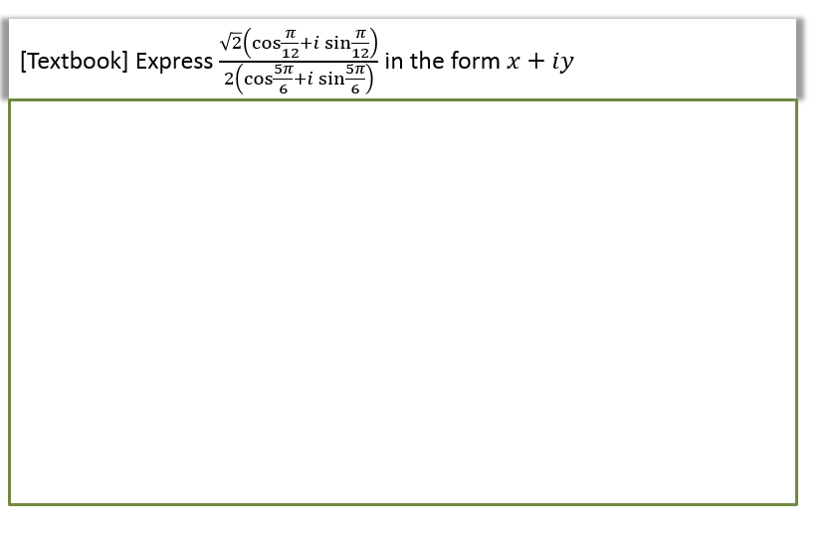

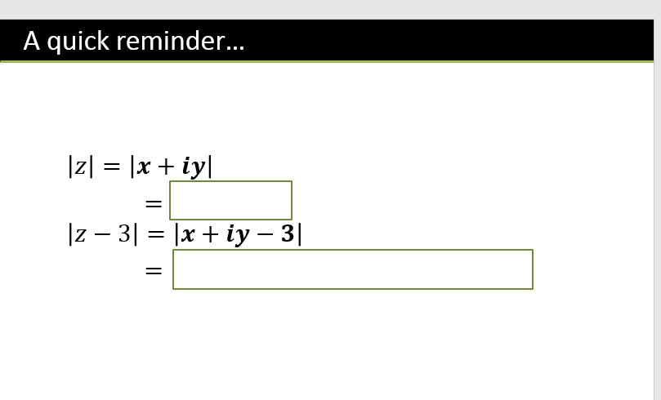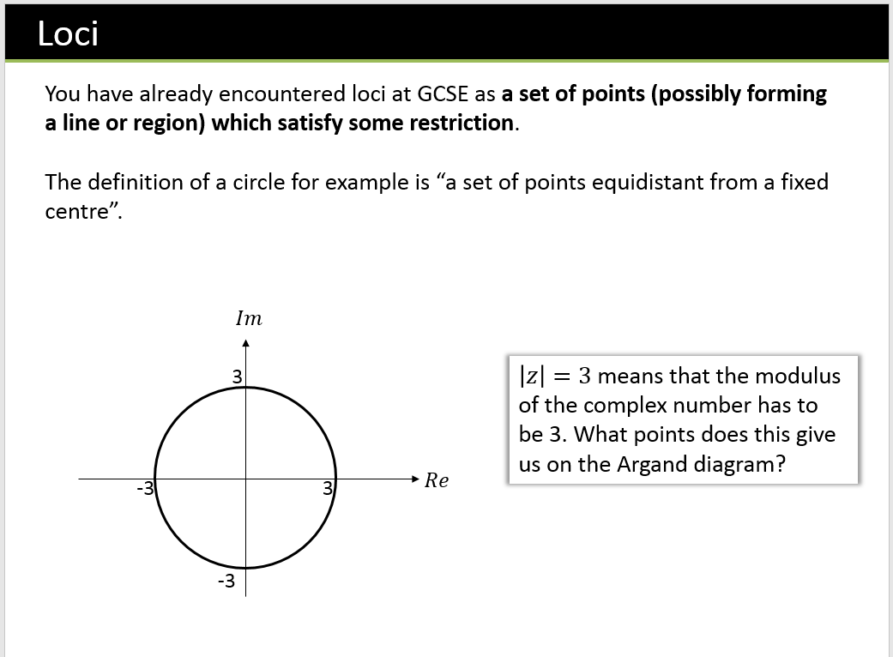

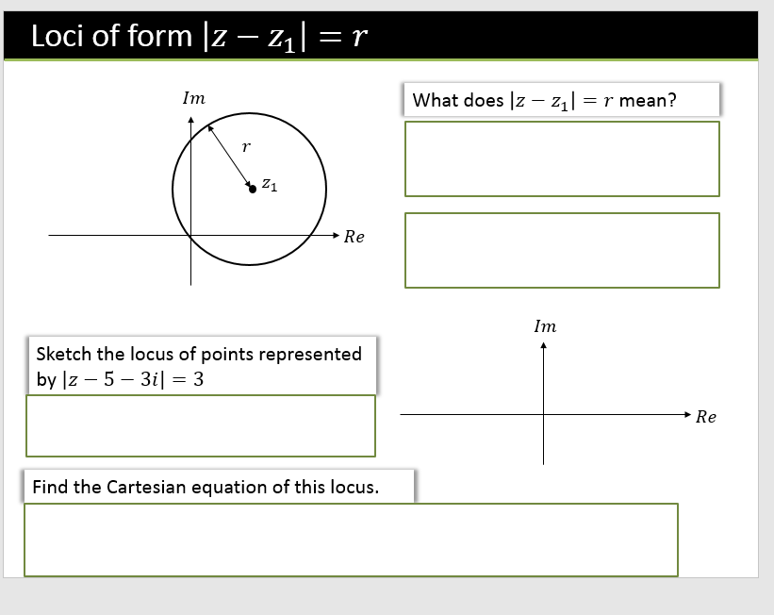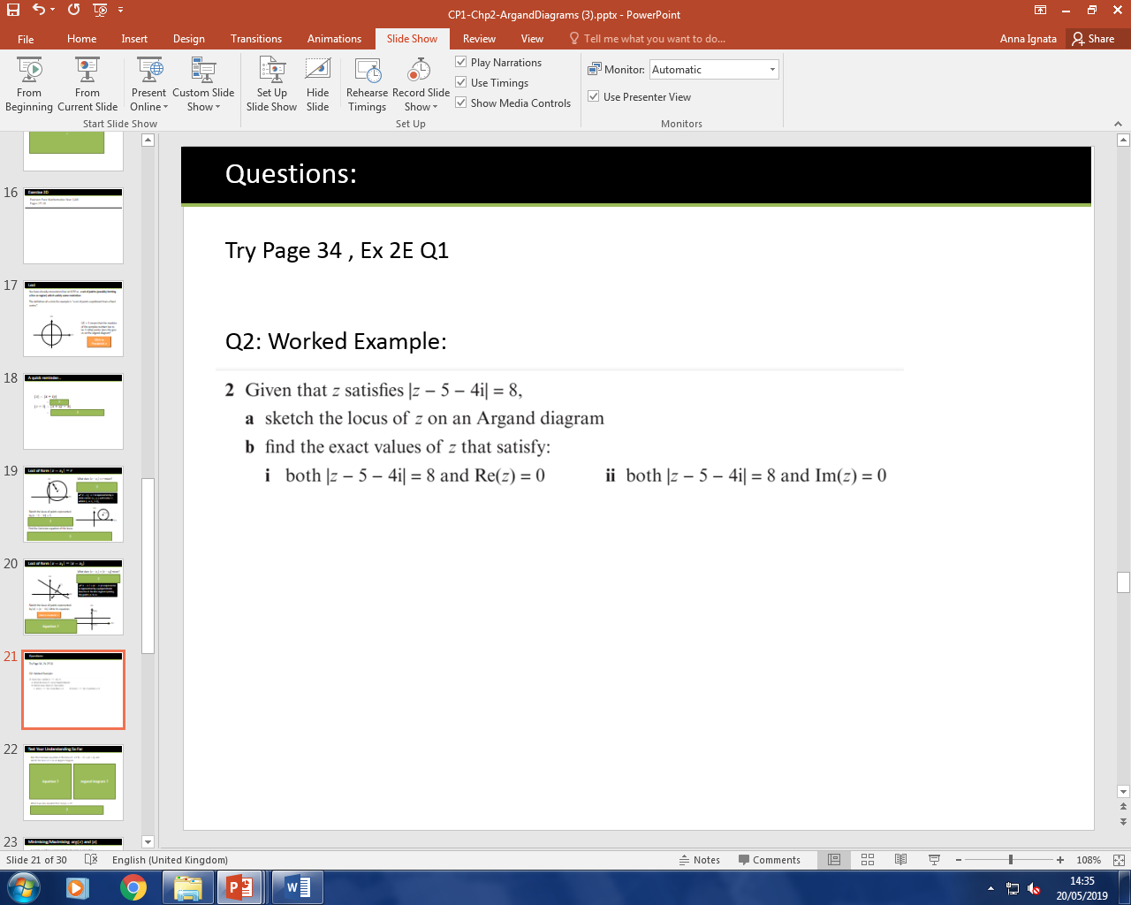

What does $\left|z-z_{1}\right|=\left|z-z_{2}\right|$ mean?

Loci of form $\left|z-z_{1}\right|=\left|z-z_{2}\right|$



Example,

Sketch the locus of points represented by $\left|z\right|=|z-6i|$. Write its equation.

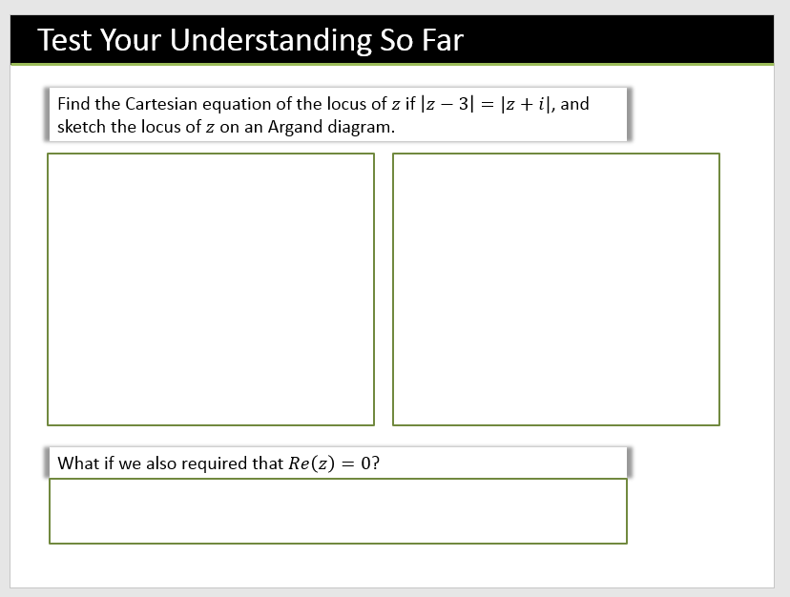

Minimising/Maximising $arg⁡(z)$ and $|z|$

A complex number $z$ is represented by the point $P$. Given that $\left|z-5-3i\right|=3$

1. Sketch the locus of $P$
2. Find the Cartesian equation of the locus.
3. Find the maximum value of $\arg{z}$ in the interval $\left(-π,π\right)$
4. Find the minimum and maximum values of $|z|$

We did this earlier…

1. b)

c)

d)

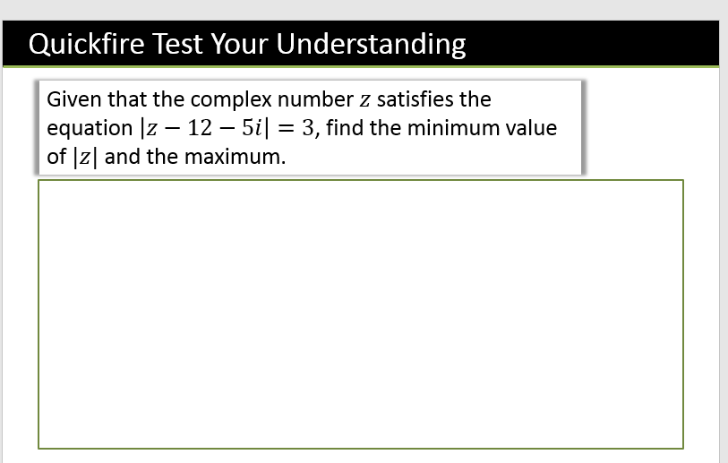

(From earlier) Find the Cartesian equation of the locus of $z$ if $\left|z-3\right|=|z+i|$, and sketch the locus of $z$ on an Argand diagram.

Minimising $|z|$ with perpendicular bisectors

**Hence, find the least possible value of $|z|$.**

$\arg\left(z\right)=\frac{π}{6}$?

$\arg\left(z-z_{1}\right)=θ$

$\arg\left(z+3+2i\right)=\frac{3π}{4}$?

