**Core Pure 1**

**Complex Numbers**

Chapter Overview

**1**: Understand and manipulate ($×, ÷$) complex numbers.

**2**: Find complex solutions to quadratic equations.

3: Find complex solutions to cubic and quartic equations.





Complex Number Basics

Examples: Write the following in terms of $i$

$√(-36)=$ $\sqrt{-1}=$

$\sqrt{-4}=$ $\sqrt{-7}=$

Simplify:

$\left(2+3i\right)+\left(4+i\right)=$

$i-3\left(2-i\right)=$

$\frac{10+4i}{2}$ =

Solving Quadratic Equations

Examples

1. Solve $z^{2}+25=0$
2. Solve $z^{2}+3z+5=0$

Exercise 1A/B Page 3 – 5

Multiplying Complex Numbers

Examples

1. Express each of the following in the form $a+bi$, where $a,b$ are integers.

$\left(2+3i\right)\left(3-2i\right)$

${\left(5-3i\right)}^{2}$

4. Determine the value of $i^{3}, i^{4}, i^{101}$ and ${\left(3i\right)}^{5}$

Test Your Understanding:

1. Edexcel FP1 June 2010

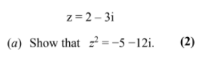

1. Expand and simplify ${\left(1+i\right)}^{3}$

Exercise 1C Page 6

Complex conjugates

Example:

Write $\frac{5+4i}{2-3i}$ in the form $a+bi$

Test Your Understanding

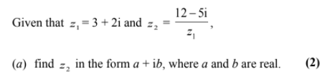

Exercise 1D Page 7-8

Roots of Polynomials

Example 1: Find the quadratic equation with roots α = 2+ 4i and β = 2 – 4i in the form $x^{2}+ax+b=0$

(2 Methods)

Roots of Quadratics

Example 1: Find the quadratic equation with roots α = 2+ 4i and β = 2 – 4i in the form $x^{2}+ax+b=0$

(2 Methods)

Example:

Find the quadratic equation with roots α = 2+ 4i and β = 2 – 4i in the form $x^{2}+ax+b=0$

(2 Methods)

[Textbook] Given that $α=7+2i$ is one of the roots of a quadratic equation with real coefficients,

(a) state the value of the other root, $β$.

(b) find the quadratic equation.

Proof that Complex Roots Appear in Complex Pairs

Proof 1

Example 1: Find the quadratic equation with roots α = 2+ 4i and β = 2 – 4i in the form $x^{2}+ax+b=0$

(2 Methods)

Proof 2

Example 1: Find the quadratic equation with roots α = 2+ 4i and β = 2 – 4i in the form $x^{2}+ax+b=0$

(2 Methods)

Test Your Understanding

Exercise 1E Page 9 -10

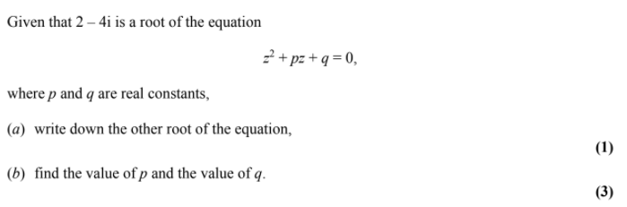

Roots of Cubic and Quartic Equations

Cubics

Quartics

Example 1: Find the quadratic equation with roots α = 2+ 4i and β = 2 – 4i in the form $x^{2}+ax+b=0$

(2 Methods)

Quartics

Example 1: Find the quadratic equation with roots α = 2+ 4i and β = 2 – 4i in the form $x^{2}+ax+b=0$

(2 Methods)

Examples

1. [Textbook] Given that $3+i$ is a root of the quartic equation

$2z^{4}-3z^{3}-39z^{2}+120z-50=0$, solve the equation completely.

2. [Textbook] Show that $z^{2}+4$ is a factor of $z^{4}-2z^{3}+21z^{2}-8z+68$. Hence solve the equation $z^{4}-2z^{3}+21z^{2}-8z+68=0$

Test Your Understanding:

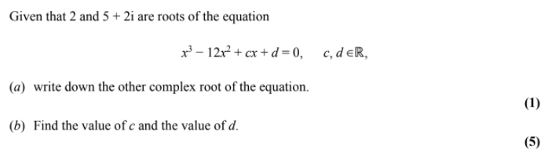

Exercise 1F Page 13 - 14