CP1 Chapter 8
Proof by Induction

Chapter Overview
- Summation Proofs
- Divisibility Proofs
- Matrix proofs

What is poof by induction?

We can often use proof by induction whenever we want to show some property holds for all integers (usually positive) up to infinity.

Example
Show that $\sum_{i=1}^{n}{i}=\frac{1}{2}n\left(n+1\right)$ for all $n∈N$.

We can show this is true for certain examples. However, no number of examples are sufficient to show the statement is true for all integers $n$.
The key part of induction is that we need to show that “if the statement is true for a particular value, then it is true for the next value”.

Basic Example:
Prove by induction that if the first term of a sequence is $a_{1}=3$ and $a_{n+1}=a_{n}+2$, then every term in the sequence is odd.

Proof by induction:
Step 1: Basis: Prove the general statement is true for $n=1$.
Step 2: Assumption: Assume the general statement is true for $n=k$.
Step 3: Inductive: Show that the general statement is then true for $n=k+1$.
Step 4: Conclusion: The general statement is then true for all positive integers $n$.

Type 1: Summation Proofs
Example 1: Show that $\sum_{r=1}^{n}{(2r-1)}=n^{2}$ for all $n∈N$.

Basis step:

Assumption:

Inductive:

Conclusion:

Conclusion step – key points

(For method mark)
Any 3 of these seen anywhere in the proof:
- “true for $n=1$”
- “assume true for $n=k$”
- “true for $n=k+1$”
- “true for all $n$/positive integers”

Example 2. Prove by induction that for all positive integers $n$,
$$\sum_{r=1}^{n}{r2^{r}}=2\left(1+\left(n-1\right)2^{n}\right)$$

Test Your Understanding
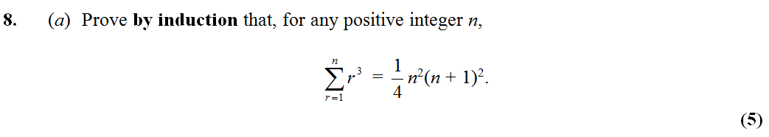

Ex 8A Pages 158-159

