Consistency of Linear Equations
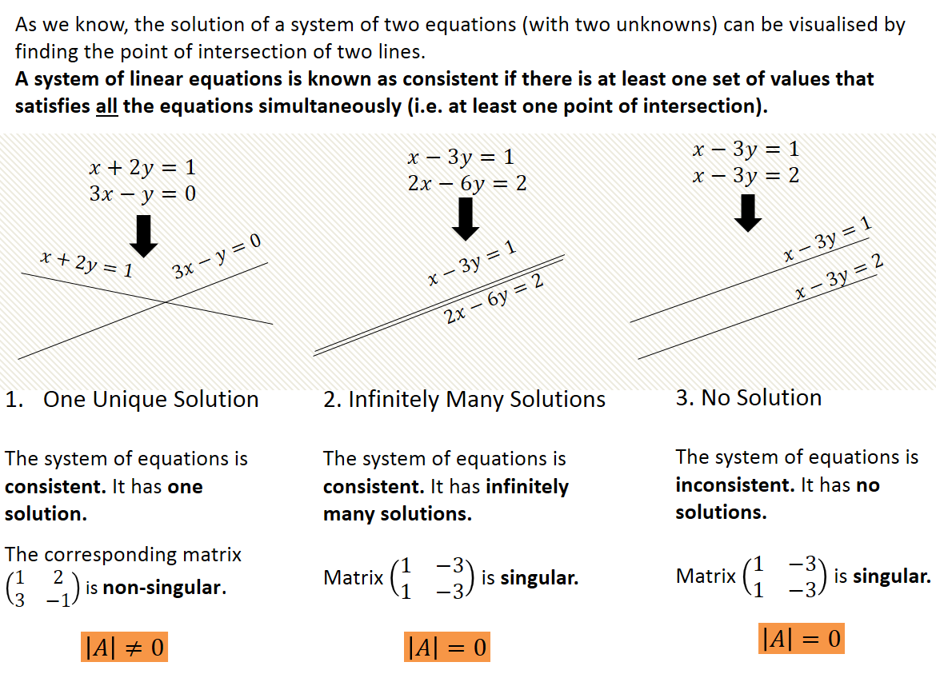

Extending to 3 Variables
Again, we get solutions to the system of linear equations when all of the planes intersect.
Consider the possible outcomes for a set of 3 planes:

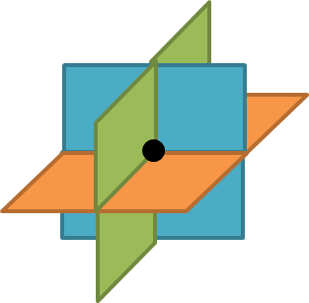
Scenario 1

Scenario 2
1.

2.

Scenario 3
1.

2.

To classify solutions, we should:
- First check for identical planes (equations which are equivalent) and therefore infinite solutions or parallel planes and therefore no solutions.

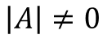
- Next find the value of det A. If the system of equations is consistent and there exists one unique solution.

- If det A = 0 we have to check for parallel planes, either by sight (rows of matrix A are multiples) or by eliminating a variable and looking at the resulting linear equations…….

- If the resulting 2d linear equations represent the same line then the original equations are consistent and therefore form a sheaf.

- Otherwise, the planes form a prism and the system is inconsistent with no unique solution. (Parallel planes can be eliminated from the original equations)

Example
A system of equations is shown below:
$$3x-ky-6z=k$$
$$kx+3y+3z=2$$
$$-3x-y+3z=-2$$
For each of the following values of $k$, determine whether the system of equations is consistent or inconsistent. If the system is consistent, determine whether there is a unique solution or an infinity of solutions. In each case, identify the geometric configuration of the plane corresponding to each value of $k$.
(a) $k=0$ (b) $k=1$ (c) $k=-6$

Test Your Understanding
The system of equations is consistent and has a single solution. Determine the possible values of $k$.
$$2x+3y-z=13$$
$$3x-y+kz=11$$
$$x+y+z=7$$
Ex 6F Pg 120

