Inverting a 3 x 3 Matrix

Example

Using your Calculator
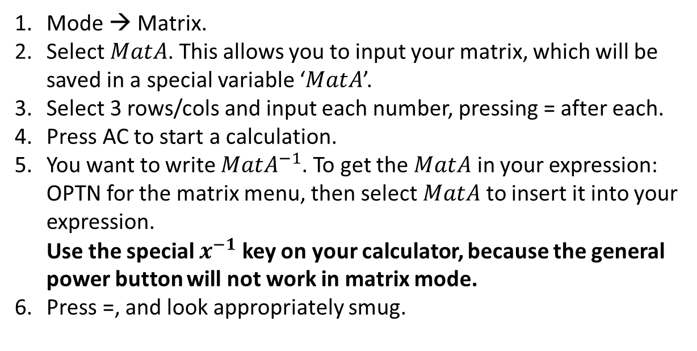

Further Example

$A=\left(\begin{matrix}-2 & 3 & -3 \\ 0 & 1 & 0 \\ 1 & -1 & 2\end{matrix}\right)$,
and the matrix $B$ is such that ${\left(AB\right)}^{-1}=\left(\begin{matrix}8 & -17 & 9 \\ -5 & 10 & -6 \\ -3 & 5 & -4\end{matrix}\right)$.
(a) Show that $A^{-1}=A$.
(b) Find $B^{-1}$.

Test Your Understanding

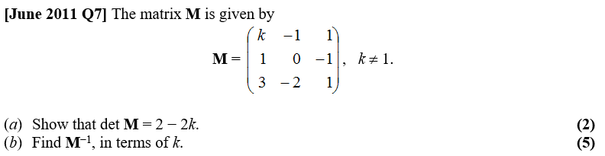

Ex 6E Pg 115

