Matrices and their Inverses

Determinants
- The determinant of a matrix has many applications in matrices. Fundamentally, the determinant is required to find the inverse of a matrix.
- The determinant of a matrix $A=\left(\begin{matrix}a & b \\ c & d\end{matrix}\right)$ is
$$\det\left(A\right)=|A|=ad-bc$$

- If $det\left(A\right)=0$, then $A$ is a singular matrix and it does not have an inverse.
- If $\det\left(A\right)≠0$, then $A$ is a non-singular matrix and it has an inverse.

Quickfire Questions:
$$A$$ | $$\det\left(A\right)$$
$$\left(\begin{matrix}1 & 0 \\ 0 & 1\end{matrix}\right)$$
$$\left(\begin{matrix}1 & 2 \\ 3 & 4\end{matrix}\right)$$
$$\left(\begin{matrix}0 & 3 \\ -1 & -4\end{matrix}\right)$$
$$\left(\begin{matrix}10 & -2 \\ 4 & -1\end{matrix}\right)$$

Example

Example
Given that $A$ is singular, find the value of $p$.

$$A=\left(\begin{matrix}4 & p+2 \\ -1 & 3-p\end{matrix}\right)$$

Test Your Understanding
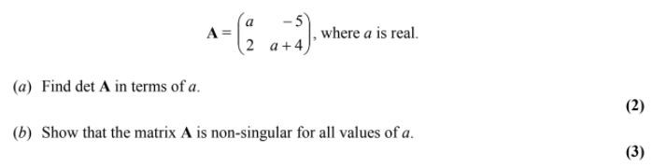

Determinants of 3x3 Matrices
To find the determinant and inverse of a 3 x 3 matrix, it is first necessary to define some new terms.

- The minor of an element
The minor of a particular element of a matrix is found by eliminating the row and column of that element and finding the determinant of the remaining matrix.
For a 3 x 3 matrix, the remaining matrix will be a 2 x 2 matrix.

- The cofactors of an element
The cofactor of an element is its minor multiplied by a multiple of
(-1) in the following pattern (called the place signs)

Example
Find the minors of the elements 0, -6 and 5 in the below matrix:
$$\left(\begin{matrix}1 & 2 & 0 \\ 4 & 5 & -6 \\ -1 & 8 & 2\end{matrix}\right)$$

Test Your Understanding

Example

Finding the determinant

The determinant of a 3 x 3 matrix can be found from the cofactors of any row or column of the matrix. Each element in that row or column is multiplied by its cofactor, and the results are added together.

Example
$\left|\begin{matrix}3 & 1 & 4 \\ 2 & 2 & 5 \\ -3 & 4 & 3\end{matrix}\right|$

Test Your Understanding
1.
$A=\left(\begin{matrix}1 & 2 & 0 \\ 4 & 5 & -6 \\ -1 & 8 & 2\end{matrix}\right)$ Determine $\det\left(A\right)$.

2.
$A=\left(\begin{matrix}3 & k & 0 \\ -2 & 1 & 2 \\ 5 & 0 & k+3\end{matrix}\right)$ where $k$ is a constant.
Given that $A$ is singular, find the possible values of $k$.

Alternative Method:
Ex 6C Pg 108

