CP1 Chapter 6

Matrices

Chapter Overview

1. Understand matrices and perform basic operations (adding, scalar multiplication)

2. Multiply Matrices

3. Find the determinant or inverse of a matrix

4. Solve simultaneous equations using matrices







Introduction

A matrix (plural: matrices) is **simply an ‘array’ of numbers**, e.g.

$$\left(\begin{matrix}1 & 0 & -2 \\ 3 & 3 & 0\end{matrix}\right)$$

On a simple level, a matrix is just a way to organise values into rows and columns, and represent these multiple values as a single structure.

The dimension of a matrix is its **size**, in terms of its number of **rows** and **columns** (in that order).

Examples:

Matrix Dimension

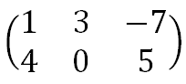

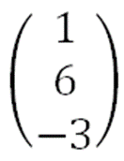



Matrix Fundamentals

Operations with Matrices

1. Addition and subtraction
2. Scalar Multiplication

Ex 6a page 97