5D Modelling with Volumes of Revolution
- A manufacturer wants to cast a prototype for a new design for a pen barrel made out of solid resin. The shaded region shown in the diagram is used as a model for the cross section of the pen barrel. The region is bounded by the x-axis and the curve with equation $y=k-100x^{2}$, and will be rotated around the y-axis. Each unit on the coordinate axes represents 1cm.
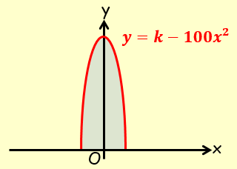
- Suggest a suitable value for k

- Use your value of k to estimate the volume of resin needed to make the prototype

- State one limitation of this model

