Modelling with Volumes of revolution
Eg. In the 1990 film ‘Ghost’. Patrick Swayze (now sadly, also no longer living) is shot, only to come back as a ghost to resolve ‘unfinished ghost business’. In one iconic scene, he engages in some saucy ghost-pottery with fiancé Demi Moore (who is not dead).
The filmmakers want to know how much clay to buy. The equation of the outside curve can be modelled with the equation
$$x=\frac{1}{100}{\left(y-30\right)}^{2}+10$$
where $x$ and $y$ are in cm. The pottery spins about the $y$-axis. If the height of the resulting pottery will be 40cm, determine the volume of clay needed, giving your answer to 3 significant figures.

Test Your Understanding
A manufacturer wants to cast a prototype for a new design for a pen barrel out of solid resin. The shaded region shown in the diagram is used as a model for the cross-section of the pen barrel. The region is bounded by the $x$-axis and the curve with equation $y=k-100x^{2}$, and will be rotated around the $y$-axis. Each unit on the coordinate axes represents 1cm.
(a) Suggest a suitable value for $k$. (Let’s say pens are 10cm long)
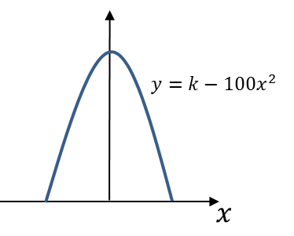
(b) Use your value of $k$ to estimate the volume of resin needed to make the prototype.
(c) State one limitation of this model.
Ex 5D Pg 84-86

