5C Composite Volumes of Revolution
Cylinder = $πr^{2}h$
Cone = $\frac{1}{3}{πr}^{2}h$
- The region R is bounded by the curve with equation $y=x^{3}+2$, the line $y=5-2x$, and the x and y axes.
- Verify that the coordinates of A are (1,3)
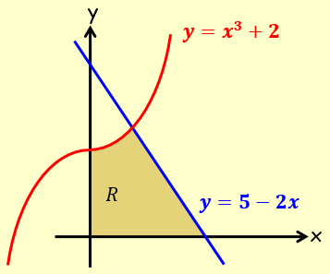

- A solid is created by rotating the region 360˚ about the x-axis. Find the volume of this solid

- The diagram shows the region R bounded by the curves with equations:
$y=\sqrt{x}$ and $y=\frac{1}{8x}$ and the line $x=1$.
The region is rotated through 360˚ about the x-axis.
Find the exact volume of the solid generated.
