Adding and Subtracting Volumes

With more complex volumes you may need to consider compound areas or volumes of general shapes.

Example
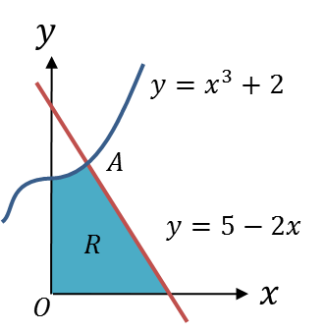
The region $R$ is bounded by the curve with equation $y=x^{3}+2$, the line $y=5-2x$ and $x$ and $y$-axes.
- Verify that the coordinates of $A$ are $\left(1,3\right)$.
A solid is created by rotating the region $360°$ about the $x$-axis.
(b) Find the volume of this solid.

Example
The diagram shows the region $R$ bounded by the curves with equations $y=\sqrt{x}$ and $y=\frac{1}{8x}$ and the line $x=1$.
The region is rotated through $360°$ about the $x$-axis. Find the exact volume of the solid generated.
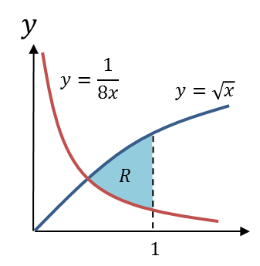

Test Your Understanding

The area between the lines with equations $y=x$ and $y=\sqrt[3]{x}$, where $x≥0$ is rotated $360°$ about the $x$-axis. Determine the volume of the solid generated.
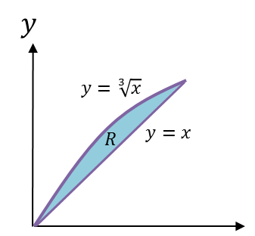
Ex 5C Pg 81-83

