5B Rotations Around the y-axis
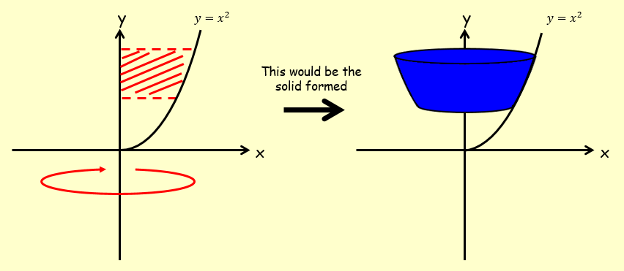

- The diagram shows the curve with equation $y=\sqrt{x-1}$.
The region R is bounded by the curve, the y axis and the lines $y=1$ and $y=3$.
The region is rotated 360˚ about the y axis.
Find the volume of the solid generated.
