Revolving around the y-axis

Examples
1. R is the area enclosed by the curve with equation $y=\sqrt{x^{2}+5},$the $y$-axis and the lines $y=3$ and $y=6$. The region is rotated through $360°$ about the $y$-axis. Find the volume of the solid generated.

2. The diagram shows the curve with equation $y=\sqrt{x-1}$. The region $R$ is bounded by the curve, the $y$-axis and the lines $y=1$ and $y=3$. The region is rotated through $360°$ about the $y$-axis. Find the volume of the solid generated.
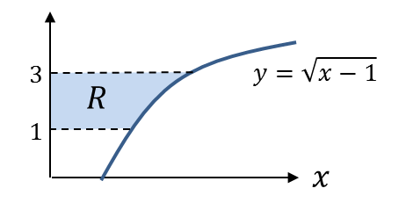

Test your Understanding
A curve has equation $y=\sqrt[3]{2x+1}$. The region $R$ is bounded by the curve, the $y$-axis and the lines $y=2$ and $y=4$. The region is rotated through $360°$ about the $y$-axis. Find the volume of the solid generated.

Ex 5b Pg 77-78

