5A Rotations Around the x-axis
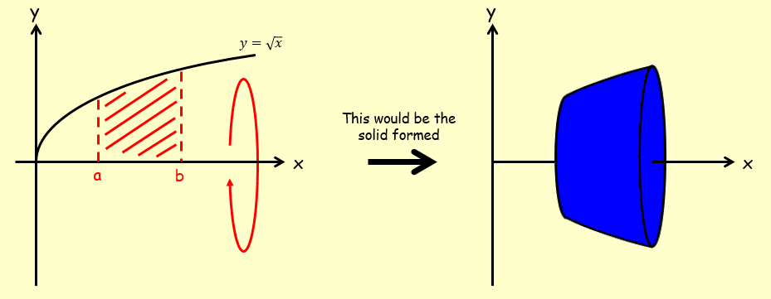

- The diagram shows the region $R$ which is bounded by the x-axis, the y-axis and the curve with equation $y=9-x^{2}$.
The region is rotated through 360˚ about the x-axis.
Find the exact volume of the solid generated.
