**Core Pure 1**

**Volumes of Revolution**

Chapter Overview

**1**: Find the volume when a curve is rotated around the $x$-axis.

**2**: Find the volume when a curve is rotated around the $y$-axis.

3: Find more complex volumes by adding/subtracting.



**Revolving around the x-axis**

$\int_{a}^{b}{y dx}$ gives the area bounded between $y=f(x)$, $x=a$, $x=b$ and the $x$-axis.

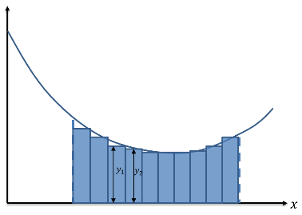

If we split up the area into thin rectangular strips,

each with width $dx$ and each with height the $y=f\left(x\right)$

for that particular value of $x$. Each has area $f\left(x\right)× dx$.

If we had ‘discrete’ strips, the total area would be:

$$Σ_{x=a}^{b} (f\left(x\right) dx)$$

But because the strips are infinitely small and we have to think continuously, we use $∫$ instead of $Σ$.

Integration therefore can be thought of as a continuous version of summation.

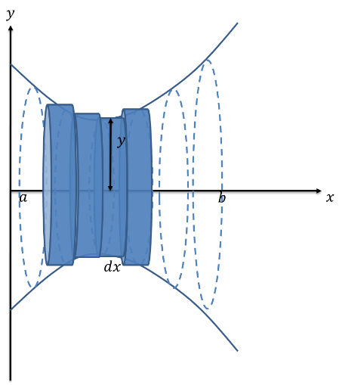

Now suppose we spun the line $y=f(x)$ about the

$x$ axis to form a solid (known as a *volume of revolution*)

**Examples**

1. The region $R$ is bounded by the $y$-axis, the curve with equation

$$y=\sqrt{(6x^{2} - 3x + 2)}$$

and the lines x = 1 and x = 2 . The region is rotated through $360°$ about

the $x$-axis. Find the exact volume of the solid generated.

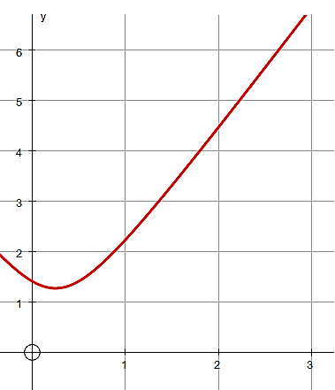

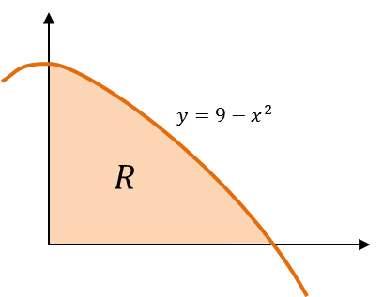2. The diagram shows the region $R$ which is bounded by the $x$-axis, the $y$-axis and the curve with equation $y=9-x^{2}$. The region is rotated through $360°$ about the $x$-axis. Find the exact volume of the solid generated.

Test Your Understanding

$$y={\left(x^{\frac{2}{3}}-9\right)}^{\frac{1}{2}}$$

The finite region *R* which is bounded by the curve *C*, the *x*-axis and the line *x* = 125 is shown shaded in Figure 3. This region is rotated through $360°$ about the *x*-axis to form a solid of revolution.

Use calculus to find the exact value of the volume of the solid of revolution.  **(5)**

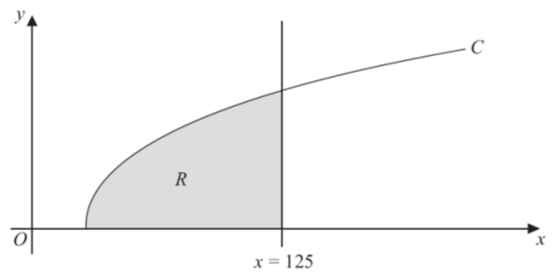

Ex 5a Pg 73-75