5A Rotations Around the x-axis
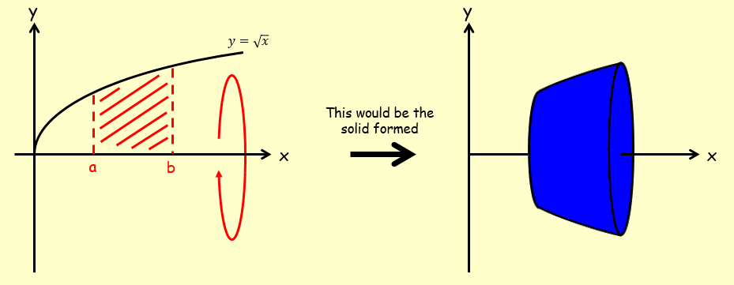

- The diagram shows the region $R$ which is bounded by the x-axis, the y-axis and the curve with equation $y=9-x^{2}$.
The region is rotated through 360˚ about the x-axis.
Find the exact volume of the solid generated.
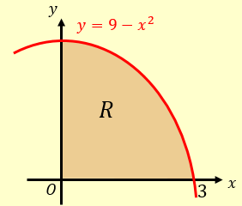

5B Rotations Around the y-axis
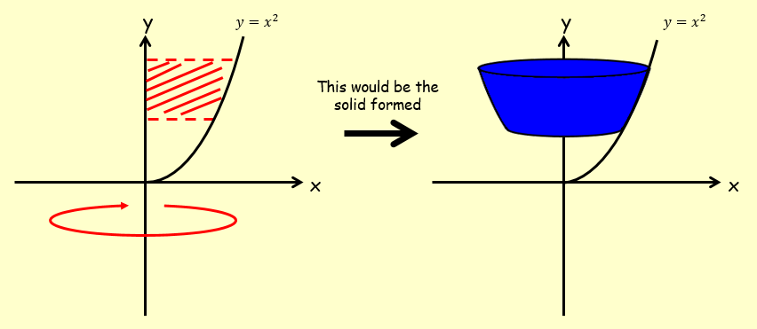

- The diagram shows the curve with equation $y=\sqrt{x-1}$.
The region R is bounded by the curve, the y axis and the lines $y=1$ and $y=3$.
The region is rotated 360˚ about the y axis.
Find the volume of the solid generated.
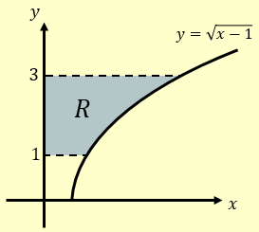

5C Composite Volumes of Revolution
Cylinder = $πr^{2}h$
Cone = $\frac{1}{3}{πr}^{2}h$
- The region R is bounded by the curve with equation $y=x^{3}+2$, the line $y=5-2x$, and the x and y axes.
- Verify that the coordinates of A are (1,3)
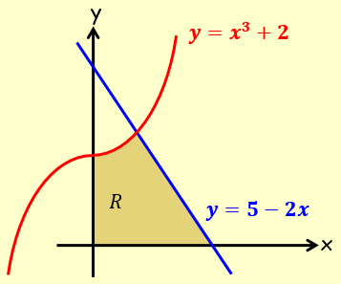

- A solid is created by rotating the region 360˚ about the x-axis. Find the volume of this solid

- The diagram shows the region R bounded by the curves with equations:
$y=\sqrt{x}$ and $y=\frac{1}{8x}$ and the line $x=1$.
The region is rotated through 360˚ about the x-axis.
Find the exact volume of the solid generated.
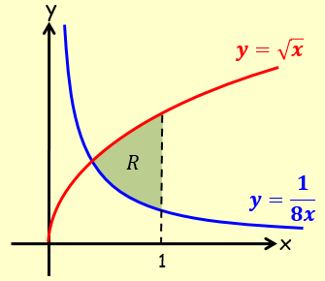

5D Modelling with Volumes of Revolution
- A manufacturer wants to cast a prototype for a new design for a pen barrel made out of solid resin. The shaded region shown in the diagram is used as a model for the cross section of the pen barrel. The region is bounded by the x-axis and the curve with equation $y=k-100x^{2}$, and will be rotated around the y-axis. Each unit on the coordinate axes represents 1cm.
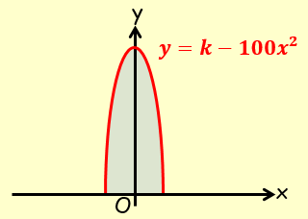
- Suggest a suitable value for k

- Use your value of k to estimate the volume of resin needed to make the prototype

- State one limitation of this model

