Linear Transformations of Roots
We can use the general results regarding roots of polynomials to find an equation whose roots are related to the roots of the original equation i.e. the roots of the new equation are simply a linear transformation of the original roots.

Example
The polynomial $x^{2}-3x-10=0$ has the roots $α$ and $β$. Without finding the roots, determine the equation with roots $α-1$ and $β-1$.
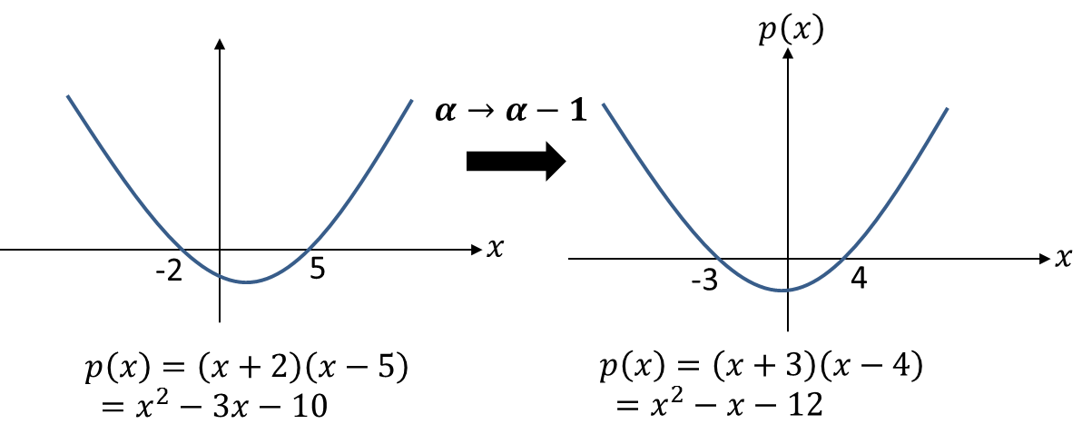

2 Methods:

Example
The quartic equation $x^{4}-3x^{3}+15x+1=0$ has roots $α, β,γ,δ$. Find the equation with roots $(2α+1)$, $\left(2β+1\right)$, $\left(2γ+1\right)$ and $(2δ+1)$.

Test Your Understanding
The cubic equation $x^{3}-2x^{2}+4=0$ has roots $α, β,γ$. Find the equation with roots $(3α-1)$, $\left(3β-1\right) and \left(3γ-1\right).$

Ex 4E pg 66-67

