4D Modelling with Volumes of Revolution
- The diagram shows a model of a goldfish bowl. The cross section of the bowl is described by the curve with parametric equations:
$x=2sint, y=2cost+2, \frac{π}{6}≤t≤\frac{11π}{6}$
Where the units of $x$ and $y$ are in cm. The bowl is formed by rotating this curve about the y-axis to form a solid of revolution.
- Find the volume of water required to fill the model to a height of 3cm.
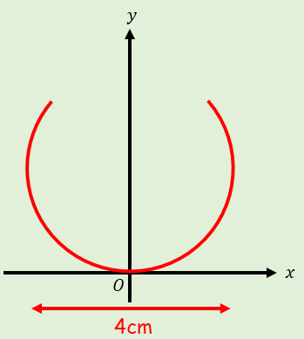

- The real bowl has a diameter of 48cm. Find the volume of water needed to fill it to the corresponding height

