Modelling with Volumes of Revolution

Example
The diagram shows a model of a goldfish bowl. The cross-section of the model is described by the curve with parametric equations
$x=2\sin{t}, y=2\cos{t}+2$, $\frac{π}{6}≤t≤\frac{11π}{6}$, where the units of $x$ and $y$ are in cm. The goldfish bowl is formed by rotating this curve about the $y$-axis to form a solid of revolution.
- Find the volume of water required to fill the model to a height of 3cm.
The real goldfish bowl has a maximum diameter of 48cm.
(b) Find the volume of water required to fill the real goldfish bowl to the corresponding height.

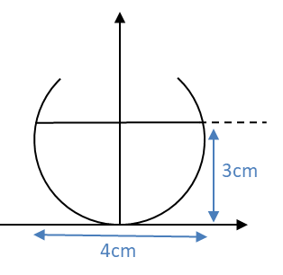
Ex4D p. 88-89

