Volumes of revolution for parametric curves
We have seen in Pure Year 2 that parametric equations are where, instead of some single equation relating $x$ and $y$, we have an equation for each of $x$ and $y$ in terms of some parameter, e.g. $t$. As $t$ varies, this generates different points $\left(x,y\right)$.
To integrate parametrically, the trick was to replace $dx$ with $\frac{dx}{dt} dt$

$V=π\int_{x=b}^{x=a}{y^{2} dx}$

Note that as we’re integrating with respect to $t$ now, we need to find the equivalent limits for $t$. We can do the same for revolving around the $y$-axis: just replace $dy$ with $\frac{dy}{dt}$ and change the limits.

Example
The curve $C$ has parametric equations $x=t(1+t)$, $y=\frac{1}{1+t}$, $t≥0$.
The region $R$ is bounded by $C$, the $x$-axis and the lines $x=0$ and $y=0$. Find the exact volume of the solid formed when $R$ is rotated $2π$ radians about the $x$-axis.

Test Your Understanding
Edexcel C4(Old) June 2011 Q7
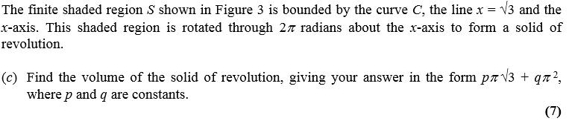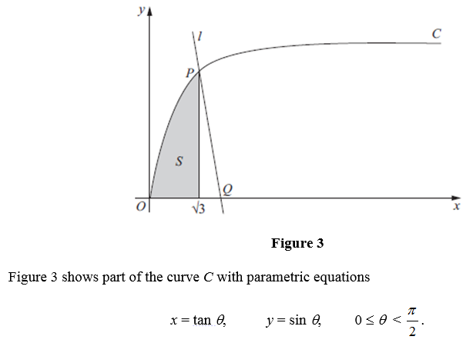

Ex4C p. 84-87

