Core Pure 2

Volumes of Revolution

Chapter Overview

1: Revolving around the $x$-axis.

2: Revolving around the $y$-axis.

3: Volumes of revolution with parametric curves.

4: Modelling



This chapter involves volumes of revolution but with trickier integration than in CP1.

Revolving around the x-axis

**Recap: When revolving around the $x$-axis, $V=π\int_{b}^{a}{y^{2} dx}$**

Example

The region $R$ is bounded by the curve with equation $y=\sin{2x}$, the $x$-axis and $x=\frac{π}{2}$. Find the volume of the solid formed when region $R$ is rotated through $2π$ radians about the $x$-axis.

Edexcel C4(Old) Jan 2013 Q6

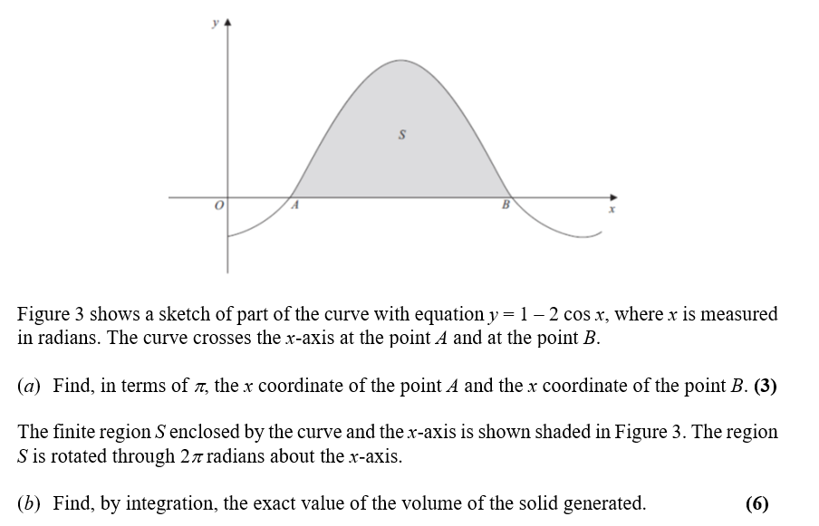

Ex4A p. 78-80

Revolving around the $y$-axis

**Recap**: When revolving around the $y$-axis, $V=π\int_{b}^{a}{x^{2} dy}$

i.e. we are just **swapping the roles of $x$ and $y$** .

Example

The diagram shows the curve with equation $y=4\ln{x}-1$. The finite region $R$, shown in the diagram, is bounded by the curve, the $x$-axis, the $y$-axis and the line $y=4$. Region $R$ is rotated by $2π$ radians about the $y$-axis. Use integration to show that the exact value of the volume of the solid generated is $2π\sqrt{e}\left(e^{2}-1\right)$.

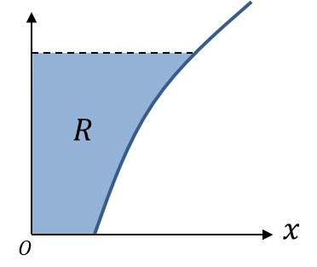

Ex4B p. 81-83