4A/B Volumes of Revolution
A Reminder from CP1:
- The region R is bounded by the curve with equation $y=sin2x$, the x-axis and the lines
$x=0$ and $x=\frac{π}{2}$.

Find the volume of the solid formed when region $R$ is rotated through $2π$ radians about the x-axis.

- The diagram shows the curve with equation $y=4lnx-1$.
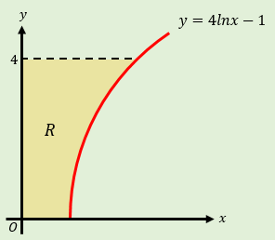

4C Revolutions with Parametrics

- The curve $C$ shown has parametric equations:
$$x=t\left(1+t\right), y=\frac{1}{1+t}, t≥0$$
The region $R$ is bounded by the curve, the x-axis and the lines $x=0$ and $x=2$.
Find the exact volume of the solid formed when $R$ is rotated $2π$ radians about the x-axis.
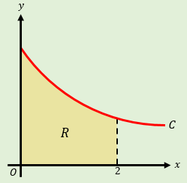

4D Modelling with Volumes of Revolution
- The diagram shows a model of a goldfish bowl. The cross section of the bowl is described by the curve with parametric equations:
$x=2sint, y=2cost+2, \frac{π}{6}≤t≤\frac{11π}{6}$
Where the units of $x$ and $y$ are in cm. The bowl is formed by rotating this curve about the y-axis to form a solid of revolution.
- Find the volume of water required to fill the model to a height of 3cm.
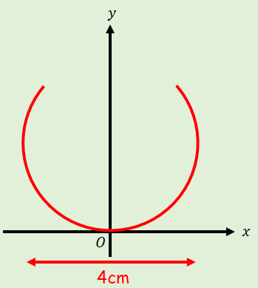

- The real bowl has a diameter of 48cm. Find the volume of water needed to fill it to the corresponding height

